**Measuring The Efficacy Of Pakistan Army Response Mechanism During Earthquake 2005 – A Case Study Of UC Balakot**

**Submited By Zaib Un Nisa Khattak**

**&**

**Syed Nasir Shah**

**ABSTRACT**

Response is the most challenging phase of disaster management. The study was aimed at understanding the response mechanism developed by the Army and measuring its efficacy from the perspective of community perception was obtained from union council Balakot. In order to get a balance and realistic input purposively those respondents were selected who were willing to provide information and were also from diverse back ground. Generally the community was found satisfied with response mechanism developed by Army. The data collected emphatically indicates the effectiveness of the same. However, certain short coming pertaining to training, equipment and coordination aspects also came into lime light. With the increasingly hostile and non visible threat climate generated by terrorism, insurgency and localized disturbances (natural and manmade) armed forces have had to adapt and train themselves in order to carry out operation other than war. Disaster management and response is one of these activities.

1.1 **Introduction**

Disasters and natural calamities are not a new phenomenon to mankind. Archeological sites and numerous lost civilizations are witness to such tragedies in the past. Generation after generations put in their efforts to dev infrastructures in towns and cities but it takes a moment to wipe out years of urban development when some disaster happens. In the present era of knowledge and resources have encourage man to reach the site of disaster and help out the victims of disasters instead of abandoning the areas like his forefathers. The day of 8 October, perhaps would be recorded as a nightmare a day of melancholy, sadness and sorrows in Pakistan’s history. More than 73000 people lost their lives and over 120000 got injured. Nearly 5 million became homeless. The Earthquake came as a shock and perhaps found nation unprepared to meet such a challenge. The Army itself suffered badly, yet it responded courageously to face the challenges. (Role of Army in Disaster Management; HQ 5 Corps)

1.2 **Disaster Profile of Pakistan**

Geographically, Pakistan is situated in hazard-prone region. The indo-australian plat upon which Pakistan, India and Nepal lie, is continuously moving northward and sub ducting under the Eurasian plate thus triggering earthquakes in the process and forming Hamalayan mountains. Pakistan is exposed to erratic seasonal monsoons that bring rain and fertility. They also cause violent flash floods inflicting heavy damages to property and land. Floods are the most recurrent natural calamity in Pakistan, followed by earthquakes, cyclones and drought. However, drought is more damaging than floods in terms of food insecurity. Pakistan has a serious vulnerability to both natural and man-made disasters. A major flood has struck Pakistan once in every six years causing heavy losses to human lives and economy. Summer monsoons result in heavy cyclones originating from Bay of Bengal and Arabian Sea. There is a well developed system in place based on multiple inputs of Pakistan Meteorological department (PMD), WAPDA and Indus Water Commission for floods early warning. However, there is no system in place to warn vulnerable communities from the flash flood hazard. During the period 1971-2001, fourteen cyclones approached coastal areas of Pakistan. Despite some gaps in the PMD’s indigenous capacity, minimum 3-4 days of cyclone early warning with fairly accurate prediction of likely impact area can be provided. The response to this hazard has been poor and outcomes disastrous. Districts Gwadar, Lasbela, Karachi, Badin and Thatta are prone to tropical cyclones and Tsunamis. Landslides can be triggered by an earthquake, rainstorm, wind or blasting. Severe monsoon rains and or exceptional melting of Himalayan glaciers provide abundant water to cause many landslides. Bagh, Bhimber, Neelum and Muzaffarabad in Azad Jammu & Kashmir, Astore, Diamer, Gilgit & Ghanche in Northern Areas and Kaghan, Naran & Chitral in KPK are prone to slides. According to the recent seismic assessments, the region is likely to face a major earthquake in future as a critical seismic gap is widening: The districts of Pakistan most likely to be earthquake prone are: Abbotabad, Mansehra, Attock, Muzaffarabad, Chitral, Dadhar, Pashin, Dir, Pasni, Gawadar, Quetta, Gilgit, Rawalpindi, Islamabad, Sawat, Kalat, Sibi, Skardu, Khuzdar, Ziarat, Kohistan, Zhob, Loralai and Malakand. (Seismic Hazard Analysis and Zonation for Pakistan, Azad Jammu and Kashmir by Pakistan metrological department)

1.3 **Existing disaster management structure of Pakistan**

Pakistan has generally followed a reactive approach to disaster management which is apparent from October 2005 earthquake experience. Key disaster management agencies like Emergency Relief Cell working under the Federal Cabinet Division, proved woefully inadequate when confronted with a major disaster. After 2005 earthquake, a system of National and Provincial Disaster Management Commissions (NDMC/ PMDCs), and Authorities (NDMA/ PDMAs) was proposed in the NDM Ordinance 2006 to facilitate implementation of disaster risk management (DRM) activities. The NDMC/ PMDCs are the policy making bodies, while the NDMA/ PDMAs are the implementing and coordinating arms. National Disaster Management Commission (NDMC) is the highest policy and decision making body for DRM. The NDMC is responsible to ensure coordination and oversee the implementation through NDMA.(www.ndma.gov.pk/)

1.4 **Problem Statement**

Repaid-onset natural disasters often occur with little or no notice and call for an immediate response in order to prevent further damage or loss to life. This is particularly true in case of earthquakes. Role of army in first 48-72 hours is vital to save lives of people trapped in rubble. The effectiveness of Army’s role in response phase to a great extent is determined by the speed of its deployment, relative to the civilian assets with the same capabilities. Late arrival and being slow to become operational will greatly reduce its effectiveness. An adequately equipped outfit, well familiar with area of responsibility coupled with high standard of training, readiness and thorough preparation are the areas to be addressed for facing such challenges in future.

1.5 **Significance of Research**

Natural disasters are on the increase and projected to rise. The primary purpose of a disaster response is to save lives. Traditionally armed forces form core of a state’s response to a disaster situation. Studying the effectiveness of response mechanism developed by the army in post 2005 earthquake shall provide a platform to review the existing drills and procedures involved in disaster response phase. Similarly the outcome may be of great value in terms of initiating improvement in the existing response mechanism.

1.6 **Objective I**

To study the response mechanism developed by army during Earthquake 2005.

1.7 **Objective II**

To determine the effectiveness of the Army’s response in the study area.

1.8 **Organization of the study**

The study has been organized into five chapters. Chapter 1 is about introducing the subject of study, highlighting problem statement and spells out the significance of the study. Chapter 2 provides the theoretical framework by reviewing the literature. Chapter 3 describes the study area including methodology of the study. The primary and secondary data has been analyzed in chapter 4 while study has been concluded along with pertinent recommendations in chapter 5.

**CHAPTER 2**

**LITERATURE REVIEW**

2.1 **Origins of disaster research**

Although historical and literary accounts of disasters date back thousands of years, scientific analyses are more recent. Dynes (2000) contends that Rousseau provided the first social scientific insights into disaster with his observation that the impacts of the 1755 Lisbon earthquake would have been diminished if the city had been less densely populated and if people had evacuated promptly in response to the initial tremors. More than 150 years later, William James’s (1983) observations in San Francisco immediately after the 1906 earthquake also anticipated important themes of later research by reporting improvisation (‘the rapidity of the improvisation of order out of chaos’, p. 336) and emergent organization (‘within twenty four hours, rations, clothing, hospital, quarantine, disinfection, washing, police, military, quarters in camp and in houses, printed information, employment, all were provided for under the care of so many volunteer committees’, p. 337). Nonetheless, the first systematic disaster research is generally acknowledged to be Samuel Prince’s (1920) study of the 1917 Halifax explosion (Scanlon, 1988). This study documented the presence of convergence and emergence, as well as the absence of role abandonment. As Quarantelli (2000) noted, little additional progress was made in disaster research until the National Opinion Research Center/National Academy of Sciences studies of the 1950s, whose findings were first summarized by Fritz and Marks (1954) and Fritz (1961), received more extensive treatment in Baker and Chapman (1962) and were the subject of a systematic analysis in Barton (1969). Other classic works of the 1950s are also reviewed in the *International Journal of Mass Emergencies and Disasters*, Vol. 6, No. 3, 1988. Drabek (1986) and Tierney et al. (2001) provided later summaries of this research. Tierney et al. (2001: 234–40) and CDRSS (2006: Ch. 8) describe the institutional context of disaster research.

2.2 **The Origins of Disaster Management**

Early society viewed disasters as preordained, however, by the 20th century, the idea of providing disaster preparedness and relief was gradually forming within governments. In the case of the United State (US), a crises administration department has functioned since 1933. The National Emergency Council (NEC) was directly subordinate to the President and served as the President’s personal crises and management consultants at the time. In 1939, the NEC was reconfigured into the office of Emergency Management (OEM), which is one unit within Executive Office of the President (Jan, Chung-yuang, 2004). During the Cold War in the 1950s the National Research Council carried out a series of crises management studies to address the nuclear threat and artificial disaster scenarios. National disaster research became interdisciplinary after the publication of White’s Natural Hazards Research in 1973 and White and Haas’ book, Assessment of Research on National Hazards in 1975. The integration and coordination of crises management in the US became more comprehensive after the establishment of the Federal Emergency Management Agency (FEMA) in 1979. Alexander (2000) discusses the relationships among crises, risk, vulnerability and disasters. He defines a catastrophe an extreme geophysical event that is sufficient to cause a disaster.

2.3 **Role of Contemporary Armies in Disaster Management**

Militaries’ Role in Contemporary Disaster Management System within the resources of most nations, military assets represent unique technological and logistical capabilities that can be mobilized on short notice in a self-contained, self sufficient and highly mobile fashion, to support lifesaving relief efforts. Nearly all nations have at one time or another used their military assets and capabilities for national disaster relief. Emerging Trends of Military Operation viz Disaster Management. The latest emerging trends for use of military in disaster management are:- (Military Role in Natural Disaster Management by James Lee,2006)

2.3.1 **Trend 1**– Disaster Management as Part of Military Operations other than War (MOOTW). Military profession is increasingly changing its focus from war fighting to a complex array of MOOTW. Disaster management is an important component of MOOTW including operations such as search, rescue, relief and rehabilitation.

2.3.2 **Trend 2**- Exclusive Military or Civil-Military Disaster Response Teams. Constitution of exclusive military or civil-military teams is emerging as another strong trend.

2.3.3 **Trend 3** – Military Acting as the Communication Hub during Disaster Management. Military often ends up as the communication hub, because of its superior Command, control and communication capability and being usually first on the disaster scene due to its inherent mobility and speed.

2.3.4 **Trend 4** – Foreign Human Assistance (FHA). FHA by military is a significant trend, the scale, speed and duration of which has already been witnessed in earthquake 2005.

2.3.5 **Trend 5** – Military Disaster Training Exercises. The latest trend is manifested in exercises like: The Northern Light, Cooperation Safeguard, Combined Protection Exercises (COMPROTEX) and Taming the Dragon - Dalmatia 2002.

2.4 **Role of US Armed Forces**

US active Armed Forces have a role in responding to and recovering from natural disasters. At the request of State’s Governor the national command authority can direct appropriate capabilities from the nation’s military to the site of a disaster. The response system is built on tiered response i.e, local leaders turn to state resources and states turn to Washington. In most disasters, local resources handle things in the first hours until national resources can be requested, marshalled, and rushed to the scene.(U.S Government ‘National response Plan’ 2004)

2.5 **Role of Chinese Armed Forces**

Due to its geographical location and meteorological conditions, more than 70 per cent of Chinese cities are located in hazardous areas. The Constitution and relevant laws have assigned the armed forces to act as the backbone of field actions during disaster responses. The Office for Public Emergencies is the joint headquarters of the military and the armed police for dealing with disaster emergencies and coordinating with central and local governments. In peace time, the PLA gathers information on disasters and dangers, set up a system of information exchange with local governments, draw up rescue and relief plans, conduct training and exercises, and offer and relief courses in military command colleges. In rescue and relief operations, PLA troops receive orders from the joint military-civilian HQ. They are subordinated to civilian authorities and undertake the following tasks:- (China National Master Plan for responding to Public Emergencies ,2005)

i. Rescuing and evacuating disaster victims and people trapped in danger.

ii. Eliminating or controlling major dangers and disasters.

iii. Ensuring the safety of important targets.

iv. Participating in the emergency rescue and transportation of goods.

2.6 **Role of Indian Armed Forces.**

India has established a multidisciplinary, multi-skilled, high-tech NDRF (National Disaster Response Force).of Eight Battalions has been set up for dealing with all types of disasters capable of insertion by air, sea and land. This is a military related response force. The battalions are to be equipped and trained for all natural disasters including four battalions in combating NBC disasters. Each battalion (approximately 1,158 strength) will provide 18 self-contained specialist search and rescue teams of 45 personnel each including engineers, technicians, electricians, dog squads and medical/paramedics. These NDRF battalions are located at nine different locations in the country based on the vulnerability profile to cut down the response time for their deployment. During the preparedness period/ disaster situation, proactive deployment of these forces will be carried out by the NDMA in consultation with state authorities.

2.7 **Case Studies (Responses)**

2.7.1 **Haiti Earthquake – 2010**

On January 12, 2010, a massive 7.0 magnitude earthquake centered 25 km southwest of Port-au-Prince, Haiti killed over 230,000 people, injured another 300,000, and created over one million homeless (IWG, 2010). The Haitian government (GoH), with a majority of civil leadership dead, was paralyzed. On the day of the quake, the President of Haiti declared a national emergency confirmed by the U.S. Ambassador to Haiti and both requested immediate assistance from the United States and the international community (USSOUTHCOM OPORD 01-10, 2010). “Since the first hours and days are absolutely critical to saving lives and avoiding even greater tragedy, I have directed my forces to be as forward-leaning as possible in getting the help on the ground and coordinating with our international partners as well” (Obama, 2010). The French, Italian, Dutch, Spanish and Canadian Navies sent ships that arrived within the first week (including the Italian Carrier Cavour). An Argentine military field hospital, that was part of the UN Mission in Haiti - MINUSTAH, was the only hospital left operating. Within a week, rescue and medical teams arrived from the United States, Canada, Russia, France, Chile, Peru, Jamaica, Brazil, Colombia, Cuba, Iceland, Sri Lanka, China, and Korea. From the Middle East, the government of Qatar sent a strategic transport aircraft (C-17) and the Qatari armed forces set up a hospital. The Israeli Defense Forces also established a field hospital which included specialized facilities to treat children and the elderly. Initially the relief teams were autonomous with independent logistics support. Since the functioning logistics train ended at the edge of the Port-au-Prince airport – the field hospitals and emergency response vehicles ended up clustered there as well. The combined military response to Haiti was highly impressive. (www.sipri.org/)

2.7.2 **Floods and cyclones in Mozambique, 2000**

In January and February 2000 prolonged heavy rains and the cyclones Connie and Eline caused catastrophic ﬂooding in Mozambique’s Gaza, Inhambane, Manica, Maputo and Sofala provinces. An estimated 2 million people were affected, 544 000 were displaced and 699 were killed. The World Bank estimated the economic damage caused by the and cyclones to be approximately 20 per cent of the country’s gross national product.1 Mozambique’s recently created disaster management structure was quickly overwhelmed by the scale of the humanitarian crisis. A major international assistance effort included foreign military assets from 11 countries. These countries eventually allowed their assets to be under United Nations coordination to an unprecedented degree. It was the ﬁrst time that the concept of a Joint Logistics Operation Centre to manage and coordinate air assets was applied in a natural disaster response. Another similar bout of ﬂooding in the country in 2007 provides a useful comparison of the responses and some indication of how, and how far, the lessons of 2000 have been applied. (www.sipri.org/)

2.7.3 **Indian Ocean tsunami, Aceh province, Indonesia, 2004.**

The tsunami that struck the coast of Aceh province in Indonesia on 26 December 2004 created an unprecedented humanitarian challenge and an equally unprecedented international response. Military assets were sent by 16 foreign governments; 14 United Nations agencies, 38 local humanitarian groups and 195 foreign or international humanitarian organizations participated in a three-month relief effort. Foreign military assets played a pivotal role in the response, particularly the emergency relief phase. (www.sipri.org/)

2.7.4 **Japan Tsunami**

The Japanese government’s response to the earthquake, tsunami and nuclear incident at Fukushima in 2011 is widely seen as exemplary. Shortly after the 2011 earthquake, almost half of Japan’s 230 000 troops deployed to disaster relief and established, for the first time, joint command of ground forces, sea air. Co-ordination with 20000 US servicepersons was smooth. (www.sipri.org/)

2.8 **Disaster and Response**

To measure a response to a disaster, the terms response and disaster must be clearly defined. As (Fritz, C.E. 1961) writes, disasters are spatial-temporal events which impact social units which then invoke responses to the event or events. Furthermore, (Kreps,G.A. 1984) goes on to write that “Responses may involve structural engineering (physical), be relevant before, during, or after the impact is felt (temporal), or result from a variety of social and organizational processes (social)”. Thus responses to disasters are essentially an effort to restore the previous status quo to an affected area. Thus, response to a disaster will be defined simply as turning chaos into order.

2.9 **Measuring the Response**

Response to a disaster must be appropriately scaled according to the size of the disaster. Because response, is considered in terms of an organized response, it will be the extent of this organization which will reflect the size of the disaster response. Currently the United States is undergoing an effort to standardize the method in which disasters are managed. It is called NIMS, National Incident Management System (Filar,Jersy2001). This system standardized an Incident Command System which classifies each individual responder into a particular sector. Within the system there might be different sectors with the same purpose, but it is designed so that the “span of control for any one person never exceeds 5-7 people” (Boyd,Carr. 2005) The system is designed to scale appropriately to handle any disaster regardless of the size. As stated by (Boyd,Carr. 2005), “The incident command system is set up to break even the largest of incidents into manageable pieces”. Thus, by measuring the number of branches and sectors initialized under the National Incident Management System guidelines, the entire scope of the rescue effort could be represented in a standardized manner, regardless of the type of disaster. However, this implies that such a system would be used in the response efforts of the disaster. Because a disaster is defined as an event which is large enough to exceed the capabilities of a community to handle the effects, it can be assumed that some system of organization has to be implemented to handle new agencies assisting in response. The NIMS is the only nationally standardized method of emergency management, outside of military protocol, and thus should be the benchmark for measuring the extent of the response.

**3.0 Goals of Response**

Next the goals of the actual response must be identified. Several expert interviews as well as personal experience have led to the conclusion that emergency responders’ goals basically fall into two categories, protect life and protect property (Boyd,carr 2005) (cannon,Robert 2005). There are also several aspects to protecting life and property during the initial phases of a disaster. These categories basically are stabilization, rescue, mitigation, and safety. Stabilization involves stabilizing any obvious threats to the population or property to the greatest extent possible so as to contain them. Rescue involves searching for and identifying casualties and properly triaging them prior to transport to a hospital or other staging facility. Mitigation involves preventing further harm to a population by diminishing the malicious effects of a disaster and restoring basic services. Mitigation goes hand in hand with stabilization in some respects. For example, in a flood situation, stabilization would involve placement of sandbags to divert water away from populated areas while mitigation would involve evacuating the residents from the potentially affected area. Lastly safety involves ensuring that the responders accomplish their mission effectively by not becoming incapacitated. When a responder is injured, not only are more victims put at risk, but also that responder then becomes yet another victim that needs aid. Thus it is imperative that in any response, those who are assisting others do so safely and in a manner so as to be able to assist others throughout the duration of the incident.

**CHAPTER 3**

**METHODOLOGY**

3.1 **Description of Study Area**

Balakot sub division is a part of District Mansehra in Hazara Division of KPK. The town is historically famous for being the site where the decisive battle between fighters Syed Ahmed Shaheed and Shah Ismail Shaheed and the tyrannous Sikhs took place in 1830. The entire Kaghan valley is part of Balakot sub division. The valley is scenically and botanically spellbinding and popular for its verdant pastures. Sprawling Glancing the torrential and windy Kunhar river lofty snow cover mountain peaks, enchanting foamy water fall, dense dark green forests, fresh water springs and Trout and beautiful deep blue lakes perched on high altitudes, all of which make it a land of captivating beauty and create magnetic charm for Tourists specially in summer. Inspite of the pressures of over increasing population and the consequent rising levels of environmental pollution, the Kaghan valley is still botanically paradise. (sourse:office of CMO Balakot)

3.2 **Geographical Feature**

Balakot sub division is like wedge driven up between Azad Kashmir on the East and Kohistan District in West and North respectively. Crow-fight distance from South. West to the North East in 100 KM and by road from Batrasi Forest to Babusar Top is 185 KM, within an average width of 25 KM. (sourse : office of CMO Balakot)

3.3 **Administrative Sketch**

Table:1

|  |  |  |
| --- | --- | --- |
|  | Date of creation of Tehsil. | 1st September 1985 |
|  | Date of creation of Sub Division | 1st July 1993 |
|  | Date of creation of TMA Balakot | 15th September 2001 |
|  | Total Population (Census 1998) | 214,630 |
|  | Total Area | 557,803 Acres |
|  | Total cultivable land | 35,115 Acres |
|  | Total Non cultivable land | 522,688 Acres |
|  | Total irrigated land | 7,079 Acres |
|  | Total non-irrigated land | 28,036 |
|  | No. of union councils | 12 |
|  | No. of Kanungo Circles | 02 |
|  | No. of patwar Circles | 16 |
|  | No. of Police Stations | 03 |
|  | No. of Police posts. | 2 |

(Office of CMO Balakot)

3.4 **Population & House Holds** (sourse: census 1998)

Table: 2

|  |  |  |  |
| --- | --- | --- | --- |
| **S.No** | **Name of Union Council** | **Population** | **House Holds** |
| 1. | Kaghan | 22,548 | 2949 |
| 2. | Mohandari | 22,567 | 3045 |
| 3. | Kawai | 13781 | 1952 |
| 4. | Ghanool | 20,274 | 1928 |
| 5. | Hangrai | 18,252 | 2458 |
| 6. | Satbani | 15,949 | 2336 |
| 7. | Balakot | 19,255 | 2777 |
| 8. | Garlat | 18,466 | 2608 |
| 9. | Shohal Mazullah | 13,277 | 1925 |
| 10. | Telhatta | 13,112 | 1908 |
| 11. | Ghari Habibullah | 19,306 | 2013 |
| 12. | Karnol | 17,806 | 2700 |
| **Total** | | **2,14,630** | **30,357** |

3.5 **Health Facilities**

Table: 3

|  |  |  |
| --- | --- | --- |
| 1. | Tehsil headquarter Hospital | One (Balakot) |
| 2. | Civil Hospital | Two (Kaghan & Ghari) |
| 3. | Rural Health Centers | One ( Kawai ) |
| 4. | Basic Health Units | 15 |
| 5. | Leprosy Hospital | One ( Balakot ) |

(sourse:office of CMO Balakot)

3.6 **Main Rivers/Lakes**

i. Kunhar

ii. Lala Zar

iii. Dodi Patsar

iv. Saiful-Malook

iv. Aansoo Jheel (Lake)

v. Lulo Sar

vi. Babu Sar

* 1. **Education Facilities**

Table: 4

|  |  |  |
| --- | --- | --- |
| I. | Boys Degree College | 01 |
| m. | Girls Degree Colleges | 0 |
| n. | Boys Higher Secondary Schools | 03 |
| o. | Girls Higher Secondary Schools | 0 |
| p. | Boys High Schools | 18 |
| q. | Girls High Schools | 06 |
| r. | Boys Middle Schools | 24 |
| s. | Girls Middle Schools | 12 |
| t. | Boys Primary Schools | 235 |
| u. | Girls Primary Schools | 140 |
| v. | Mosque / Maktab School | 152 |

(sourse: office of CMO Balakot)

3.8 **Distances (km)**

1. Mansehra to Balakot 39
2. Balakot to Kawai 24
3. Balakot to Naran 66
4. Naran to Tarka Jour 40
5. Naran to Baisal 50
6. Naran to Babu Sar 66
7. Naran to Malkandi 14

3.9 **Forests**

Upper Kaghan & Lower Kaghan area 52,022 Acres

3.10 **Universe of Study.** UCBalakot being the worst affected was selected as universe for study.

3.11 **Study Design.** Cross-sectional study design was adopted to obtain the requisite data from the respondents

3.12 **Sample design and size**

Purposive sampling design was adopted considering ease of access and selection of respondent who could provide requisite information willingly. Community perception on the subject was obtained using both close ended / open ended questionnaire. 70 respondents from diverse back ground were selected.

3.13 **Data Analysis**

Data has been processed/analyzed using Excel sheets and presented in the form of diagrams and tables.

3.14 **Indicators**

A set of indicators has been used to measure effectiveness of Response from the perspective of community perception. Timeliness, efficiency (saving precious lives), appropriateness of equipment, coordination and security were kept as yardstick / parameter for measuring the response mechanism.

**CHAPTER 4**

**RESULTS AND DISCUSSIONS**

4.1 **Response**

Somewhere around 9 `O' clock corridors of Military Operations Directorate (MO Dte) echoed with the ringing of phone. One pick of receiver triggered what seemed to be whole chain of reactions. Formations from 1 Corps, 10 Corps, 11 Corps and 30 Corps were quick to react. Pakistan Army once again found itself at the base of "Mount Challenge". The mission assigned to the Army by VCOAS was "Bring back smile to the people of earthquake affected areas" (Operation Life line HQ 1 Corps)

4.2 **Movement and Deployment**

First to react were the deployed formations, most of these formations were victims themselves. As information/reports started pouring in from North Eastern part of KPK, Army reacted and formations moved to following areas:-

**Ser** **Formation** **Date of Location Location**

**Move/Arrival**

i. 102 Brigade 8 October 06 Gari Habib Ullah

ii. 104 Air Brigade Defence 9 October 06 Batgram

iii. 107 Brigade 10 October 06 Balakot

iv. Headquarters 37 Division 11 October 06 Mansehra

v. 14 Para Brigade 12 October 06 Battal

vi. 9 Armoured Brigade 12 October 06 Chattar Plain

vii. 7 Armoured Brigade 25October 06 Kala Dhaka

4.3 **Tasks**

In the absence of any national organization coordinating the effort, Pakistan Army assumed the role of "central coordinating agency". After appreciating the situation, commanders decided on following tasks:-

i. Recovery, rescue and evacuation of the casualties.

ii. Provision of medical support to the injured.

iii. Provision of relief goods.

iv. Maintenance of law and order.

v. Restoration of communication infrastructure.

vi. Rubble removal.

vii Coordination of the activities of foreign NGOs.

viii. Establishment of Tent villages.

ix. Construction of semi-permanent shelters

x. Assistance of civil administration.

xii. Assessment / collection of data of dead, injured and damaged houses.

4.4 **Basic Strategy for Rescue Operation.** The strategy evolved to conduct immediate rescue operation in the assigned area of responsibility was:-

i. Deployment of troops in every 8-10 kilometer area to make access to all affected villages and harmonize all segments of population to participate in relief work.

ii. Relief goods to be provided in all weather conditions to all affectees through air, man pack and Animal Transport to avoid the hazards of coming weather.

iii. Utilize local population by motivating and strengthening them.

iv. Clear all roads and tracks as soon as possible to restore normalcy.

v. Harmonize efforts of civil administration, NGOs and locals through necessary coordination and direction and act as hub of all activities. (Operation Life line HQ 1 Corps)

4.4.1 **Government and Civil Society Response**

4.4.2 **National Response**. Nation responded in an unrivalled manner which cannot be described in words. However it can be assimilated by an incident that an old man kept roaming around the pile of relief items being collected at Haripur. He could be taken as a petty thief. However, after much of hesitation, he reached out to the pile, removed his shoes and walked away barefooted. He did not have more to offer. We have millions of such like examples. (Operation Life line HQ 1 Corps)

4.5 **Federal Government Response**. Government of Pakistan, blamed for slow initial reaction, as the media remained focused on **Margalla** Towers in Islamabad, played an important and critical role not only at the inner front in harnessing the rescue and relief efforts but its performance was also applauded at the external front in international community donors. (Operation Life line HQ 1 Corps)

4.6 **Provincial Government Response**. Response of KPK Provincial Government could have been a shade better, as compared to their other provincial counter parts.

4.7 **Response of International Community**. The international community responded swiftly and generously to strengthen Pakistan's response to overcome unprecedented challenge. Immediate arrival of 5 x rescue teams from various countries and latter arrival of helicopters tremendously enhanced the efficiency of rescue and rehabilitation work. On an average, 50 tons of relief goods were arriving at Chaklala Base only. The overwhelming response of world community at the donor's conference in Islamabad provided an impetus to the process of re-construction and re-habilitation work. (Operation Life line HQ 1 Corps)

4.8 **Army Level**

4.9 **Rescue and Relief**. The Army mounted its relief and rescue efforts. Engineer assets proved more than useful as compare to bare hands, shovels and hammers. More than 100,000 people had received injuries of various natures. Thousands of them needed to be removed from affected areas to main hospitals down the country. All available means were used by the troops to evacuate these injured to medical camps and hospitals at different locations. Over 17000 were evacuated through helicopters only. In addition adequate arrangements were made to counter the threat of abduction of injured specially women and children, evacuated beyond Mansehra, as most of them were not accompanied by their relatives. Burial of dead bodies was another emotional trauma. Army teams first helped the affectees to dig their loved one from rubbles of debris and then helped to arrange for their burial. In the beginning mass graves were made to bury a large no of dead bodies. (Operation Life line HQ 1 Corps)

4.10 **Provision of Food.** Earthquake posed major problem of food shortages. Troops who came with very limited rations immediately exhausted their rations giving away to those in need. Demand of food grew with every passing hour. All efforts were put to bring the food to the affectees. Army was assisted by locals in providing food and water to the affectees. (Operation Life line HQ 1 Corps)

4.11 **Engineer Operations**. In Operation Life Line the "main manoeuvre" consisted of Engineers and Aviation. The engineers were involved in: -

i. **Opening of Roads** Engineers embarked on the challenge and put their heart and soul. Worked zealously and were able to deliver. 715 kilometres of roads and 320 kilometres of tracks were restored in KPK alone. Their achievement also includes the launching of major bridges like Hassa and Ghanul. It is important to mention that in initial survey report of a UN organization, they ruled out the possibility of opening of these roads with in a year. Despite the enormity of the task, main arteries of the area were opened for regular traffic with in the span of one month in KPK.

ii. **Removal of Debris**  Removal of debris of buildings was one task which had to be done simultaneously with rescue and relief. A comprehensive plan ascertaining the priorities for removal of debris was chalked out and executed accordingly. Everyone employed in `Operation Life Line' has been involved in removal of debris in one way or another. Troops carried out this task with bare hands, shovels, and hammers. Engineers employed all possible resources and took on the job with steadfast approach, but the amount of debris was such that it would take years to remove it completely. A total of 23570 dumpers load of debris have been removed. It is interesting to know that if these many dumpers stand as one convoy with a distance of 100 metres between each other, it would cover the half the circumference of the earth.

iii. **Water Supply** Disruption / destruction of existing water supply schemes posed threat of epidemics due to contaminated water. Army Engineers immediately established water points for provision of chlorinated water. Commander 1 Corps taking personal interest arranged 5 x water treatment plants for the affectees. (Operation Life line HQ 1 Corps).

4.12 **Role of Army Aviation**

i. According to a report issued by the UN, October earthquake was "the most devastated natural disaster in the most difficult terrain". In this environment Aviation proved the only workable solution, and became an important component of this episode. Never in its history, had Army Aviation been put through such a testing time. The courage motivation and tireless effort put in by pilots and ground staff of Army Aviation would never be forgotten. An episode of an aviator epitomises this aviation spirit and effort. On 5 November 2005 at 2200 hours, a fire broke out in tent village of Shuhal, Balakot. Two young siblings were severely burnt and needed immediate evacuation to Burn Centre at CMH Kharian_ There was only one pilot (Major Khattak) at Abbottabad who had night vision devices, but he has had a very busy day. He volunteered to fly again, when not permitted by the GOC; he insisted and flew after getting permission from Director General Aviation. He landed at CMH Kharian after midnight. One out of these two survived.

ii. Army Aviation was handicapped by non availability of helipads in these areas. Establishment of suitable helipads on slopes of high mountains and narrow valleys was skilful job carried out well by troops with the help of local people.

iii. In the biggest ever heliborne relief operation conducted, Army Aviation emerged as true professionals. They conducted operations in day and night and even during withering weathers, they flew from top of the mountains to narrow and closed valley. In the absence of any air traffic control and metrological facilities, Army Aviation ensured continuous supply of relief goods. Please note that during this operation more than 29000 sorties were flown which is higher than total number of sorties made by Army Aviation since its inception. The total aviation assets used during Operation Life Line are: -

(i) Pakistan Army 42

(ii) Air Force / Navy 09

(iii) Ministry of Interior 08

(iv) Agha Khan Foundation 04

(v) Government of Punjab 01

(vi) Edhi Trust 01

(vii) United States Military 25

(viii) UN 17

(ix) NATO 05

(x) Miscellaneous Sources 28

**Total 140**

4.13 **Logistics**

In order to ensure smooth and regulated flow and distribution of relief goods reaching the calamity stricken districts, it was considered essential to evolve a logistic system, in line with that followed in the Army. To this end, a central collection point in the form of Main Operating Base(MOB) at Mansehra, Forward Operating Bases (FOB) at brigade level and Advance Operating Bases (AOB) at the unit level were established. This strategy helped in achieving the following:-

i. Expeditious distribution of relief goods to the most affected area / individuals in an organized manner.

ii. Controlling pilferage of the relief items.

iii Proper documentation / accounting of all relief goods down to blankets and quilts received / issued to various FOBs.

iv. Build confidence and trust of the donors and provide them a safe, reliable and professionally organized place to deliver their donations.

v. Helped Divisional Headquarters to decide distribution priority to forward areas. (Operation Life line HQ 1 Corps).

4.14 **Forward Observation Bases (FOBs)**

In order to regulate and ensure speedy delivery of relief items to the affectees, FOBs were established at all Brigade Headquarters. On daily basis required relief items were transported from MOB to FOBs on available trucks. Proper record was maintained for all such donations. These FOBs also served as distribution points for the villages falling within the designated area of responsibility. (Operation Life line HQ 1 Corps)

4.15 **Advance Observation Bases (AOBs)**

In order to meet the biggest challenge of reaching to the affected population settled in/around inhospitable/difficult terrain and to provide them immediate support, a large number of AOBs were established. To ensure the transparency and just distribution, notables of the area were also incorporated in the distribution process. These AOBs eventually became hub of all the relief activities in the affected areas. (Operation Life line HQ 1 Corps).

4.16 **Mode of Transportation**.

To win the race against time, all possible transport modes were utilized to reach the stranded people. These included: -

i. Helicopters

ii. Road Transport

iii. Animal Transport

iv. On Foot.

Despite the availability of these modes of transportation, there were thousands of places which could only be accessed by foot. It was the soldier on ground that took the lead and delivered relief items on man packed basis to those affected areas where no other mode of transport could have reached. On daily basis, affectees were provided relief items on their door step by these parties after scaling hard, difficult and inhospitable terrain, while also keeping Fast. Simultaneously these troops also used to issue chits to the needy for collection of relief items from the bases. (Operation Life line HQ 1 Corps).

4.17 **Provision of Medical Facilities**

Medical persons / organizations, especially AMC played a vital role in the operation. They never wasted a single minute to start their job. They applied dressings, stitched open wounds and even operated without availability of any sophisticated equipment and operation theatre. It is considered prudent to mention about a lady doctor at Balakot. She started treating the injured immediately; when she had exhausted all her medicine and bandages she went to her destroyed house and brought her cloths to be used as bandages. To provide psychological relief, she even started injecting saline water without any medicine. All of this was happening despite the fact that she had no news of her two sons. Summary of Medical resources / patients attended so far is as under.

**Table: 5 (Medical skilled personnel mobilized in initial phase)**

|  |  |
| --- | --- |
| Surgeons | 19 |
| Anaesthetists | 13 |
| Medical Officers | 96 |
| Paramedics | 433 |
| Nursing Officers | 33 |

(Source: Medical Directorate GHQ Rwp)

**Table: 6 (Patients attended, treated, deaths, amputation and spinal injuries in the country)**

|  |  |
| --- | --- |
| Patients Attended | 1846744 |
| Patients Evacuated | 17150 |
| Surgeries Performed | 130588 |
| Presently Admitted | 2264 |
| Deaths in Hospital | 643 |
| Amputations | 707 |
| Spinal Injuries | 721 |

 (Source: Medical Directorate GHQ Rwp)

|  |  |  |  |  |  |  |  |  |  |  |  |  |  |  |  |  |  |  |  |  |  |  |  |  |  |  |  |  |  |  |  |  |  |  |  |  |  |  |  |  |  |  |  |  |  |  |  |  |  |  |  |  |  |  |  |  |  |  |  |  |  |  |  |  |  |  |  |  |  |  |  |  |
| --- | --- | --- | --- | --- | --- | --- | --- | --- | --- | --- | --- | --- | --- | --- | --- | --- | --- | --- | --- | --- | --- | --- | --- | --- | --- | --- | --- | --- | --- | --- | --- | --- | --- | --- | --- | --- | --- | --- | --- | --- | --- | --- | --- | --- | --- | --- | --- | --- | --- | --- | --- | --- | --- | --- | --- | --- | --- | --- | --- | --- | --- | --- | --- | --- | --- | --- | --- | --- | --- | --- | --- | --- |
| **Table: 7 (Details of casualties – in three major Armed Forces hospitals)**   |  |  |  |  | | --- | --- | --- | --- | | **Details of Causalities** | **CMH Rwp** | **MH Rwp** | **CMH Atd** | | Causalities Received | 3363 | 1789 | 2384 | | Discharged/Transferred/Outdoor | 3219 | 1681 | 2321 | | No of Deaths in Hospitals | 47 | 34 | 42 | | No of Brought in Dead | 182 | 76 | 6 | | No of Major Operations | 2442 | 531 | 1356 | | No of Minor Operations | 3086 | 1941 | 546 | | No of Still Admitted | 97 | 74 | 21 | | a.             Army | 18 | 12 | 0 | | b.             Civil | 79 | 62 | 21 | | Total unattended Patients | 27 | 12 | 10 | | No of unattended Patients Remaining | 0 | 0 | 0 | | Total No of Amputations | 56 | 24 | 56 | | a.             Army | 12 | 7 | 1 | | b.             Civil | 44 | 17 | 55 | | Total No of Paraplegics | 11 | 20 | 15 | | a.             Army | 2 | 3 | 0 | | b.             Civil | 9 | 17 | 15 |   (Source: Medical Directorate GHQ Rwp) |
| **Table: 8 (Details of field hospitals / teams)**   |  |  | | --- | --- | | Medical Teams | 281 | | Field Hospitals National | 44 | | Field Hospitals Foreign | 64 |   **Table: 9 (Air relief operations)**   |  |  | | --- | --- | | **Type of Mission** | **Number** | | Casualty evacuation | 17155 | | Dead bodies transported | 130 | | Personnel transportation | 43785 | | Relief goods transported | 32799 tons | | Ration and food items transported | 99410 tons | | Total flying | 19957 Hours |   (Source: Medical Directorate GHQ Rwp)  **4.8 Community Perception Regarding Effectiveness of response by Army** |

4.8.1 **Diversified Sample**

The sample size of this study is 70 respondents. An endeavour has been made to select a diversified sample size through purposive sampling. The respondents from all age groups, profession and education back ground were selected for getting a whole some and diversified input. Fig 1, 2, 3 reflects the same**.**

FIGURE 2: **EDUCATION**

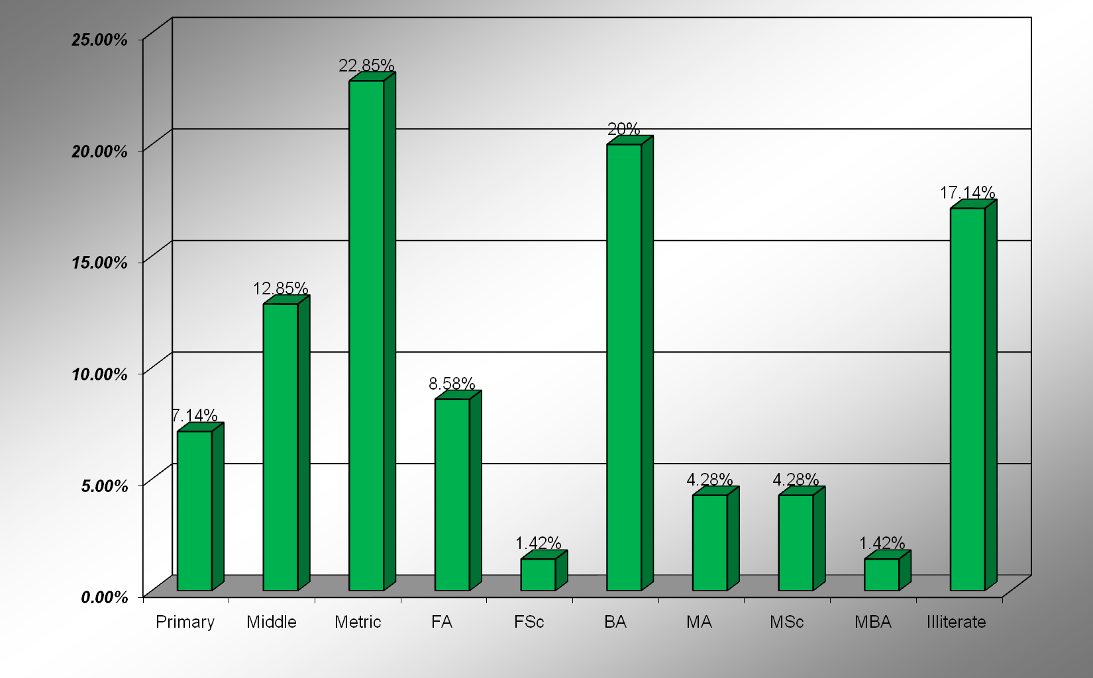

SOURCE: OWN SERVEY, 2013

FIGURE 1: PROFESSION



SOURCE: OWN SERVEY, 2013

FIGURE 3: AGE WISE %



SOURCE: OWN SERVEY, 2013

4.8.2 **Timeliness**

Rapid onset natural disasters often occur with little or no notice and call for immediate response in order to prevent further damage of life. This is particularly true in case of earthquake. First 72 hours are very critical for saving lives of people trapped in the rubble. When asked (Fig 4) as when the army reached the affected area after the onset of disaster 60% respondents replied that army was in the affected area after 24 hours, 24% said that army took 48 hours to reach the area. Similarly for timely response the clearance of line of communication is also vital. The perception in this regard is clear from Fig 5 which indicates that 60% respondents are of the opinion that army reached the affected area in 24 hours. 24% said that army arrived after 48 hours. 14% were of the opinion that army reached within 72 hours and only 1% said that they don’t know.



SOURCE: OWN SERVEY, 2013

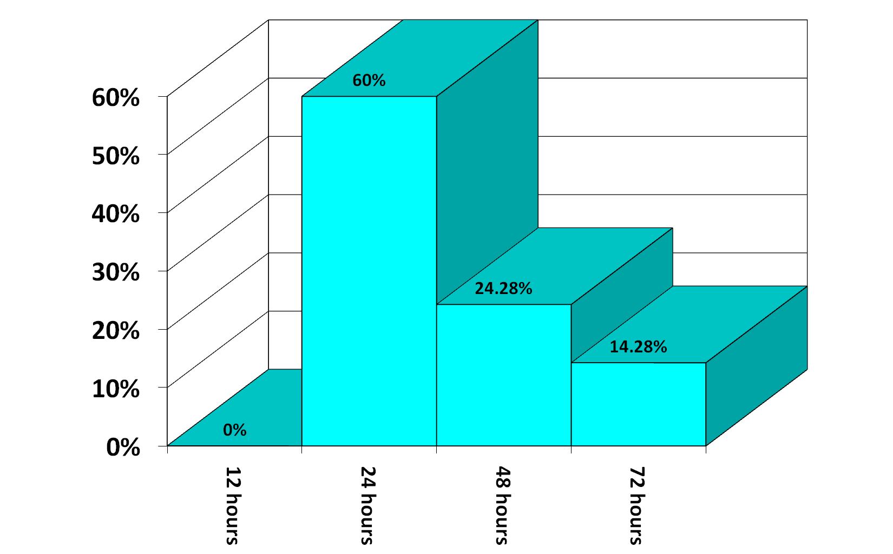

SOURCE: OWN SERVEY, 2013

4.8.3 **Efficiency** (**Saving Precious Lives)**

One of the prime task during response phase is saving precious lives. When asked Fig 6 as how the community assesses the army role in saving lives more than 75% respondents declared it as highly successful. The same question was supplemented by asking as how prompt was evacuation of the injured executed 71% termed it “Very Good”. Similarly when asked as how the army efforts were successful in saving lives of children, in one of the discourse with respondents during focus group discussion the respondents narrated an incident that 70 students of a school got trapped when a building collapsed. The community informed the army and the army rushed towards the site initially a tunnel on one side was made and a dog with water bottle in mouth was sent inside after some time the dog returned with empty bottle in his mouth which indicated that some children were still alive. Subsequently the slabs with help of concrete cutters and heavy machinery were removed and only 35 out of 70 students could be saved as one side of building was completely flushed with the ground. When the respondents were asked about rescuing school going children (fig 7) 94% said the army rescued most of the children. Similarly prompt evacuation of injured did save lives of many people ( fig 8 ) indicates that more than 70% respondents were quite satisfied with evacuation strategy executed by the Army.

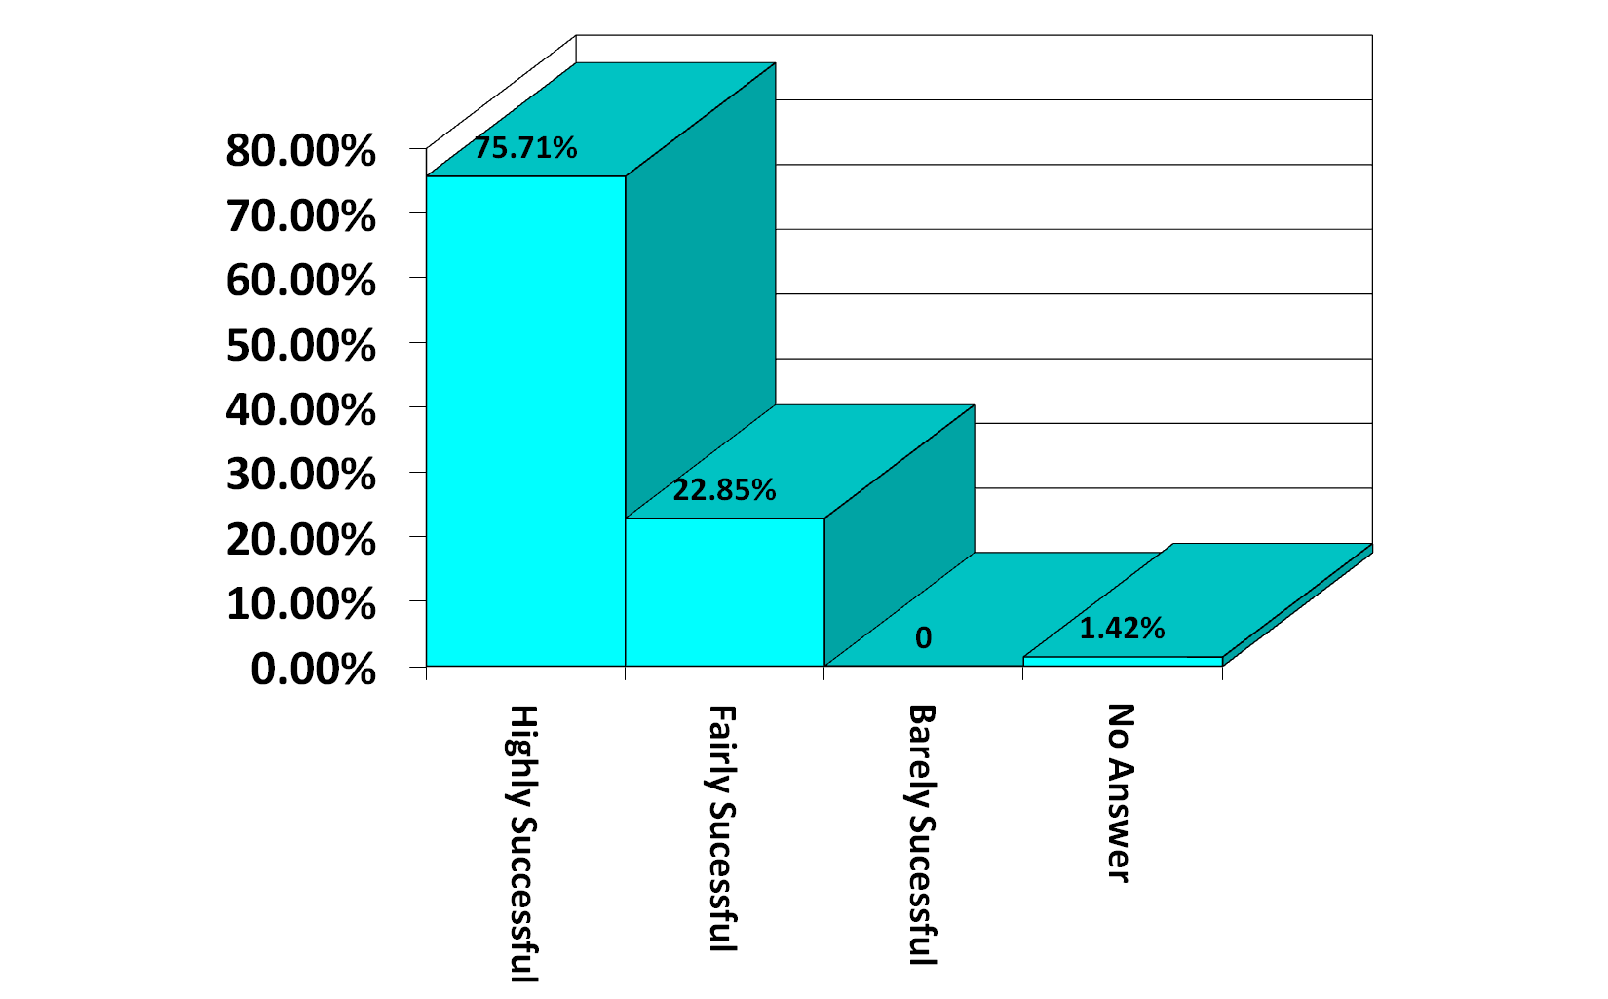

SOURCE: OWN SERVEY, 2013

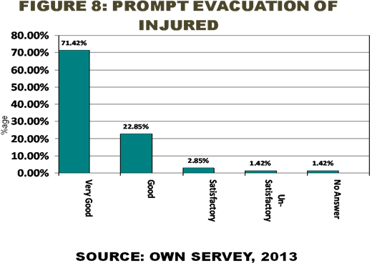

SOURCE: OWN SERVEY, 2013



4.8.4 **Appropriateness of Equipment**

Reaching the affected area is indicative of a prompt response but carrying along the proper tools and equipment is equally important. As only a rightly and properly equiped force can deliver the best. When the community perception in this regard was sought (Fig 9), more than 48% of respondents declared it that the army was fairly equiped where as 45% said that it was sufficiently equipped. Similarly when respondents opinion was sought (fig 10) regarding equipment utilized during Search and Rescue 77% declared it appropriate where as 23% said that the troops were not properly equipped.

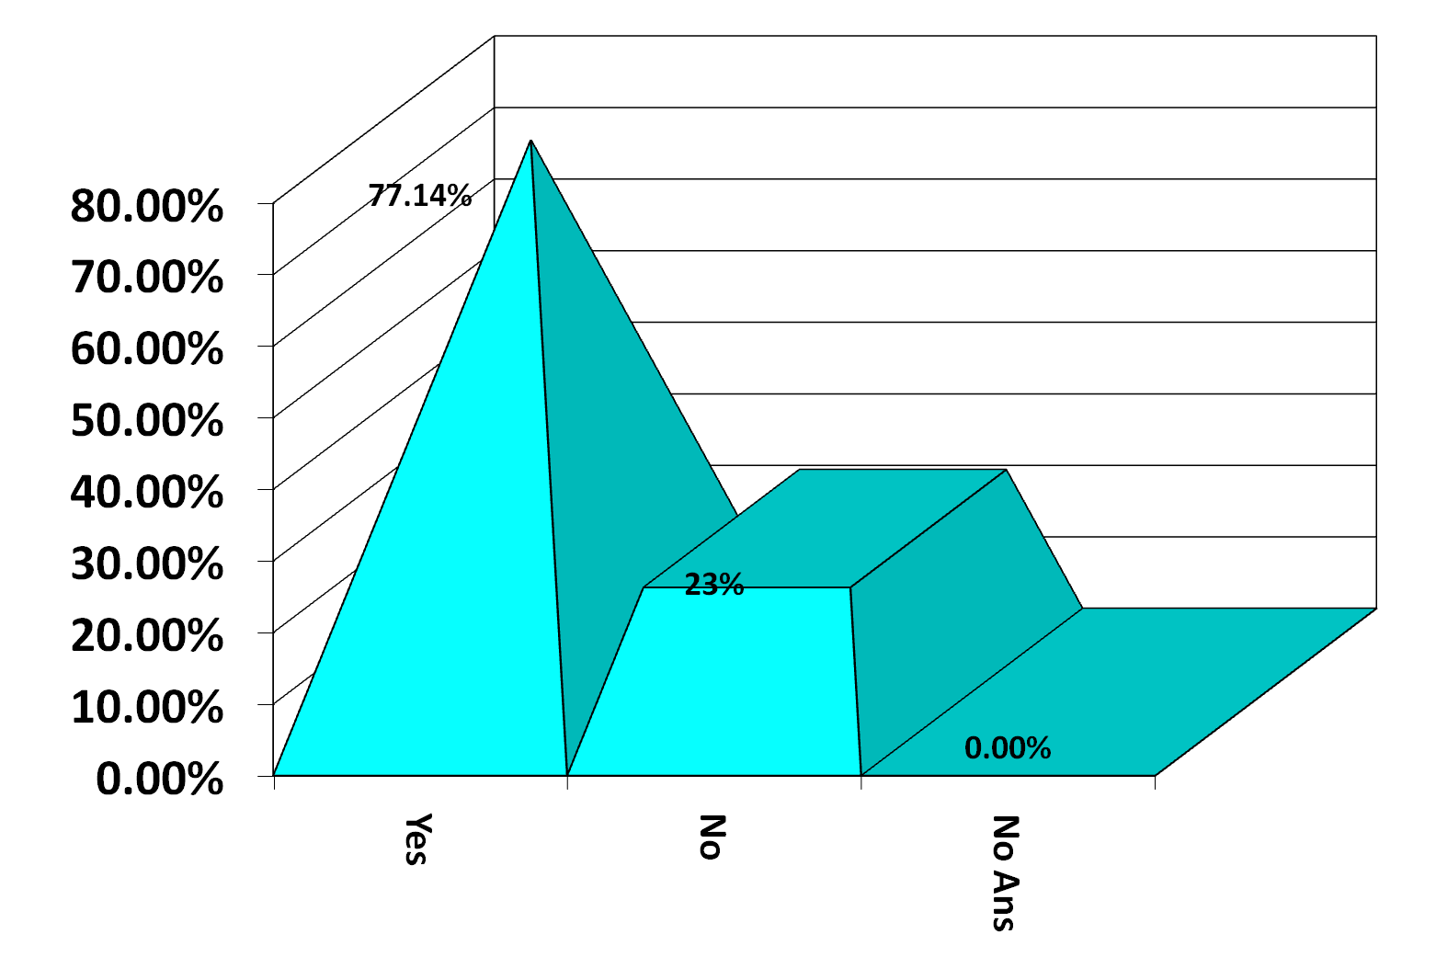

SOURCE: OWN SERVEY, 2013



SOURCE: OWN SERVEY, 2013

4.8.5 **Coordination**

To avoid duplication of efforts and to enhance efficiency coordination among all the actors/agencies is necessary. When the perception of respondents was sought (Fig 11) 51% respondents declared it very effective, 40 % termed it effective where as only 2.8 percent considered it ineffective. Fig 11 clearly indicate that the whole effort of response was well coordinated.

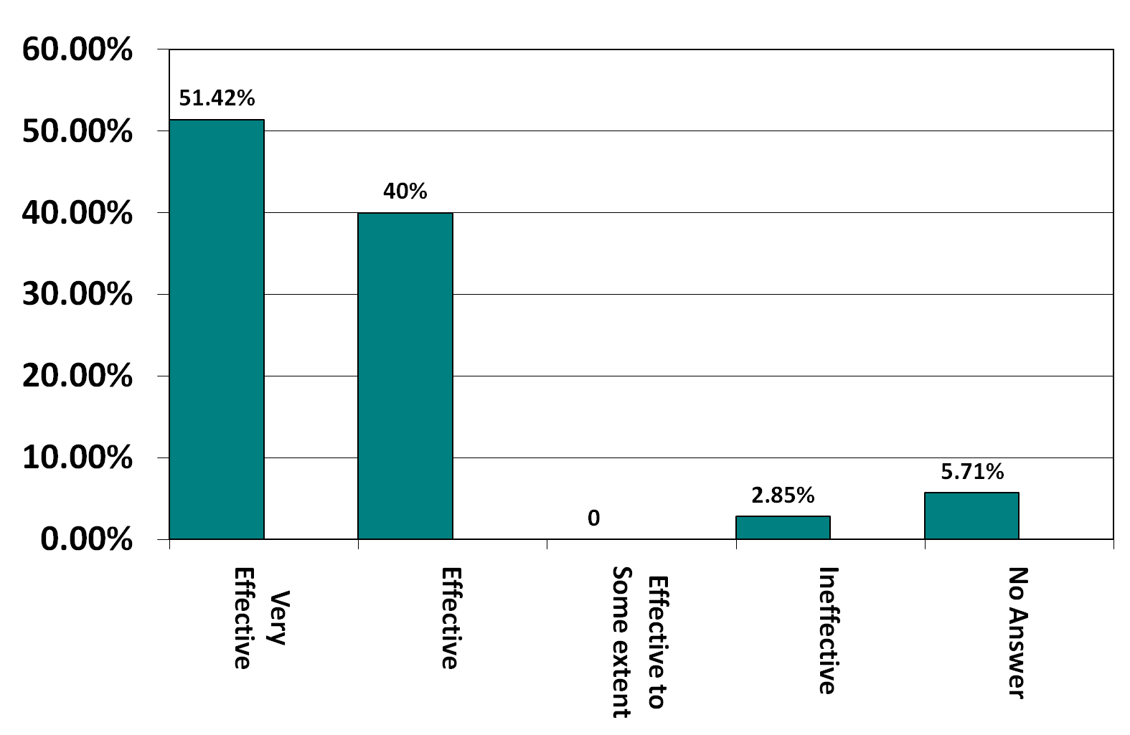

SOURCE: OWN SERVEY, 2013

4.8.6 **Security**

For any endeavor peace of mind is vital. Secure environment increases efficiency and greatly contribute towards timely completion of tasks. The earth quake of 2005 occurred when Pakistan was fighting war against terrorism. Similarly there were a lot of foreign agencies operating and helping the affected people. Their safety was again very important when the respondents were asked (Fig 9) as how successfully the army provided security cover to the complete response mechanism. More than 85% responded in affirmative where as only 8% respondents were not satisfied with security arrangements provided by the army. Similarly when respondents were asked as how effectively prevented looting of relief goods 90% replied in affirmative (fig13) where as only 9% said that it was not properly handled.

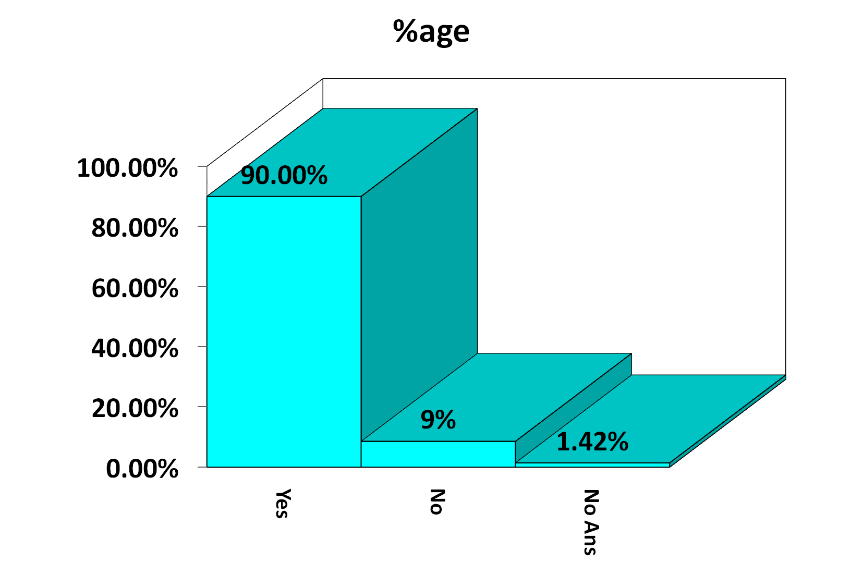

SOURCE: OWN SERVEY, 2013

FIGURE 12: **SECURITY**



SOURCE: OWN SERVEY, 2013

4.8.7 **Training**

Adequate training and professional handling is required during search and rescue. When respondents were asked about the state of training of troops Fig 14 indicates that only 40% were satisfied where as 54.28% said the the troops were fairly trained , 2.85% of respondents were of the view that they were barely trained.



SOURCE: OWN SERVEY, 2013

4.8.8 **General Behaviour**

When respondents were asked about the general behavior and attitude of troops towards the affected people, 48.57% of respondents said that they were helpful, 35.71% termed them friendly and only 2.85% declared them disrespectful.

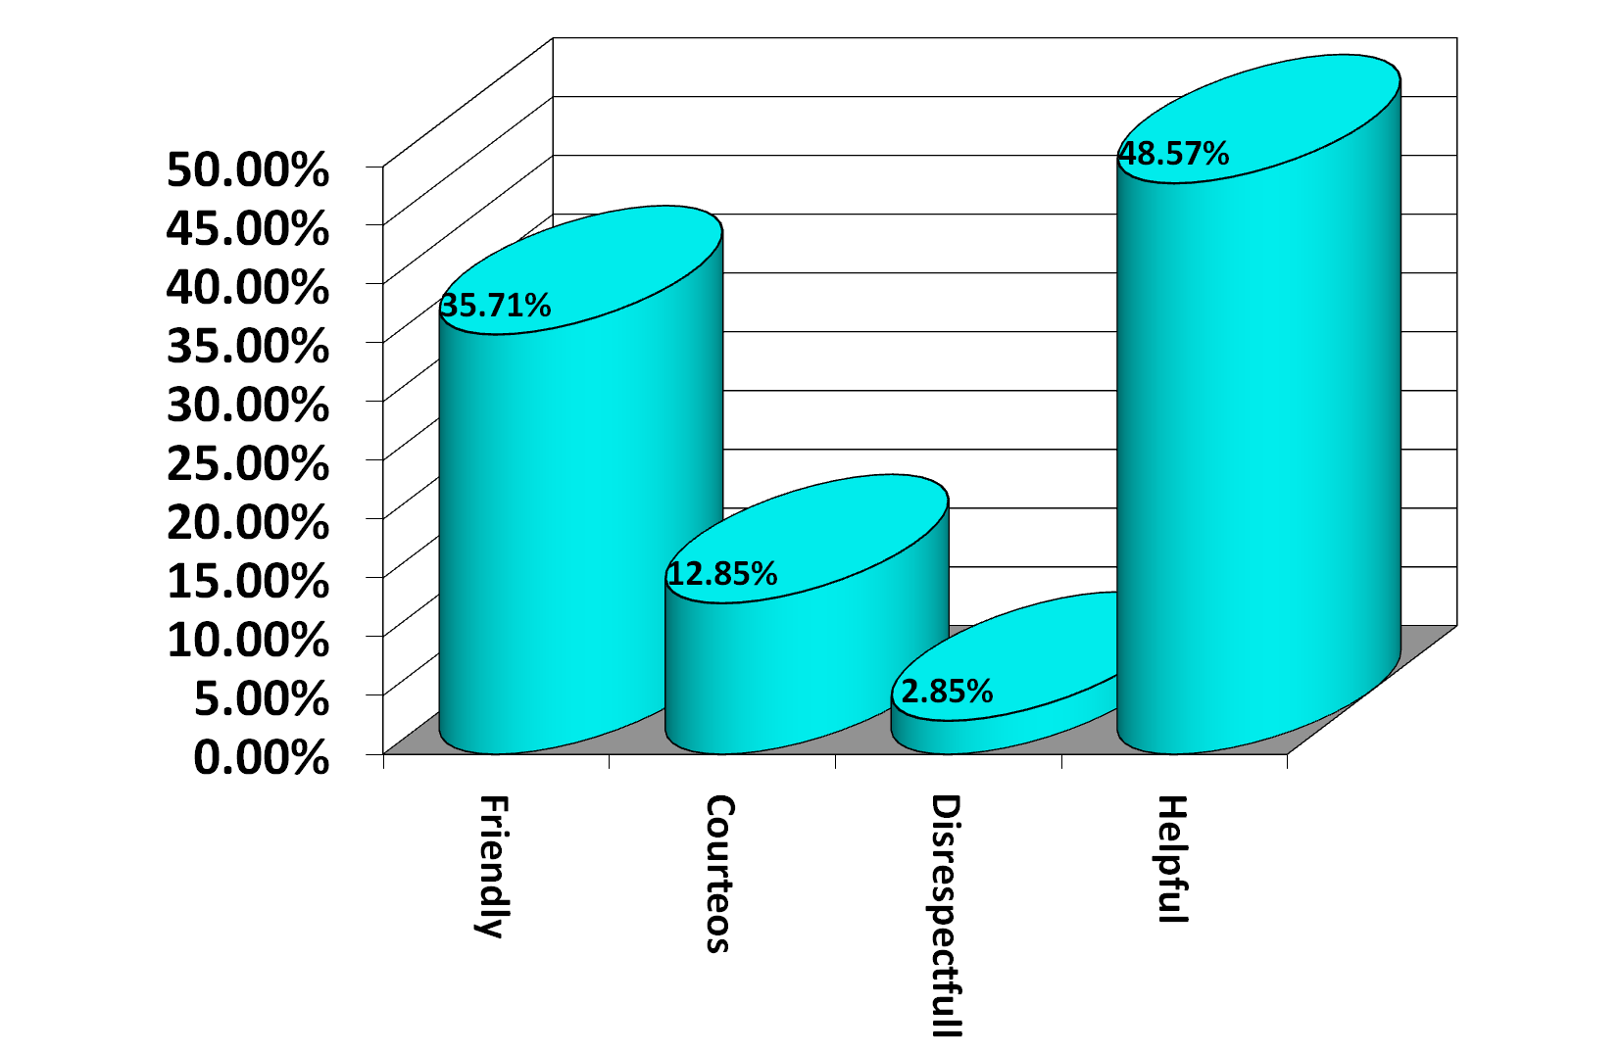

SOURCE: OWN SERVEY, 2013

**CHAPTER 5**

**CONCLUSIONS AND RECOMMENDATIONS**

5.1 **Conclusion**

Aim of the study was to ascertain the efficacy of response mechanism developed by Army during earthquake 2005 in UC Balakot. Though a lot of material has been published and is available in the form of secondary data since the occurrence of the disaster however, to test the effectiveness of the response mechanism community perception was obtained. Timeliness, Efficiency (saving precious lives), carrying along appropriate tools and equipment ,coordinating the entire process and provision of fool proof security cover were the main aspects that were used as a yardstick for measuring the effectiveness of the response mechanism. The primary data obtained was tested and compared with secondary data.

Pakistan current disaster management focus is largely limited to post - disaster consequence management, with little attention, if any, to pre-disaster prevention, preparation and response activities. The Armed Forces play a vital role in a range of disaster and crises management activities in nations around the globe. However, total dependency on Army leaves other government functionaries ineffective. State-level disaster preparedness and mitigation measures are heavily tilted towards structural aspects and undermine non-structural elements such as the knowledge and capacities of local people, and the related livelihood protection issues.

Since all the indicators set forth to measure the effectiveness of response mechanism, get a positive response from the community hence effectiveness of response mechanism has been established to a certain extent. However, few grey areas that have been identified during analysis for which pertinent recommendations are given in succeeding paras.

**5.2 Recommendations**

To create an awareness of the complexity of disaster management and the military's tasks, it is necessary to impart training at all levels. At the Army level, there is a need to interact with foreign institutions to gain training for rescue teams' and other "specialized" disaster related training. The latter should form part of the national response capacity. Specialized equipment for flood relief, urban disaster and maritime disaster needs to be procured after having identified this equipment should be kept as station stores. Specialized equipment required in such like operations should be issued at unit level and made part of the TO&E. Following items are suggested:-

1. Steel cutters
2. Sensors
3. Respirators
4. Generator sets
5. Powerful torches and Search lights
6. Special sound detecting devices
7. Sniffing dogs (at formation level)

Local political and administrative set up must be incorporated in relief effort to make it self-sustaining. National capacity must be enhanced to combat such disaster in future.

Civilian Aviation capacity needs to be increased to address dependence on military helicopters since helicopters will be the most likely means of transport in any such disaster related scenario, where damage to infrastructure is immense. The role of Army in Response phase can not be relegated; however, total dependency on Army leaves other government functionaries ineffective.

At the same time, timeline for employment of Army and its de-induction must be spelt out. Disaster management requires civil response through civil institutions, because the primary mission of Armed Forces is to prepare for war. Present HF and VHF sets with Brigades and Units should be replaced with latest HF and VHF sets to ensure provision of reliable and clear transmission. There should be a high degree of communication interface with LEA, CAF and civil departments. The role of army disaster management must be clearly defined. In this case role of army should have been restricted to relief and rescue operation only and thereafter, the provincial government should have taken over the responsibility. For an integrated response, the three services would require dedicated cells with a coordinating headquarters at the Joint Staff level. A Disaster Management Wing at Joint Service Headquarters to interact with NDMA at Federal level is suggested. Relief mechanism should be transparent and accountable in order to enhance public confidence.