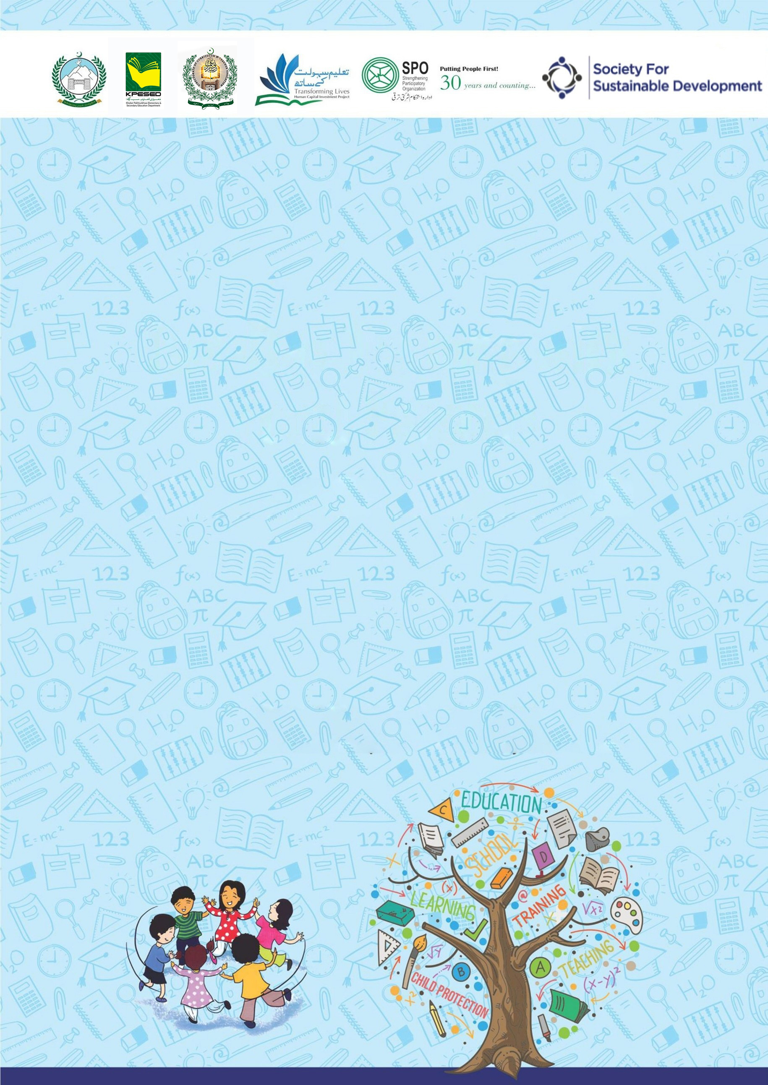
Developed by KP Human Capital Investment Project (KP-HCIP)
2 Hour Session for Boys Primary School
on School-Related Safety/Safeguards

All rights reserved with the KP HCIP Peshawar, Pakistan
Module designed by KP HCIP
Approved by Directorate of Curriculum and Techer Education (DCTE), Khyber Pakhtunkhwa

Authors:
- Fouzia Anjum Environmental & Social Specialist, KPHCIP
- Sadia Khan Gender Specialist, KPHCIP
- Dr Safia Noor GBV Specialist, KPHCIP

Review Supervision:
Gohar Ali Khan, Director, Curriculum and Teacher Education, Khyber Pakhtunkhwa

Review Coordination:
Muhammad Ashfaq Khan Jadoon, Additional Director Curriculum and Teacher Education, Khyber Pakhtunkhwa

Review Committee:
- Mr. Aman Ullah, Instructor RPDC(M) Peshawar
- Mr. Noshad Abbasi, Subject Specialist GHSS Rich Behn Abbottabad
- Mr. Raza Hassan, Principal GHSS Mohammad Zai Kohat
- Dr. Sher Bahadur, Subject Specialist GHSS Spin Dhand Bara, Khyber
- Mr. Gul Khatab, Subject Specialist, Curriculum and Teacher Education, Khyber Pakhtunkhwa

Table of Contents
S# | Content | Page No.
 | Agenda | 01
 | Overall Objectives | 02
 | Introduction to the training | 02
 | Activity 1: Our protected; strong and Smart boys | 03
 | Roleplay | 04
 | Activity 2. Good and Bad feeling | 05
 | Activity 3. Body Safety | 07
 | Activity 4. Trusted adult to whom I can ask for help | 09
 | Activity 5: Learn to Ask for Help | 11

Agenda
Activity | Title | Duration
 | Introduction to the training | 05 minutes
1 | Our protected, strong and smart boys | 25 minutes
2 | Good and Bad feelings | 25 minutes
3 | Body Safety | 20 minutes
4 | Trusted Adult to whom I can ask for help | 20 minutes
5 | Learn to ask for help | 20 minutes

Over all Objectives
At the end of this session, participants will be able to:
- Understand the importance of respect, empathy, and safety within the school environment.
- Identify red flags (warning signs) and green flags (positive behaviors) in situations related to bullying, harassment, or unsafe behavior.
- Demonstrate safe bystander intervention strategies when witnessing bullying or harassment.
- Identify trusted adults and support systems within and outside the school.
- Practice help-seeking skills and know how to report concerns safely.

Introduction to the Training (Duration: 05 minutes)
Objectives:
At the end of this activity, children will be able to:

- Introducing participants to one another
- Talk with each other
- Create relaxed atmosphere, and establish an informal tone for the training
- Create safe environment to share and discuss issues

Steps:

- Start the session with recitation from the Holy Quran.
- Welcome and opening remarks by the trainer and his/her introduction.
- Ask children to introduce themselves by sharing their names and one thing they are happy for.
- Brief the participants about the objectives of the session.
- Share with participants norms for the training.

A sample of some common ground rules/norms
- Start on time, end on time.
- Do not interrupt while others are speaking.
- Everyone should try to listen as well as speak.
- Maintain confidentiality of what is shared, no gossiping.
- Show respect for others experiences.
- Avoid making personal remarks
- Be aware of language difficulties i.e. speak slowly if needed.
- Keep mobile phones on silent mode or vibration

Activity 1: Our protected; strong and Smart boys (25 minutes)
Objectives:

By the end of this activity, children will be able to:
- Recognize unsafe situations when someone asks them to keep secrets or go somewhere without permission.
- Understand the importance of saying “No” to something that makes them feel uncomfortable or scared.
- Identify trusted adults (parents, teachers, elders) they can talk to when they face a problem.
- Practice speaking up and reporting, just like Ahmad did in the role play.
- Build confidence to make safe and smart choices in real-life situations.

Instructions for Roleplay: (20 minutes)
- Make appropriate groups of children
- Ask them to discuss the role play in group and assign role
- Invite few groups to demonstrate the roleplay
- Ask children how they felt while watching the role play.
Discussion:
- Initiate discussion by asking the following questions:
- What happened in the story?
- Who were the main characters?
- How did the children feel when the stranger approached them?
- Why is it unsafe to go with stranger?
- What are the three important things we should do if we feel unsafe?
Help children understand the difference between safe and unsafe situations.

Role Play
“Speaking up is bravery. Safety comes first.”
Title: The Brave Choice
Characters:
- Ahmad
- Older Boy
- Ahmad’s Father
- Hafiz Sahib (Teacher)

(Ahmad was a good and pious boy. He used to go to the masjid every day to recite the Qur’an).
Hafiz Sahib: Well-done, Ahmad! You recite very nicely today.
Ahmad: Thank you/ Shukriya, Hafiz Sahib.
(After finishing his lesson, Ahmad was leaving the masjid)
- Older Boy: Hey Ahmad! Come here.
- Ahmad: Yes
- Older Boy: Come with me. I will show you a very nice cartoon movie.
- Ahmad: Really!
- Older Boy: Yes, but this must be our secret. Don’t tell anyone.
(Ahmad suddenly felt scared. He remembered what his father had told him.)
- Ahmad’s Father (memory): Ahmad, remember! The real brave person is the one who stays away from wrong things and always tells elders.
(Ahmad thought for a moment and then spoke bravely)
- Ahmad: No! I will not go with you.
(Ahmad quickly ran back to the masjid and went to his teacher)
- Ahmad: Hafiz Sahib, I need to tell you something.
- Hafiz Sahib: Yes Ahmad, what happened?
- Ahmad: A boy outside asked me to go with him and told me to keep it a secret.
- Hafiz Sahib: You did the right thing by saying no and telling me. I am very proud of you.
(Ahmad felt happy because he made the brave and right choice.)

Activity 2. Good and Bad feeling (Duration: 25 minutes)
Objectives:

By the end of this activity, children will be able to:
- Recognize different feelings
- Understand the difference between good feelings and bad feelings
- Know that bad or uncomfortable feelings are warning signs
- Learn to tell a trusted adult when they feel unsafe
Material Required:
- Emotion cards or pictures (happy, sad, scared, angry), Chart paper or board, Markers, Smiley and sad face drawings
Warm-Up Activity (5 minutes)
Activity: “Show Your Feelings”
Facilitator provide feeling cards to students and instruct them to recognize different feelings.
Now facilitator Says
- Show me a happy face 😊
- Show me a sad face 😢
- Show me an angry face 😠
- Show me a scared face 😨

Ask Children
- When do you feel happy?
- When do you feel sad?

Facilitator Explanation

Good feelings
- Make us feel happy, safe, and comfortable
Examples:
- Playing with friends
- Getting a hug from parents
- Learning something new

Bad feelings
- Make us feel scared, uncomfortable, or worried
Examples:
- Someone shouting at you
- Being bullied
- Someone asking you to keep a secret that feels wrong

Feeling Game (10 minutes)
The facilitator describes situations and children decide Good Feeling or Bad Feeling.

Example situations:
- Your teacher praises your work.
- A stranger asks you to go somewhere with them.
- Your friend shares toys with you.
- Someone pushes you or calls you names.
- Your parents hug you.
Children raise:
- Thumbs up 👍 = Good feeling
- Thumbs down 👎 = Bad feeling

Safety Message (08 minutes)
Explain to children:
Bad feelings are like a warning alarm in our body.
If you feel:
- scared
- uncomfortable
- confused

Recall 3 Safety Steps you have learned:

- Say NO
- Move away
- Tell a trusted adult

Closing Activity (02 minutes)
- Ask children to repeat together:
- “My feelings are important!”
“If I feel bad or unsafe, I will tell a trusted adult.”

Activity 3. Body Safety (Duration: 20 minutes)
Objectives:

By the end of this activity children will be able to:
- Understand that their body is special and valuable
- Know that private body parts must be covered and protected
- Learn that no one is allowed to touch their private parts
- Know what to do if someone makes them uncomfortable

Facilitator says:
Children! Allah has given us a beautiful body.
We should take care of our body and protect our dignity.
Islam teaches us to protect our honor and also respect others

Body Safety Rule (5 minutes)
Explain simply:
Children, some parts of our body are special (private).
“The parts of our body that are covered by our clothes (under shirt and pants) are private.”
No one can touch these parts:
- Friends
- Relatives
- Strangers

Important Exceptions (Explain Carefully)
The only exceptions are:
- Mother or Father, for cleaning or helping
- Doctor, during medical check-ups in presence of parents’.

Activity: Safe or Unsafe (5 minutes)
Facilitator reads situations and children respond by raising:
👍 Safe
👎 Unsafe
Examples:
- Mother is helping you bathe.
- Doctor is checking you and your parents are with you.
- Someone says, “This is a secret, don’t tell anyone.”
- Someone tries to take you alone into a room.

Safety Action Rule (5 minutes)
- Teach children 3 Body Safety Steps
- If someone tries to touch you in a wrong way:
- Say “NO!” loudly
- Move away quickly
- Tell a trusted adult immediately

Examples of trusted adults:
- Mother
- Father
- Teacher
- School Head
- Older sibling

Practice Activity (05 minutes)

Children practice saying loudly:
Children say together:
- “This is my body!”
- “Do not touch me in the wrong way!”
- “I will tell an adult immediately!”

Key Messages (Closing)
Facilitator summarizes:
- Our body is a trust from Allah
- We must protect our dignity
- If something feels wrong, tell a trusted adult immediately
Ask children to repeat together.

Activity 4. Trusted adult to whom I can ask for help (20 minutes)
Objectives:
By the end of this activity children will be able to:
- Understand the concept of a trusted adult Identify adults they can safely ask for help
- Recognize situations when they need to talk to a trusted adult
- Know how to approach a trusted adult if they feel unsafe

Material Required:
- Chart paper, markers
Facilitator says:
“Boys, everyone needs help sometimes A trusted adult is someone who:
- Listens to you
- Cares about you
- Can help you when you feel scared, confused, or unsafe
Trusted adults help keep you safe and happy.”

- Draw two columns on the board: (07 minutes)
Trusted Adults | Not Trusted Adults

- Ask boys to name adults in their life. Write them in the Trusted Adults column if they are safe and caring.
- Discuss why some adults may be safe while others may not.
Facilitator explains:
“Not everyone is safe to ask for help. If someone makes you feel uncomfortable, scared, or confused, you should go to a trusted adult.”

Scenario Game (10 minutes)
- Facilitator reads a situation aloud. Boys respond by pointing to a trusted adult or saying what they would do.

Sample Situations:
- Someone at school is bullying you.
- A stranger asks you to go with them.
- You feel scared at home.
- You get hurt while playing.
- Someone tells you to keep a secret that feels wrong.

Discussion:
- Whom should you tell?
- What steps will you take?

Facilitator reinforces:
- Always tell a trusted adult immediately
- Trusted adults will listen, believe you, and help you

Key Messages (Closing – 3 minutes)

Facilitator summarizes:
- Trusted adults are people who care, listen, and protect you
- Always tell a trusted adult if something makes you feel unsafe, scared, or uncomfortable
- It is never your fault if someone behaves wrongly
- Saying NO and asking for help shows strength and smartness

Group Repeat:

- “I know who my trusted adults are!”
- “I will ask them for help if I feel unsafe!”

Activity 5: Learn to Ask for Help (Duration: 20 minutes)
Objectives: (Time: 20 minutes)

By the end of this activity children will be able to:

- Understand that asking for help is safe and brave
- Identify situations when they need to ask for help
- Know who their trusted adults are
- Practice how to ask for help clearly and confidently

Material Required:
- Chart paper or board

Facilitator says: (02 minutes)
“Boys and girls, everyone needs help sometimes.
Asking for help is not wrong. In fact, it is a smart and brave thing to do.
Sometimes we need help when we are:

- scared or hurt
- bullied
- not understanding something
- feeling confused or uncomfortable
Asking for help keeps us safe, strong, and happy.”

When to Ask for Help (5 minutes)

Facilitator asks children:
When you need help:
- To whom will you ask for help?
- How do you feel when you asked for help?

Facilitator explains:
“These are all times when asking for help is the right thing to do.”

Role Play Practice (7 minutes)

Instructions:
- Divide children into pairs or small groups
- Give them short scenarios where someone needs help
- One child act as the one needing help, the other as the trusted adult

Sample Scenarios:
- A boy falls while playing football.
- A boy is scared because a stranger is following him near school.
- A child doesn’t understand homework and feels frustrated.

Invite groups/ pairs for role play
- Reinforce that asking for help makes you strong and smart

Say It Loud! (3 minutes)
Children practice a simple phrase together:
- “I need help!”
- “Please help me!”
- “I will tell my trusted adult if I feel unsafe.”

Facilitator explains:
- It is okay to ask for help loudly
- Asking for help is always safe

Key Messages (Closing – 3 minutes)

Facilitator summarizes:
- Asking for help is brave and smart
- You should always ask trusted adults when you feel scared, hurt, or uncomfortable
- Do not keep secrets that make you feel bad or unsafe
- Trusted adults listen, believe, and help you

Children repeat together:
“I am safe, strong, and smart. I know how to ask for help!”

Tips for Facilitators
- Use simple, clear language
- Use examples from school, home, and community
- Encourage children to practice asking for help in different situations
- Reinforce that asking for help is never wrong

******************************************************

