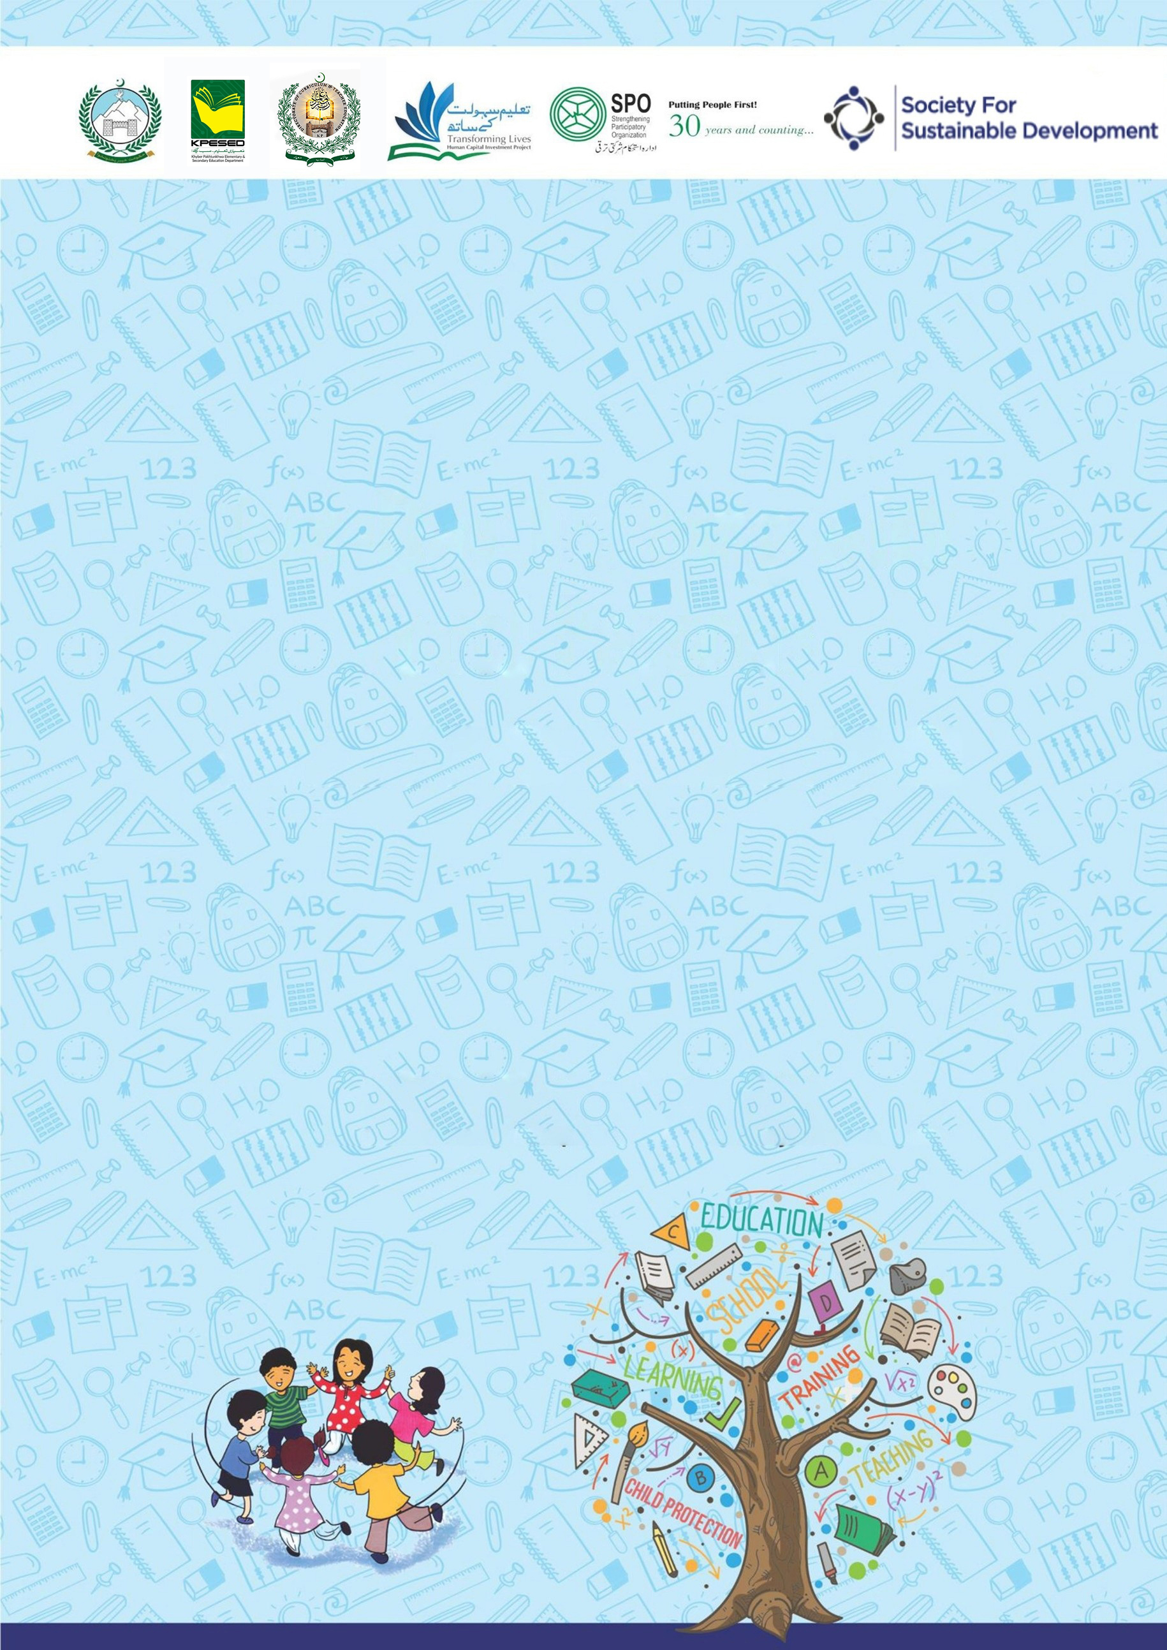
Developed by KP Human Capital Investment Project (KP-HCIP)
2 Hour Session for Boys Secondary School
on School-Related Safety/Safeguards

All rights reserved with the KP HCIP Peshawar, Pakistan
Module designed by KP HCIP
Approved by Directorate of Curriculum and Techer Education (DCTE), Khyber Pakhtunkhwa

Authors:
- Fouzia Anjum Environmental & Social Specialist, KPHCIP
- Sadia Khan Gender Specialist, KPHCIP
- Dr Safia Noor GBV Specialist, KPHCIP

Review Supervision:
Gohar Ali Khan, Director, Curriculum and Teacher Education, Khyber Pakhtunkhwa

Review Coordination:
Muhammad Ashfaq Khan Jadoon, Additional Director Curriculum and Teacher Education, Khyber Pakhtunkhwa

Review Committee:
- Mr. Aman Ullah, Instructor RPDC(M) Peshawar
- Mr. Noshad Abbasi, Subject Specialist GHSS Rich Behn Abbottabad
- Mr. Raza Hassan, Principal GHSS Mohammad Zai Kohat
- Dr. Sher Bahadur, Subject Specialist GHSS Spin Dhand Bara, Khyber
- Mr. Gul Khatab, Subject Specialist, Curriculum and Teacher Education, Khyber Pakhtunkhwa

Table of Contents
S# | Content | Page No.
 | Agenda | 01
 | Overall Objectives | 02
 | Introduction to the training | 02
 | Activity 1: Ice Breaker – The Line of Respect | 03
 | Activity 2. Scenario Analysis – Red Flags and Green Flags | 04
 | Activity 3. The Power of Bystanders – Role Play | 06
 | Activity 4: Mapping my support galaxy | 07
 | Activity 5: Knowledge into Action – Help Seeking Simulation | 09
 | Activity 6: Closing and Empowering Pledge | 11

Agenda
Activity | Title | Duration
 | Introduction to the training | 05 minutes
1 | Ice Breaker – The line of respect | 10 minutes
2 | Scenario – Red Flags and Green Flags | 25 minutes
3 | The power of Bystander – The Roleplay | 20 minutes
4 | Mapping My Support Galaxy | 20 minutes
5 | Knowledge into actions – Help Seeking Simulation | 15 minutes
6 | Closing and Empowering Pledge | 25 minutes

Over all Objectives
At the end of this session, participants will be able to:
- Demonstrate Honor, Respect, and Responsibility
- Identify and Respond to Threats or Peer Pressure
- Practice Bystander Responsibility
- Promote Digital Safety and Respect Online
- Build a Support Network
- Commit to Positive Behaviour through a Personal Pledge

Introduction to the Training (Duration: 05 minutes)
Objectives:
At the end of this activity, participants will be able to:
- Introduce to one another
- Talk with each other one-on-one
- Create relaxed atmosphere, and establish an informal tone for the training
- Create safe environment to share and discuss issues

Steps:

- Start the session with recitation from the Holy Quran.
- Welcome the participants and brief introduction of the trainer.
- Ask Participants to introduce themselves.
- Brief the participants about the objectives of the session.
- Ask the participants to set norms for the training.

A sample of some common ground rules/norms
- Start on time, end on time.
- Do not interrupt while others are speaking.
- Everyone should try to listen as well as speak.
- Maintain confidentiality of what is shared, no gossiping.
- Show respect for others, and other’s experiences.
- Avoid personal remarks.
- Be aware of language difficulties i.e. speak slowly if needed.
- Keep mobile phones on silent mode or vibration

Activity 1: Ice breaker – The Line of Respect (10 minutes)
Objectives:
At the end of this activity, participants will be able to:

- Encourage open discussions and reflect on different attitudes related to respect, bullying and responsibility.

Steps:
- Ask participants to stand in a straight line across the room.
- Explain the activity:
"I will read a statement. If you agree, take one step forward. If you disagree, take one step back. There are no right or wrong answers; we want to hear different opinions."
- Read the following statements:
• “It is okay to tease someone if they are your friend.”
• “If someone is being bullied, it is not my responsibility to help.”
• “If a friend shares a secret about being hurt, I should never tell anyone.”
• “I know at least two adults in this school whom I can trust.”
• “Boys should support each other instead of spreading rumors.”
- After each statement, ask 1–2 participants why they stepped forward or back.
- Facilitate a short discussion emphasizing respect, kindness, and supporting each other.

Activity 2: honor, respect, and responsibility (25 minutes)
Objectives:
At the end of this activity, participants will be able to:

- Understand the concepts of honor, respect, and responsibility in the context of personal growth and community life.
- Identify behaviors that reflect true manhood.
- Reflect on their own actions and set personal goals for demonstrating integrity and respect.

Materials Required:
- Whiteboard/markers, Sticky notes or index cards
What Does It Mean to Be a Man? (4 min)
- Ask students to think about someone they admire as a “real man” (could be a family member, teacher, or public figure).
- Write on the board some qualities they mention.
- Lead a brief discussion by asking:
  - Are these qualities about physical strength, or about character and actions?
Understanding Key Concepts (4 min)
Briefly introduce the key concepts of honor, respect and responsibility.
a. Honor
- Definition: Acting with integrity, being truthful, and standing by your values.
- Examples of honorable behavior: keeping promises, standing up for what is right, being fair.
b. Respect
- Definition: Treating others with consideration and valuing their feelings, rights, and property.
- Examples: listening when someone is speaking, using polite language, accepting differences.
c. Responsibility
- Definition: Being accountable for your actions and fulfilling duties at home, school, and society.
- Examples: completing assignments on time, helping family, being a positive role model.
Group Activity: Real-Life Scenarios (15 min)
- Divide students into small groups.
- Give each group a scenario (e.g., witnessing bullying, seeing someone cheat, or being offered a shortcut that’s dishonest).
Ask:
  - How would an honorable person respond?
  - How would he/she show respect in this situation?
  - How would he/she demonstrate responsibility?
- Groups present their solutions to the class.
- Lead discussion, comparing actions driven by peer pressure and actions that reflect true manhood
5. Closing Discussion (3 min)
- Summarize key points:
  - Honor: Stand by your values.
  - Respect: Treat others well.
  - Responsibility: Be accountable for your actions.
- Reinforce that real manhood is not about physical strength or showing off, but about character, actions, and respect for self and others.

Activity 3: A Matter of Awareness: Handling Social pressure and threats (Duration: 20 minutes)
Objectives:
By the end of this activity, students will be able to:
- Recognize social pressure and bullying situations.
- Understand safe ways to respond to threats or blackmail.
- Identify trusted adults and support systems they can approach

Materials Required:
- Whiteboard/markers, Scenario cards (optional)
1. Introduction (5 min)
- Pose the following question:
  - “Have you ever felt pressured to do something you knew was wrong?”
- Lead a short discussion on social pressure, peer influence, and fear of consequences.
- Introduce the scenario:
“Your friend Ahmad has been threatened by a senior student that he will steal his phone and expose it to others if Ahmad doesn’t help him cheat in the exam. Ahmad is upset but says ‘Let it be, I’ll handle it myself.’”
2. Scenario Discussion (10 min)
- Ask students to reflect and discuss in pairs or small groups:
  - How do you think Ahmad feels in this situation?
  - What are the risks if Ahmad tries to handle it alone?
  - What are some safe and smart ways to respond?
- Write down students’ ideas on the board, guiding them toward key points:
  - Do not try to deal with threats alone.
  - Reach out to trusted adults (parents, teachers, school counselor).
  - Do not give in to blackmail or pressure.
  - Document the threat if possible (screenshot, write it down).
  - Support each other: friends should stand together, not encourage wrongdoing.
3. Reflection (5 min)
- Summarize session:
  - Social pressure and threats are serious; don’t try to handle them alone.
  - Trusted adults and friends are there to help.
  - True courage is asking for help and making safe choices.

Activity 4. The Role of a Bystander: You are Not Alone (20 min)
Objectives:
By the end of this activity, students will be able to:
- Understand the role and power of a bystander in preventing bullying or harassment.
- Learn practical ways to act safely when witnessing bullying.
- Practice the “3 D’s” approach: Direct, Distract, Delegate.

Materials Required:
- Whiteboard/markers, Scenario cards for role-play
Introduction (5 min)
- Ask following question:
  - “Have you ever seen someone being bullied and not known what to do?”
- Explain the concept of a bystander (gawah):
  - A bystander is someone who witnesses bullying or wrongdoing.
  - Doing nothing can make the situation worse.
  - Small actions can make a big difference.
- Emphasize: “You are not alone” – there is always a safe way to help.
2. Explain the “3 D’s” of Safe Intervention (5 min)
Action | What it Means | Example
Direct | Calmly confronting the bully without aggression | (Brother, let him go.)
Distract | Divert attention to safely interrupt bullying | (Fazal, the principal is calling you.)
Delegate | Seek help from a trusted adult immediately | (Sir, a young boy is in trouble, please come.)

- Discuss briefly when each approach is safe to use.
- Emphasize safety first: if the bully is violent, always delegate.
3. Role-Play Practice (10 min)
- Divide students into small groups.
- Assign them different scenarios for example:
- Scenario: Seeing a younger student being bullied for money.
- Assign roles: bully, victim, bystander.
- Each group practices the 3D’s:

  - Direct – calmly speaking to the bully.
  - Distract – creating a safe interruption.
  - Delegate – finding a teacher or chowkidar for help.
- Rotate roles so every student gets a chance to practice each “D.”
- Debrief:
  - How did it feel to act as a bystander?
  - Which “D” was easiest or hardest?
  - Why is it important not to stay silent?

Activity: 5. Digital Safety & Respect; Online Respect (15 minutes)
Objectives:
By the end of this activity, students will be able to:
- Understand the importance of respectful online behaviour.
- Recognize actions that violate someone’s privacy or dignity online.
- Apply safe practices when receiving inappropriate messages or content

Material Required:
- Whiteboard/markers, Scenario cards or examples of online messages, Paper and pens
1. Introduction (3 min)
- Ask the following questions:
  - “How many of you use WhatsApp, Instagram, TikTok, or other social media?”
  - “Have you ever seen someone share pictures or messages without permission?”
- Discuss briefly how our online behaviour reflects our real-life character.
  - Emphasize: “What you do online shows who you are in real life.”
2. Discussion: Online Respect (4 min)
- Now share with students, the main focused point and give some examples:
“Sharing someone’s picture or message without his/her permission is against respect.”
- Discuss examples:
  - Forwarding a friend’s photo without asking.
  - Sharing embarrassing videos of someone.
  - Posting someone’s personal information publicly.
- Ask students:
  - “How would you feel if someone shared your picture or message without permission?”
- Reinforce: Respect online = Respect offline.
3. Guidelines for Online Safety (5 min)
- Present simple rules students can follow:
  - Delete inappropriate content: If you receive something wrong or uncomfortable, delete it.
  - Do not reply: Responding can escalate the problem.
  - Tell a trusted adult: Inform parents, teachers, or school counselor immediately.
- Optional: Write these as a short poster for the classroom:
  - Delete → Don’t Reply → Tell
4. Reflection (3 min)
- Ask students to write down one promise:
  - “I will respect others online by _________________________.”
- Reinforce key messages:
  - Online actions = Real-life respect
  - Think before sharing
  - Safety first: Delete, Don’t Reply, Tell
- Ask students to create a digital safety poster for their classroom or social media.
- Share stories where online respect prevented misunderstandings or harm.

Activity: 6. Mapping My Support System: My Safety Network
(Duration: 25 minutes)
Objectives: (Time: 25 minutes)
By the end of this activity, students will be able to:
- Identify people they can trust for help in different areas of their life.
- Understand that asking for help is a sign of smartness, not weakness.
- Build confidence in using their support network when faced with problems.

Material Required:
- Worksheets (or paper) with three columns: Family, School, Outside, Pens or pencils, Whiteboard, markers
1. Introduction (04 min)
- Ask the following questions:
  - “Have you ever felt worried or scared but didn’t know who to tell?”
  - “Who do you usually talk to when you have a problem?”
- Explain the concept of a support system / safety network:
  - “These are the people you can trust to help you, guide you, or protect you when you face problems.”
- Emphasize the key message:
(Asking for help is not a weakness. It is smartness.)
2. Mapping Activity (08 min)
- Draw the following table on the writing board and ask students to copy it on their notebooks or provide pre-pared sheets:
In Family | In School | Outside/ Community

- Ask students to list 2–3 people in each category whom they trust.
  - Examples you can give if needed:
    - Family: Father, elder brother, uncle
    - School: Class teacher, GBV focal person, principal
    - Outside: Imam of the local masjid, trusted shopkeeper, neighbor
- Encourage them to think about adults they feel safe talking to, not just anyone.
3. Group Discussion / Sharing (05 min)
- Invite volunteers to share one person from their network (without naming if they feel uncomfortable).
- Discuss:
  - Why it’s important to know who you can turn to.
  - How asking for help can prevent bigger problems.
  - How a support system is part of being responsible and smart.
4. Closing Remarks & Pledge: "میرا عہد" (My Pledge) (08 minutes)
  - Recap Key Lessons (2 minutes)
- Summarize the main points from the session:
  - Honor: Always act with integrity and truthfulness.
  - Respect: Treat everyone—friends, family, and peers—with kindness and consideration.
  - Responsibility: Be accountable for your actions and make smart choices.
  - Digital Safety: Think before sharing online, and respect others’ privacy.
  - Support System: It’s wise to ask for help; it’s not a weakness.
  - Bystander Action: Even small actions can stop bullying and protect others.
- Emphasize:
“All these lessons are about becoming a real protector—not just for yourself, but for everyone around you.”
  - Transition to the Pledge (1 minute)
- Address the students:
“We have learned how to act bravely, respectfully, and responsibly, it’s time to make a personal promise—a pledge to guide your actions every day.”
- Explain:
  - The pledge is a commitment to your friends, peers, and yourself.
  - It is not just words; it is about how you behave and help others in real life.

  - Recite the Collective Pledge (4 minutes)
- Ask all students to stand (if possible) and repeat after you slowly:
میں عہد کرتا ہوں کہ میں اپنے دوستوں اور ساتھیوں کا محافظ بنوں گا۔
میں عزت اور احترام کے ساتھ پیش آؤں گا۔
اور ضرورت پڑنے پر ہمت سے کام لوں گا اور مدد لوں گا۔
(I pledge to be a protector of my friends and peers. I will behave with honor and respect. And I will act bravely and seek help when needed.)
4. Final Words / Motivation (01 minute)
- Conclude by saying:
“Remember, being a protector and acting with honor, respect, and responsibility is not always easy—but it makes you a strong, respected, and real man. Every small action you take matters. You have the power to make a positive difference in your life and in the lives of others.”
- Encourage them to practice what they learned every day at school, home, and online.

********************************************

