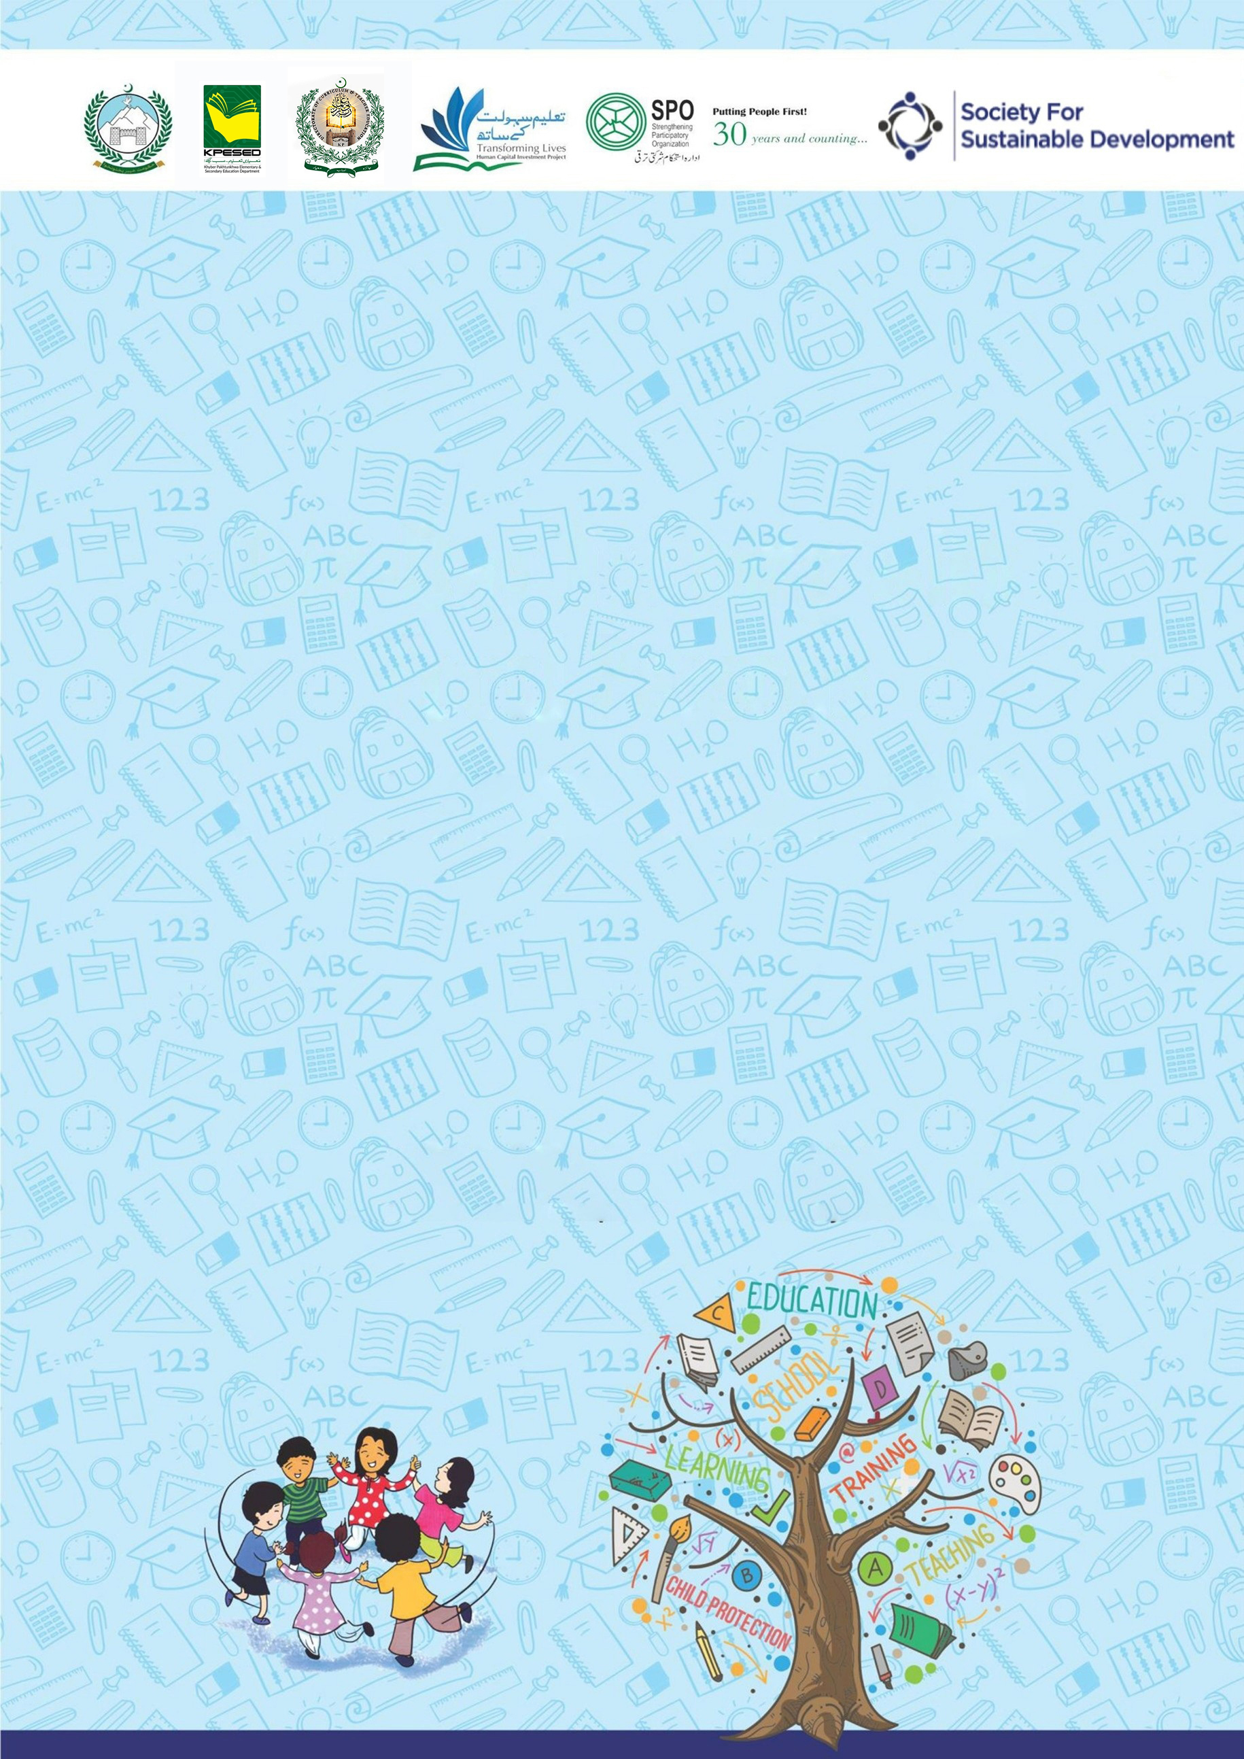
Developed by KP Human Capital Investment Project (KP-HCIP)
2 Hour Session for Girls Primary School
on School-Related Safety/Safeguards

All rights reserved with the KP HCIP Peshawar, Pakistan
Module designed by KP HCIP
Approved by Directorate of Curriculum and Techer Education (DCTE), Khyber Pakhtunkhwa

Authors:
- Fouzia Anjum Environmental & Social Specialist, KPHCIP
- Sadia Khan Gender Specialist, KPHCIP
- Dr Safia Noor GBV Specialist, KPHCIP

Review Supervision:
Gohar Ali Khan, Director, Curriculum and Teacher Education, Khyber Pakhtunkhwa

Review Coordination:
Muhammad Ashfaq Khan Jadoon, Additional Director Curriculum and Teacher Education, Khyber Pakhtunkhwa

Review Committee:
- Mr. Aman Ullah, Instructor RPDC(M) Peshawar
- Mr. Noshad Abbasi, Subject Specialist GHSS Rich Behn Abbottabad
- Mr. Raza Hassan, Principal GHSS Mohammad Zai Kohat
- Dr. Sher Bahadur, Subject Specialist GHSS Spin Dhand Bara, Khyber
- Mr. Gul Khatab, Subject Specialist, Curriculum and Teacher Education, Khyber Pakhtunkhwa

Table of Contents
S# | Content | Page No.
 | Agenda | 01
 | Overall Objectives | 02
 | Introduction to the training | 02
 | Activity 1: Our protected; strong and Smart boys | 03
 | Roleplay | 04
 | Activity 2. Good and Bad feeling | 05
 | Activity 3. Body Safety | 07
 | Activity 4. Trusted adult to whom I can ask for help | 09
 | Activity 5: Learn to Ask for Help | 11
 | Handout: Roleplay | 13

Agenda
Activity | Title | Duration
 | Introduction to the training | 05 minutes
1 | Our protected, strong and smart girls | 25 minutes
2 | Good and Bad feelings | 30 minutes
3 | Body Safety | 20 minutes
4 | Trusted Adult to whom I can ask for help | 20 minutes
5 | Learn to ask for help | 20 minutes

Over all Objectives
At the end of this session, participants will be able to:
- Understand the importance of respect, empathy, and safety within the school environment.
- Identify red flags (warning signs) and green flags (positive behaviors) in situations related to bullying, harassment, or unsafe behavior.
- Demonstrate safe bystander intervention strategies when witnessing bullying or harassment.
- Identify trusted adults and support systems within and outside the school.
- Practice help-seeking skills and know how to report concerns safely.

Introduction to the Training (Duration: 05 minutes)
Objectives:

At the end of this activity, children will be able to:

- Introduce participants to one another
- Talk with each other
- Create relaxed atmosphere, and establish an informal tone for the training
- Create safe environment to share and discuss issues

Steps:

- Start the session with recitation from the Holy Quran.
- Welcome and opening remarks by the trainer and her introduction.
- Ask Participants to introduce themselves by sharing their names and one thing they are happy for.
- Brief the participants about the objectives of the session.
- Share with participants norms for the training.

A sample of some common ground rules/norms
- Start on time, end on time.
- Do not interrupt while others are speaking.
- Everyone should try to listen as well as speak.
- Maintain confidentiality of what is shared, no gossiping.
- Show respect for others’ experiences.
- Avoid making personal remarks.
- Be aware of language difficulties i.e. speak slowly if needed.
- Keep mobile phones on silent mode or vibration

Activity 1. Our protected; strong and Smart Girls (25 minutes)
To enable children to recognize feelings that may make them uncomfortable or unsafe, understand the importance of personal body privacy and appropriate boundaries, and learn how to seek support from a pre-identified and trusted adult within their family or school.
Objectives:
By the end of this activity, children will be able to:
- Recognize unsafe situations when someone asks them to keep secrets or go somewhere without permission.
- Understand the importance of saying “No” to something that makes them feel uncomfortable or scared.
- Identify trusted adults (parents, teachers, elders) they can talk to when they face a problem.
- Practice speaking up and reporting, just like Ayesha did in the role play.
- Build confidence to make safe and smart choices in real-life situations.

Steps: (10 minutes)
- Make appropriate groups of participants/ students
- Ask them to discuss the roleplay scripts in group and assign roles
- Invite 1-2 groups to demonstrate the role play
- Ask children how they felt while watching the role play.
- Initiate discussion by asking following questions: (10 minutes)
- What happened in the story?
- Who were the main characters?
- How did the children feel when the male staff member approached them?
- Why is it unsafe to go with someone you do not know?
- What are the three important things we should do if we feel unsafe?
Final Message (All Together)
All Students Together: (05 minutes)
"If something feels wrong:
- Trust your feelings
- Stay with friends
- Say NO politely
- Tell a trusted adult."

Roleplay: “Speaking up is bravery. Safety comes first.”
Role Play: Zainab’s Brave Choice
Characters
- Zainab – a smart and brave girl
- Friend 1 (Hina) – Zainab’s classmate
- Friend 2 (Areeba) – another friend
- Male Staff Member – not Zainab’s teacher
- Female Teacher
Scene 1: School Courtyard
(Zainab, Hina, and Areeba are playing during break.)
Hina: Zainab, throw the ball to me!
Zainab: Okay! Catch it!
(They laugh and play together.)
(A male staff member comes near them.)
Staff Member: Zainab, come with me to the classroom. I need help carrying some books.
Zainab: (Looks unsure)
Staff Member: تم اکیلی آؤ، دوسری لڑکیوں کو مت بتانا۔
(You come alone, don’t tell the other girls.)
(Zainab feels uneasy.)
Zainab: (Thinking) مجھے کچھ گھبراہٹ ہو رہی ہے۔ میری امی نے کہا تھا کہ اکیلے کسی کے ساتھ نہ جانا۔
Zainab: میں ابھی اپنی سہیلیوں کے ساتھ کھیل رہی ہوں۔
(I am playing with my friends right now.)
(Zainab walks away with her friends.)
Hina: Zainab, what happened?
Zainab: I felt something was not right. Let’s go to our teacher.
Telling a Trusted Adult
(They go to their female teacher.)
Zainab: میم، کوئی بات ہے۔
(Ma’am, there is something.)
Teacher: Yes Zainab, tell me.
Zainab: A staff member asked me to go alone to a classroom and told me not to tell anyone.
Teacher: You did the right thing by coming to me. I am proud of you.

Activity 2. Good and Bad feelings (Duration 30 minutes)
Objectives:

By the end of this activity, children will be able to:
- Recognize different feelings
- Understand the difference between good feelings and bad feelings
- Know that bad or uncomfortable feelings are warning signs
- Learn to tell a trusted adult when they feel unsafe

Materials Required
- Emotion cards or pictures (happy, sad, scared, angry), Chart paper or board, Markers, Smiley and sad face drawings
Warm-Up Activity (5 minutes)
Activity: “Show Your Feelings”
Facilitator Says: The facilitator explains: “Our heart and mind give us signals about how we feel. When we feel happy or comfortable, it is a good signal. But when we feel sad, scared, or uncomfortable, it may be a warning that something is not right and we should tell a trusted adult.”
The facilitator will provide the emotional cards and instruct them to recognize different feelings

Now facilitator says
- Show me a happy face 😊
- Show me a sad face 😢
- Show me an angry face 😠
- Show me a scared face 😨

Ask Children
- When do you feel happy?
- When do you feel sad?

Facilitator Explanation

Good feelings
- Make us feel happy, safe, and comfortable
Examples:
- Playing with friends
- Getting a hug from parents
- Learning something new

Bad feelings
- Make us feel scared, uncomfortable, or worried
Examples:
- Someone shouting at you
- Being bullied
- Someone asking you to keep a secret that feels wrong

Activity: Feeling Game (10 minutes)
The facilitator describes situations and children decide Good Feeling or Bad Feeling.

Example situations:
- Your teacher praises your work.
- A stranger asks you to go somewhere with them.
- Your friend shares toys with you.
- Someone pushes you or calls you names.
- Your parents hug you.
Children raise:
- Thumbs up 👍 = Good feeling
- Thumbs down 👎 = Bad feeling

Safety Message (10 minutes)
Explain to children:
Bad feelings are like a warning alarm in our body.
If you feel:
- scared
- uncomfortable
- confused

Recall 3 Safety Steps you have learned: (03 minutes)

- Say NO
- Move away
- Tell a trusted adult
Closing Activity (2 minutes)
- Ask children to repeat together:
- “My feelings are important!”
“If I feel bad or unsafe, I will tell a trusted adult.”

Activity 3. Body Safety (Duration: 20 minutes)
Objectives:
By the end of this activity, children will be able to:
- Understand that their body is special and valuable
- Know that private body parts must be protected
- Learn that no one is allowed to touch their private parts
- Know what to do if someone makes them uncomfortable

Body Safety Rule (5 minutes)
Facilitator says:
Children! Allah has given us a beautiful body.
We should take care of our body and protect our dignity.
Islam teaches us to protect our honor and also respect others.
Explain simply:
Children, some parts of our body are special (private).
“The parts of our body that are covered by our clothes (under shirt and pants) are private.” No one can touch these parts:
- Friends
- Relatives
- Strangers

Important Exceptions (Explain Carefully)
The only exceptions are:
- Mother or Father, for cleaning or helping
- Doctor, during medical check-ups in presence of parents.

Activity: Safe or Unsafe (5 minutes)
Facilitator reads situations and children respond by raising:
👍 Safe
👎 Unsafe
Examples:
- Mother is helping you bathe.
- Doctor is checking you and your parents are with you.
- Someone says, “This is a secret, don’t tell anyone.”
- Someone tries to take you alone into a room.

Safety Action Rule (5 minutes)

Make aware the students how to keep their body safe. Suggest three steps:
- Say “NO!” loudly
- Move away immediately
- Tell a trusted adult immediately
Examples of trusted adults:
- Mother
- Father
- Teacher
- School Head
- Older sibling

Practice Activity (2 minutes)

Children practice saying loudly:
Children say together:
- “This is my body!”
- “Do not touch me in the wrong way!”
- “I will tell an adult immediately!”

Key Messages (Closing) (03 minutes)
Facilitator summarizes:
- Our body is a trust from Allah
- We must protect our dignity
- If something feels wrong, tell a trusted adult immediately
Ask children to repeat together:

Activity: 4. Trusted Adult to whom I can ask for Help (20 minutes)
Objectives:
By the end of this activity children will be able to:
- Understand the concept of a trusted adult Identify adults they can safely ask for help
- Recognize situations when they need to talk to a trusted adult
- Know how to approach a trusted adult if they feel unsafe

Material Required:
- Chart paper, markers
Facilitator says:
“Girls, everyone needs help sometimes.
A trusted adult is someone who:
- Listens to you
- Cares about you
- Can help you when you feel scared, confused, or unsafe
Trusted adults help keep you safe and happy.”

- Draw two columns on the board: (05 minutes)
Trusted Adults | Not Trusted Adults

- Ask girls to name adults in their life. Write them in the Trusted Adults column if they are safe and caring.
- Discuss why some adults may be safe while others may not.

Examples of Trusted Adults: (02 minutes)
- Parents (Mother, Father)
- Grandparents
- Teachers
- Older siblings

Facilitator explains:
“Not everyone is safe to ask for help.
If someone makes you feel uncomfortable, scared, or confused, you should go to a trusted adult.”

Scenario Game (10 minutes)
- Facilitator reads a situation aloud. girls respond by pointing to a trusted adult or saying what they would do.

Sample Situations:
- Someone at school is bullying you.
- A stranger asks you to go with them.
- You feel scared at home.
- You get hurt while playing.
- Someone tells you to keep a secret that feels wrong.

Discussion:
- Whom should you tell?
- What steps will you take?

Facilitator reinforces:
- Always tell a trusted adult immediately
- Trusted adults will listen, believe you, and help you

Key Messages (Closing – 3 minutes)
Facilitator summarizes:
- Trusted adults are people who care, listen, and protect you
- Always tell a trusted adult if something makes you feel unsafe, scared, or uncomfortable
- It is never your fault if someone behaves wrongly
- Saying NO and asking for help shows strength and smartness

Group Repeat:

- “I know who my trusted adults are!”
- “I will ask them for help if I feel unsafe!”

Activity 5. Learn to Ask for Help/how to say it, to whom
(Duration: 20 minutes)
Objectives:
By the end of this activity, children will be able to:

- Understand that asking for help is safe and brave
- Identify situations when they need to ask for help
- Know who their trusted adults are
- Practice how to ask for help clearly and confidently

Material Required:
- Chart paper or board

Facilitator says:
“Boys and girls, everyone needs help sometimes.
Asking for help is not wrong. In fact, it is a smart and brave thing to do.
Sometimes we need help when we are:

- scared or hurt
- bullied
- not understanding something
- feeling confused or uncomfortable
Asking for help keeps us safe, strong, and happy.”

When to Ask for Help (5 minutes)

Facilitator asks children:
- To whom you ask for help?
- Who did you ask for help?
- How did it feel when you asked for help?

Facilitator explains:
“These are all times when asking for help is the right thing to do.”

Activity : Role Play Practice (8 minutes)

Instructions:
- Divide children into pairs or small groups
- Give them short scenarios where someone needs help
- One child acts as the one needing help, the other as the trusted adult

Sample Scenarios:
- A girl falls while playing with ball.
- A girl is scared because a stranger is following her near school.
- A child doesn’t understand homework and feels frustrated.

Invite groups/ pairs for role play
- Ask the children how it felt to ask for help
- Ask the “trusted adult” how they helped
- Reinforce that asking for help makes you strong and smart
Say It Loud! (3 minutes)
Children practice a simple phrase together:
- “I need help!”
- “Please help me!”
- “I will tell my trusted adult if I feel unsafe.”

Facilitator explains:
- It is okay to ask for help loudly
- Asking for help is always safe

Key Messages (Closing – 3 minutes)
Facilitator summarizes:
- Asking for help is brave and smart
- You should always ask trusted adults when you feel scared, hurt, or uncomfortable
- Do not keep secrets that make you feel bad or unsafe
- Trusted adults listen, believe, and help you

Children repeat together:
“I am safe, strong, and smart. I know how to ask for help!”
- The facilitator leads a simple, collective promise.

****************************************************************

HANDOUT
Roleplay
“Speaking up is bravery. Safety comes first.”
Role Play: Zainab’s Brave Choice
Characters
- Zainab – a smart and brave girl
- Friend 1 (Hina) – Zainab’s classmate
- Friend 2 (Areeba) – another friend
- Male Staff Member – not Zainab’s teacher
- Female Teacher
Scene 1: School Courtyard
(Zainab, Hina, and Areeba are playing during break.)
Hina: Zainab, throw the ball to me!
Zainab: Okay! Catch it!
(They laugh and play together.)
(A male staff member comes near them.)
Staff Member: Zainab, come with me to the classroom. I need help carrying some books.
Zainab: (Looks unsure)
Staff Member:
(You come alone, don’t tell the other girls.)
(Zainab feels uneasy.)
Zainab: (Thinking)
Zainab:
(I am playing with my friends right now.)
(Zainab walks away with her friends.)
Hina: Zainab, what happened?
Zainab: I felt something was not right. Let’s go to our teacher.
Telling a Trusted Adult
(They go to their female teacher.)
Zainab:
(Ma’am, there is something.)
Teacher: Yes Zainab, tell me.
Zainab: A staff member asked me to go alone to a classroom and told me not to tell anyone.
Teacher: You did the right thing by coming to me. I am proud of you.

******************************************

