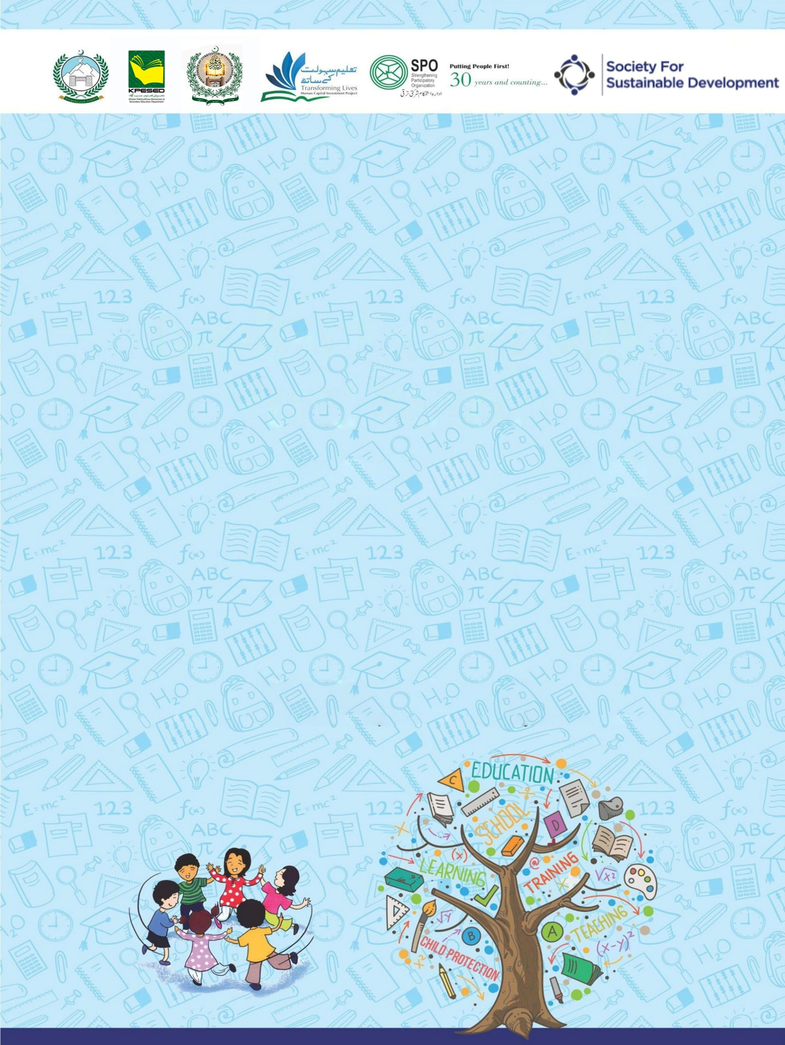
Developed by KP Human Capital Investment Project (KP-HCIP)
2 Hour Session for Girls Secondary School
on School-Related Safety/Safeguards

All rights reserved with the KP HCIP Peshawar, Pakistan
Module designed by KP HCIP
Approved by Directorate of Curriculum and Techer Education (DCTE), Khyber Pakhtunkhwa

Authors:
- Fouzia Anjum Environmental & Social Specialist, KPHCIP
- Sadia Khan Gender Specialist, KPHCIP
- Dr Safia Noor GBV Specialist, KPHCIP

Review Supervision:
Gohar Ali Khan, Director, Curriculum and Teacher Education, Khyber Pakhtunkhwa

Review Coordination:
Muhammad Ashfaq Khan Jadoon, Additional Director Curriculum and Teacher Education, Khyber Pakhtunkhwa

Review Committee:
- Mr. Aman Ullah, Instructor RPDC(M) Peshawar
- Mr. Noshad Abbasi, Subject Specialist GHSS Rich Behn Abbottabad
- Mr. Raza Hassan, Principal GHSS Mohammad Zai Kohat
- Dr. Sher Bahadur, Subject Specialist GHSS Spin Dhand Bara, Khyber
- Mr. Gul Khatab, Subject Specialist, Curriculum and Teacher Education, Khyber Pakhtunkhwa

Table of Contents
S# | Content | Page No.
 | Agenda | 01
 | Overall Objectives | 02
 | Introduction to the training | 02
 | Activity 1: Ice Breaker – The Line of Respect | 03
 | Activity 2. Scenario Analysis – Red Flags and Green Flags | 04
 | Case studies | 05
 | Activity 3. The Power of Bystanders – Role Play | 06
 | Activity 4: Mapping my support galaxy | 08
 | Support Galaxy Worksheet | 09
 | Activity 5: Knowledge into Action – Help Seeking Simulation | 10
 | Activity 6: Closing and Empowering Pledge | 11

Agenda
Activity | Title | Duration
 | Introduction to the training | 05 minutes
1 | Ice Breaker – The line of respect | 15 minutes
2 | Scenario – Red Flags and Green Flags | 25 minutes
3 | The power of Bystander – The Roleplay | 25 minutes
4 | Mapping My Support Galaxy | 20 minutes
5 | Knowledge into actions – Help Seeking Simulation | 20 minutes
6 | Closing and Empowering Pledge | 10 minutes

Over all Objectives
At the end of this session, participants will be able to:
- Understand the importance of respect, empathy, and safety within the school environment.
- Identify red flags (warning signs) and green flags (positive behaviors) in situations related to bullying, harassment, or unsafe behavior.
- Demonstrate safe bystander intervention strategies when witnessing bullying or harassment.
- Identify trusted adults and support systems within and outside the school.
- Practice help-seeking skills and know how to report concerns safely.

Introduction to the Training (Duration: 05 minutes)
Objectives:
At the end of this activity, participants will be able to:

- Introduce to one another
- Talk with each other one-on-one
- Create relaxed atmosphere, and establish an informal tone for the training
- Create safe environment for participants to share and discuss issues

Steps:
- Start the session with recitation from the Holy Quran.
- Welcome the participants, followed by opening remarks and brief introduction by trainer.
- Ask Participants to introduce themselves by sharing their names and one thing they are happy for.
- Brief the participants about the objectives of the session.
- Ask the participants to set norms for the training.

Activity 1: Ice breaker – The Line of Respect (15 minutes)
Objectives:
At the end of this activity, participants will be able to:

- Encourage open discussions and reflect on different attitudes related to respect, bullying and responsibility.

Steps:
- Ask participants to stand in a straight line across the room.
- Explain the activity:
"I will read a statement. If you agree, take one step forward. If you disagree, take one step back. There are no right or wrong answers; we want to hear different opinions."
- Read the following statements:
• “It is okay to tease someone if they are your friend.”
• “If someone is being bullied, it is not my responsibility to help.”
• “If a friend shares a secret about being hurt, I should never tell anyone.”
• “I know at least two adults in this school whom I can trust with a serious problem.”
• “Girls should support each other instead of spreading rumors.”
- After each statement, ask 1–2 participants why they stepped forward or back.
- Facilitate a short discussion emphasizing respect, kindness, and supporting each other.

Activity 2: Scenario Analysis – Red Flags and Green Flags
(Duration: 25 minutes)
Objectives

By the end of this activity, participants will be able to:
- Identify warning signs (Red Flags) of online harassment, threats, and blackmail in everyday situations.
- Recognize safe and supportive responses (Green Flags) that help protect and support victims.
- Understand that threats, harassment, and blackmail are forms of abuse and are unacceptable.
- Promote empathy and non-blaming attitudes toward victims of online harassment.
- Encourage help-seeking behavior by identifying trusted adults or authorities to report unsafe situations

Material Required:
- Flip Charts, paper tapes, Permanent markers
Steps:
- Briefly discuss the objective with the participants.
- Divide the participants into three groups.
- Provide each group with a printed copy of the case study
- Give participants 15 minutes to read their scenario and answer the discussion question.
- Ask every group to present their presentation. Take few comments and questions from the participants and clarify if there are any misconceptions.
- Appreciate their ideas and active participation

Case Study 1
Sara noticed that her classmate Nadia seemed upset and distracted. When Sara gently asked if something was wrong, Nadia shared that one of her class fellows has shared Nadia’s phone number and pictures with her male cousin and now that boy is sending her threatening messages and asking for personal photos.
However, instead of supporting her, Sara reacted differently. She told Nadia that she should not have talked to strangers online and warned her not to tell anyone because it could damage her reputation. Sara also suggested Nadia that simply ignore the messages and delete the conversation.
Feeling blamed and unsupported, Nadia became more worried and isolated. She did not report the situation to any adult or authority, and the person continued sending threatening messages.
Use the following questions to guide the discussion:
  - What red flags (warning signs) can you identify in this situation?
  - How did Sara’s reaction make the situation worse for Nadia?
  - Why is victim-blaming harmful in cases of online harassment?
  - What risks can arise if threats and harassment are ignored or hidden?
  - What should a safer and more supportive response look like?

Case Study 2
Sara noticed that her classmate Nadia seemed upset and distracted. When Sara gently asked if something was wrong, Nadia shared that one of her class fellows has shared Nadia’s phone number and pictures with her male cousin and now that boy is sending her threatening messages and asking for personal photos.
Instead of blaming Nadia, Sara listened calmly and reassured her that what happened was not her fault. She encouraged Nadia to save screenshots of the messages and suggested reporting the situation to a trusted teacher and her parents.
Sara also offered to go with Nadia to speak with the school counselor. Together, they reported the incident, and the school helped Nadia take steps to block the person and ensure her safety.
Use the following questions to guide the discussion:
  - What green flags (supportive actions) do you see in Sara’s response?
  - How did Sara show empathy and non-judgment?
  - Why is it important to report online harassment to trusted adults or authorities?
  - What other actions could help protect someone experiencing online harassment?

Activity 3: The Power of Bystanders – Role Play (25 minutes)
Objectives:
By the end of this activity, participants will be able to:

- Understand the role of bystanders in preventing and responding to harassment, bullying, or unsafe behavior.
- Demonstrate appropriate bystander actions through role play, such as speaking up, offering support to victims, or reporting the issue to a trusted adult.
- Build confidence and empathy to support peers who may be experiencing harassment or abuse.
- Recognize safe and responsible ways to intervene without putting themselves or others at risk.
- Promote a culture of respect and accountability where students help create a safe environment for everyone.

Steps:
- Explain the concept of a bystander:
A bystander is someone who witnesses a situation but is not directly involved.
- Demonstrate a short role play with a volunteer.
Example Scenario:
A student is being teased about her appearance or clothes.
Show two responses:
Negative Bystander
- Laughs at the teasing
- Ignores the situation
Positive Bystander
- Says calmly: “That is not respectful.”
- Supports the targeted student
- Reports the issue to a teacher if necessary
- Introduce three safe bystander strategies:
Direct: Calmly ask the person to stop.
Distract: Change the situation or remove the targeted student.
Delegate: Seek help from a teacher or school staff.
- Ask participants to practice short role plays in pairs.
- Invite 2–3 pairs to demonstrate their responses.
Role Play 1: Teasing About Appearance (Direct Strategy)
Characters:
- Ayesha (targeted student)
- Sana (student teasing)
- Fatima (bystander)
Scene: During school break in the courtyard.
Sana: (laughing) Ayesha, why do you always wear your dupatta like that? It looks so strange!
Ayesha: (looks uncomfortable) Please stop, Sana…
Negative Bystander
Fatima: (laughs with Sana) Yes, it does look funny.
(Ayesha feels embarrassed and quietly walks away.)
Positive Bystander – Direct
Fatima: Sana, that’s not respectful. Everyone has the right to dress the way they feel comfortable.
Sana: I was just joking.
Fatima: It doesn’t feel like a joke to her. Please stop saying things like that.
Fatima: (to Ayesha) Are you okay? Come, sit with me.
Learning Point:
A bystander can directly speak up in a calm and respectful way to stop teasing and support the person being targeted.

Role Play 2: Teasing in the Corridor (Distract & Delegate Strategy )
Characters:
- Nadia (targeted student)
- Hira (student teasing)
- Amina (bystander)
Scene: School corridor during the break.
Hira: (laughing) Nadia, why does your hairstyle look like that today? It looks so strange!
Nadia: (quiet and upset)
Negative Bystander
Amina: (sees the situation but ignores it and walks away)
(Nadia remains uncomfortable and alone.)
Positive Bystander – Distract
Amina: Hey Nadia! The teacher was asking for you in the classroom. Let’s go together.
(Amina walks with Nadia away from the situation.)
Positive Bystander – Delegate
Amina: (later speaking to the teacher) Miss Hira was teasing Nadia in the corridor and she looked upset. I thought you should know.
Learning Point:
A bystander can change the situation by distracting the person being targeted or by seeking help from a trusted adult such as a teacher.

Activity 4: Mapping My Support Galaxy (Duration: 20 minutes)
Objectives:
By the end of this activity, participants will be able to:
- Identify trusted individuals in their personal lives who they can approach for support in difficult situations.
- Recognize different levels of support networks, including family members, school staff, community members, and formal services.
- Understand the importance of seeking help and not dealing with problems or unsafe situations alone.
- Increase awareness of available support services, such as school administration and child protection helplines.
- Build confidence in accessing support systems when facing challenges, harassment, or safety concerns.

Steps:
- Distribute the Support Galaxy Worksheet.
- Ask participants to write “ME” in the center circle.
- Explain the three circles around it.
Inner Circle – People I Trust Most
Examples:
- Mother
- Sister
- Female teacher
- School counselor
- Principal
Second Circle – People I Can Reach for Help
Examples:
- Aunt
- Older cousin
- Neighbor
- Community mentor
Outer Circle – Support Services
Examples:
- Child Protection Helpline 1121
- School administration
- Local support services
- Encourage participants to think about who they can turn to in difficult situations.
- Emphasize that everyone deserves a support network.

SUPPORT GALAXY WORKSHEET

Support Services
People I can reach for help
People I trust most

Activity 5: Knowledge into Action – Help-Seeking Simulation
(Time: 20 minutes)
Objectives:
By the end of this activity, participants will be able to:
- Apply knowledge from previous sessions to identify appropriate steps for seeking help in difficult or unsafe situations.
- Practice communicating concerns and asking for support from trusted adults or support services.
- Understand the importance of timely reporting of harassment, threats, or unsafe behavior.
- Build confidence in using available help-seeking channels, such as teachers, school administration, or helplines.
- Reinforce the message that seeking help is a positive and responsible action

Steps:
- Explain that sometimes students may need to ask an adult for help.
- Ask participants to identify the GBV Focal Person or trusted female teacher in the school.
- Demonstrate how to start a conversation when seeking help.
Example:
"Ma’am, I need to talk to you privately about something important."
- Explain possible ways students can describe the situation:
- “Someone is bothering me online.”
- “I am worried about my friend.”
- “Something happened and I need help.”
- Teach students that if the teacher is busy, they can say:
"It is important. Can we talk later today?"
- Ask participants to practice this conversation in pairs.

Activity 6: Closing and Empowerment Pledge (10 minutes)
Objectives:
By the end of this activity, participants will be able to:
- Reflect on key lessons learned during the session about respect, safety, and support.
- Commit to positive behaviors, including standing against harassment and supporting peers.
- Strengthen personal responsibility for creating a safe and respectful school environment.
- Encourage confidence and empowerment to speak up and seek help when needed.
- Promote a culture of respect and solidarity through a shared pledge.

Steps:
- Summarize the key messages from the session:
- Respect and kindness create a safe school environment.
- Students can play a positive role as upstanders instead of bystanders.
- Seeking help is a sign of strength, not weakness.
- Lead participants in a collective pledge.
Empowerment Pledge
"I pledge to respect myself and others.
I pledge to support and protect my friends.
I pledge to speak up against bullying and harassment.
I pledge to seek help when I need it.
Together we will create a safe and respectful school."
- Thank participants for their participation and encourage them to practice these values in their daily school life.
Wrap up:
- Thank participants for their ideas and their participation.
- Remind participants that they are in a great position to become agents of change and to make a difference in the lives of their students.
- Share Training post evaluation form with participants and request them give their feedback on it.
******************************************************

