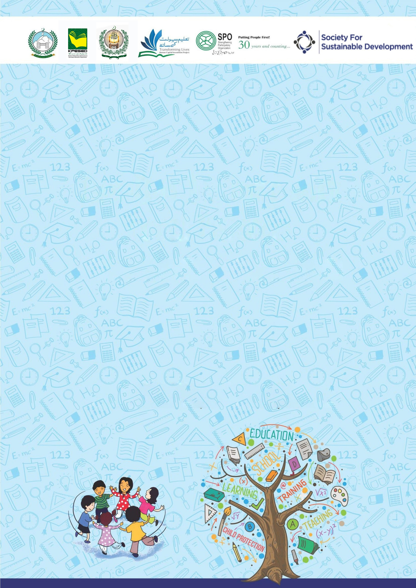

Developed by KP Human Capital Investment Project (KP-HCIP)
Two-Day Training with Focal Persons
on School-Related Safety/Safeguards

All rights reserved with the KP HCIP Peshawar, Pakistan

Module designed by KP HCIP
Approved by Directorate of Curriculum and Techer Education (DCTE), Khyber Pakhtunkhwa

Authors:
- Fouzia Anjum Environmental & Social Specialist, KPHCIP
- Sadia Khan Gender Specialist, KPHCIP
- Dr Safia Noor GBV Specialist, KPHCIP

Review Supervision:
Gohar Ali Khan, Director, Curriculum and Teacher Education, Khyber Pakhtunkhwa

Review Coordination:
Muhammad Ashfaq Khan Jadoon, Additional Director Curriculum and Teacher Education, Khyber Pakhtunkhwa

Review Committee:
- Mr. Aman Ullah, Instructor RPDC(M) Peshawar
- Mr. Noshad Abbasi, Subject Specialist GHSS Rich Behn Abbottabad
- Mr. Raza Hassan, Principal GHSS Mohammad Zai Kohat
- Dr. Sher Bahadur, Subject Specialist GHSS Spin Dhand Bara, Khyber
- Mr. Gul Khatab, Subject Specialist, Curriculum and Teacher Education, Khyber Pakhtunkhwa

Contents

Session 1: Provision of Conducive Environment 3
Session 2: Vision of an Ideal Society for the Children 4
Session 3: Self Awareness 6
Session 4: Violence in the Society and its types 10
Session 5: Root Cause of violence 15
Session 6: Myths and Facts of Child Abuse 19
Session 7: How to Respond to Violence against Children 21
Session 8: School Prevention and Redressal 23
Session 9: Orientation on Modules 30
Session 10: Role of a Facilitator 31
Session 11: Communication Skills for Facilitator 35
Session 12: Practice Session 39
Session 14: Action Planning 40
Annexure 42

Acknowledgment

Training Module School-Related Safety and Safeguarding of Children is designed for designated Focal person from 1000 School in selected districts of Khyber-Pakhtunkhwa with the aim of creating a safe environment in schools where students can learn and flourish without any fear of violence. The module is a detailed session by session training guide to run 2-day training aimed at enhancing sensitization, knowledge and skills of School Focal Person to conduct sessions with children and teachers on safety and safeguarding with profound knowledge and skills and also with sensitive and empowering attitude. It also capacitates the Focal persons to recognize, prevent, and respond to cases of violence against children in school through effective implementation of code of conduct and response redressal mechanism.

HCIP would like to express gratitude to the team of DCTE (Directorate of Curriculum and Teacher Education) for their invaluable services in reviewing and rephrasing the training modules. Their expertise and insights have been instrumental in enhancing the quality and effectiveness of these modules which are designed to educate school children on the critical issues of violence against women and children. We appreciate the time and effort invested by following team members, in thoroughly reviewing the modules and providing constructive feedback.

Mr. Aman Ullah, Instructor RPDC(M) Peshawar
Mr. Noshad Abbasi, Subject Specialist GHSS Rich Behn Abbottabad
Mr. Raza Hassan, Principal GHSS Mohammad Zai Kohat
Dr. Sher Bahadur, Subject Specialist GHSS Spin Dhand Bara, Khyber
Mr. Gul Khatab, Subject Specialist, Directorate of Curriculum and Teacher Education, Khyber Pakhtunkhwa

Approval of DCTE for the modules is a testament of quality and relevance, and we are confident that they will make a positive impact on the lives of the children who will benefit from these modules.

We are thankful to the SPO & SSD teams, which includes Dr Safia Noor, Gender Specialist Miss Rizwana Aziz, Team Lead Miss Saba Rehman, GBV Officer Miss Fozia Hanif, Field Supervisor Miss Maryam Zulfiqar, Field Supervisor Muhammad Umair Afridi, Field Supervisor Bilal Ahmad, for their technical input in development of this resource pack.

This activity was made possible through the funding support of the World Bank, under the Human Capital Investment Project (HCIP). We are grateful for their commitment to promoting education and well-being among children in Khyber Pakhtunkhwa.

ACRONYMS

CP | Child Protection
CPC | Child protection Cell
VAC | Violence Against Children
GBV | Gender Based Violence
SH | Sexual Harassment
GRM | Grievance Redressal Mechanism
E&SED | Elementary and Secondary Education Department
KPHCIP | Khyber Pakhtunkhwa Human Capital Investment Project
VC | Village Council
NC | Neighborhood Council
PMU | Project Management Unit
DEO | District Education Officer
ASDEO | Assistant Sub-Divisional Education Officer
PTC | Parent Teacher Council
ESMPs | Education and Social Management Plan
EMIS | Environmental Management Information System
UNFP | United Nations Fund for Population
UNHCR | United Nations High Commission for Refugees
WHO | World Health Organization
SGBV | Sexual and Gender-Based Violence

Overall Objectives of the Training:

By the end of the 2-day training participants will be able to:

1 | Deepen participants’ understanding about the dynamics of school safeguarding, prevention and measures of Violence against Children (VAC).
2 | Discuss the impact of violence on children and possible ways to protect and respond violence against children.
3 | Equip Focal Person to provide orientation and training to school teachers, Parent-Teacher Councils (PTCs), Village Council and Neighborhood Councils, and with information about school safe guarding and redress mechanism and their role in ensuring children’s safety.
4 | Equip Focal persons to conduct sessions with the children, to educate them about safe and unsafe situations or behaviors they may encounter and understand how to seek help if they feel unsafe or uncomfortable.

Training methodology

This module has been developed with an interactive and participatory approach in mind, allowing for group interaction and discussion at all levels. Both facilitators and participants are encouraged to benefit from the knowledge gained from each other's diverse experiences and perspectives. Participants are encouraged to lead their learning; engage in self-reflection, and take responsibility for applying the knowledge and skills gained through participation in real-world situations. Although there are presentations by trainers, the emphasis remains on allowing the participants the space and opportunity to discuss, analyze and reflect on new awareness and concepts. Trainers should ensure the use of the participatory methodology based on the need of the sessions and to ensure maximum participation.

Training Agenda

Session | Title | Time
Day One
1 | Tone Setting | 8:30 am -9:30 am
2 | Vision of an Ideal Society for Children, Qualities of an Ideal Teacher | 9:30-10:15
3 | Self-Awareness | 10:15-12:00
4 | Violence in the Society and Definitions | 12:00-12:45
5 | Root causes of violence | 12:45-1:30
Lunch |  | 1:30-2:15
6 | Myths and Facts | 2:15-3:00
7 | How to respond to Violence against Children | 3:00-3:45
8 | Prevention and Redressal of Violence | 3:45-4:15
9 | Orientation on Modules | 4:15-5:00
Day Two
10 | Recap of Previous Day | 8:30-9:00
11 | Role as a Facilitator | 9:00-10:00
12 | Communication Skills | 10:00-11:00
13 | Practice session of Modules | 11:00-1:15
Lunch |  | 1:15-2:00
14 | Practice session cont. | 2:00-3:00
16 | Action Planning | 3:00-4:00
17 | Conclusion and wrap up | 4:00-4:30

Session 1: Provision of Conducive Environment （Duration： 30 minutes）

Objectives:

By the end of the session 1, participants will be able to:
- Introduce to one another
- Talk with each other
- Create relaxed atmosphere, and to establish a conducive environment for the training
- Create safe environment to share and discuss issues around Child protection, Violence Against Children

Material required: Black board/flip chart, markers

Training Material: Slide/chart on Objectives

Activity: Introduction and Ice Breaker

Steps:

1 | Start the session with recitation from the Holy Quran.
2 | Welcome and opening remarks by the trainer and his/her introduction.
3 | Ask Participants to introduce themselves by sharing their names, designation and one thing they like while working with children.
4 | Brief the participants about the objectives of the session.
5 | Ask the participants to discuss what are their expectations and if they have any fears from the 2 Days training. Ask them to share how are they going to contribute in training.
6 | Ask the participants to set norms for the training.

A sample of some common ground rules/norms
- Start on time, end on time.
- Do not interrupt while others are speaking.
- Everyone should try to listen as well as speak.
- Maintain confidentiality of what is shared, no gossiping.
- Show respect for others, and other’s experiences.
- Avoid personal remarks.
- Be aware of language difficulties i.e. speak slowly if needed.
- Keep mobile phones on silent mode.

Session 2: Vision of an Ideal Society for the Children (Duration： 45 minutes)

Objectives of the Session

By the end of the session 2, participants will be able to:
- Brainstorm and envision an ideal society where children can flourish.
- Highlight the role of adults in creating a safe environment for children.

Material Required: Whiteboard/flip chart, markers
Steps

1 | Encourage participants to brainstorm ideas about what kind of school environment children would flourish in the most. Take few comments.
2 | Ask participants to brainstorm what should be the characteristics of teacher to create such a society for children. Encourage them to remember the teacher they like most in their childhood; what characteristics they have. Ask them to write one characteristic on each card.
3 | Ask participants to place the cards on the floor and help them categorize in 3 main headings of attitude, skills, and knowledge.
4 | Discuss with the participants what is the most important category for a good teacher.  Share the following with participants  - For an ideal Teacher all three components, knowledge, skills and attitude are essential. However, most of the time in the formal education as well as in trainings the focus is on knowledge acquisition, importance of attitudes is largely ignored. Whereas, teachers need to be conscious of their feelings, beliefs and attitudes towards women/children, as these may have implications for their behavior with children.  - Attitudes are also transmitted through words and has implications for how one deals with the other individuals especially children. Therefore, it is important to be aware of our own use of language and the underlying attitudes it reveals.
5 | Draw an iceberg on the chart as given below. And share the following points.  - The personality of individuals can be compared to an iceberg. Only the tip of the iceberg appears above the water, while the base remains hidden.  - The base can be compared to attitudes; while the observable tip can be compared to the knowledge and skills acquired by the person and these are the areas that can be easily measurable.  - When the iceberg hinders the course of a ship, the most permanent and effective way of removing the ice berg is to destroy it from the base and not merely to scrape the tip.  - If the iceberg is not destroyed from the base, there will be great uncertainty of how safely the ship can move.  - The base can be compared to the attitudes, which are difficult to move, yet if one works on that level, change is more effective and lasting.

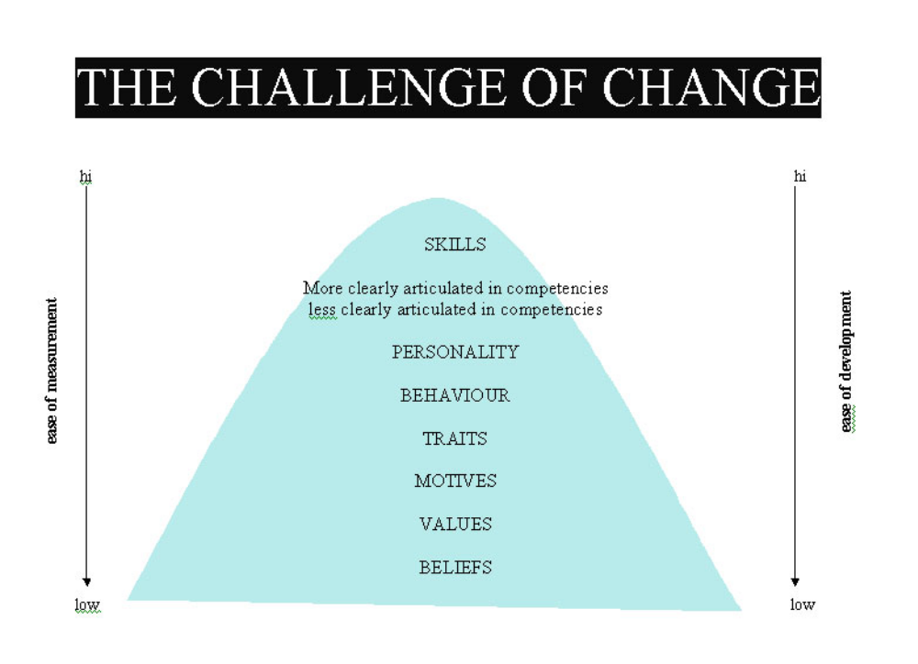
6 | Take few comments from the participants to check their understanding of the session.
7 | Conclude the session with note that for bringing a sustainable positive change in the school environment, a teacher with good knowledge, skills and positive attitude can play a major role.

Session 3: Self Awareness (Duration： 105 minutes)

Objectives of the Session:

By the end of the session 3, participants will be able to:
- Define the concept of self-awareness and identify its importance.
- Identify the basic blocks of self-awareness.
- Identify childhood messages and experiences that have an impact on one’s personality

Material Required: Whiteboard/flip chart, markers

Activity 1: Introduction to self- awareness (45 min)

Steps:

1 | Divide the participants into suitable groups. Ask participants to brainstorm and present in groups, “what they understand by self-awareness and what is included in it (one participant to note his/her group’s responses down in his/he notebook)
2 | Invite representative from each group to share their points/responses. The trainer note them down on writing board.
3 | Share the definition of self-awareness and discuss how self-awareness is a broad concept that includes all of the responses that the participants have identified, that it is a life long journey that is not always easy. Yet it is extremely important for one’s personal and professional development and is worth the difficulty.

 | Note for the Teacher/ Facilitator:  This can be a difficult activity for participants to do and the trainer may need to go around the groups and ask prompting questions, e.g. what does self-awareness mean? How do you become self-aware? What happens when you become self-aware?  When noting down participant responses on the board, ensure that responses are not repeated, i.e. if one response has already been written down, it does not need to be written down again even if another groups has identified the same thing.

Activity 2: Hindrances to self-awareness (15 min)

Steps:

1 | The trainer asks the participants to brainstorm on what may prevent people, particularly from becoming more self-aware. These should be noted on the board.
2 | Show the list of hindrances to self-awareness and points out if any were left out from either the participants’ or the trainer’s list, making the point that some of these blocks are external (lack of time) while others are internal (fear of discovering your own faults). It is also important to point out that sometimes blocks that we think are external (e.g. time) may actually be internal, in the sense that perhaps it is we who are not managing our time well enough.
3 | Emphasize the importance of identifying one’s own hindrances/blocks and find ways to overcome them.

Note for the teacher/Facilitator:
- If the participants initially find it difficult to identify hindrances blocks, the trainer will need to start them off by giving examples.
- When the trainer shows the list, he/she should point out any hindrances / blocks identified by one list (e.g. participants’) that were left out

Activity 3: Childhood Messages and Experiences (Duration： 45 minutes)

Steps:

1 | Let the participants know that they will now be doing an exercise on identifying childhood messages and their impact on one ‘s personality, attitudes and behaviour.
2 | Ask participants to recall their childhood and to complete statements read out by the facilitator. Let them know that if there is anything they do not feel comfortable talking about, they have the right to pass.
3 | Read out each of the following statement one by one.

Childhood message statements

- My mother told me that a good boy/girl should.....
- My father told me that a good boy/girl should......
- I was told that a good boy/girl could.....
- I was told that a good boy/girl could not…
- I was told that what a girl (or boy – if the participant is a man) could, but a boy (or girl – if the participant is a man) could not do was…
- In a conflict situation I was told that a good boy/girl should....
- I often get things by....
- In comparison to other boys/girls I felt....
- What I am feeling right now....

4 | Process the experience by discussing the following:  - Was it difficult/easy to complete the sentences?  - How did you feel while completing the sentences?  - What sort of themes did you find were common?  - Was there a difference in the kind of messages?
5 | Ask each participant to write down any messages (positive or negative) received in their childhood regarding different aspects of their personalities  - physical appearance,  - skills,  - abilities,  - relationships and  - future.
6 | Ask the participants to take turns sharing their messages.
7 | Ask the participants the following:  - How do you feel about these messages as adults?  - How have they impacted your lives?  - Which one/s of these is/are healthy – that you still value?  - Which one/s is/are unhealthy – that you have changed for yourself or would like to do so?
8 | Discuss the importance of childhood messages in shaping our values and behavior through following points and conclude the session.  - Although parents and caretaker want the best for their children, we all sometimes unconsciously or consciously give children messages about gender and social roles that can be harmful to them. This is how the process of gender socialization continues. Girls for example, often receive messages that encourage self-control, restriction, submission, focusing on appearance rather than career, etc. Their academic or professional skills are not always recognized. One impact of this is that many young girls with potential are not able to recognize or develop it as they feel they are not worthy of it or that is not their role. Boys, on the other hand, are often encouraged to be strong and independent, to have strong careers and achievements and to always be able to take care of things. They may even at times be encouraged to be aggressive. This could lead to stress, aggression and a need to always be in control.

Note for the teacher/Facilitator:
- As with the other activities in this session, this exercise is meant to take the concept of gender to a personal level, where the participants reflect on how gender has affected them, starting with the verbal and non-verbal messages received as children.
- Some participants may find this activity difficult initially. This may be because they find it difficult to think about and share personal experiences, especially painful ones, or it may be that they fear presenting their families and their loved ones in a negative way. Therefore, the facilitator needs to explain at the beginning that participants are to share only what they are comfortable sharing and if there is a sentence they would rather not complete, they can ―pass‖.

Session 4: Violence in the Society and its types (Duration： 45 minutes)

Objectives:

By the end of the session 4, participants will be able to:
- Understand the concept and forms of Gender-Based Violence (GBV), Violence Against Children (VAC).

Material Required: Flip Charts, paper tapes, Permanent and board markers

Training Material: Case Studies

Handouts:
- 4.1:Gender Based Violence

Activity 1: Understanding Gender-Based Violence (GBV) (20min)

Steps

1 | Briefly discuss the objective with the participants.
2 | Divide the participants into three groups giving each group one case study.
3 | Ask one participant to read the case study out loud.
4 | Ask participants to read their scenario and answer the discussion questions.
5 | Ask groups to present one by one and share some common impact of abuse based on discussion questions.

Use the following questions to guide the discussion:
- What kind of violence in the respective case study the person is facing?
- Who are the perpetrators? Who is the survivor?
- Where the violence is taking place,
- How does this violence affect the survivor?

6 | Ask every group to present their presentation to the large group. Take few comments and questions from the large group and clear if there are any misconceptions.
7 | Appreciate participants for their ideas and their participation.
8 | Share the definition and effects of violence mentioned in Slide Handout 4.1
9 | Conclude the session emphasizing the following  - There are different types of gender violence, and they all have an impact on women and children and their mental well-being.  - Remind participants that they are in a great position to become agents of change and to make a difference in the lives of their students.  - Remind participants that they are going to revisit these scenarios and discuss strategies for addressing gender violence in depth in the upcoming sessions.

Handout 4.1 Gender-Based Violence

Gender-Based Violence

The term "gender-based violence" is generally used to refer to any harmful act.:
- to discriminatory behavior and the creation of social differences based on an individual's being male or female.
- includes acts that inflict physical, sexual or mental harm or suffering, threats of such acts, coercion, and other deprivations of liberty.
- These acts can occur in public or in private.

Types of Gender-Based Violence:

GBV takes multiple forms. Some of the most common forms of GBV are:

Physical violence includes hitting, slapping, beating, shaking, pushing, biting, pulling hair, burning, torture, choking, cutting, shooting, and others. In other words, it is intentional use of violent physical force so as to cause a person actual or likely physical injury or suffering that is not sexual in nature.

Emotional violence includes humiliating or degrading treatment, name-calling, persistent shaming, constant criticism, stalking, harassment, solitary confinement or isolation, intimidation, or threats of physical violence. It involves persistent attacks on a person’s sense of self and inflicting mental or emotional injury.

Sexual violence/behavior means any unwanted behavior related to a person’s dignity or modesty that makes him/her feel unsafe, uncomfortable or disrespect.

Early/ Forced marriages are marriages in which one or both parties have not personally expressed their full and free consent to the union.

Early marriage is any marriage where at least one of the parties is under 18 years of age. A child marriage is considered to be a form of forced marriage, given that one or both parties have not expressed full, free and informed consent.

Sexual Harassment: An act that is severe, persistent, or pervasive, limits a student’s ability to participate in, or benefit from, an educational program, or creates a hostile or abusive environment.
it may include……

- Gender-based jokes or teasing
- Words such as “honey, sweetie
- Wolf whistle or other derogatory noises
- Comments about one’s body
- Derogatory comments based on gender
- Inappropriately touching

Violence Against Children:

The United Nations defines violence against children as:
"All forms of physical or mental violence, injury and abuse, neglect or negligent treatment, maltreatment or exploitation, including sexual abuse"

Types of Violence Against Children:

- Physical Violence: Physical violence is the non-accidental use of physical force that deliberately or inadvertently causes a risk of/or actual injury to a child. The infliction of physical harm, such as hitting, slapping, or any other form of body injury, leaves behind scars on a child`s physical and mental wellbeing.

- Emotional Violence: Emotional violence involves doing harm to a child’s emotional, intellectual, mental or psychological development. Constant criticism, humiliation or the manipulation of a child`s emotions can lead to severe psychological distress and hinder healthy emotional development.

- Sexual Abuse: The involvement of a child (anyone under 18) in any sexual activity. Sexual Abuse includes all forms of sexual violence including incest, sexual slavery, using sexually explicit language towards a child.
- Neglect: Neglect means the failure to meet children’s physical and psychological needs, protect them from danger, or obtain medical, birth registration or other services when those responsible for children’s care have the means, knowledge and access to services to do so.

5. Bullying (including cyberbullying) is unwanted aggressive behaviour by another child or group of children. It involves repeated physical, psychological or social harm, and often takes place in schools and other settings where children gather.

Cyberbullying is bullying with the use of digital technologies. It can take place on social media, messaging platforms, gaming platforms and mobile phones. It is repeated behaviour, aimed at scaring, angering or shaming those who are targeted. Examples include:

- spreading lies about or posting embarrassing photos or videos of someone on social media
- sending hurtful, abusive or threatening messages, images or videos via messaging platforms
- impersonating someone and sending mean messages to others on their behalf or through fake accounts.

Effects of Violence may include:

- Unexplained recurrent injuries or burns
- Improbable excuses or refusal to explain injuries
- Bald patches
- Fear of medical help or examination
- Self-destructive tendencies
- Aggression towards others
- Personality changes such as becoming insecure or clinging
- Fear of physical contact - shrinking back if touched
- Admitting that they are punished, but the punishment is excessive (such as a child being beaten every night to make him study)
- Fear of suspected abuser being contacted
- Other extreme reactions, such as depression, suicide attempts, running away, overdoses, anorexia
- Sudden loss of appetite or compulsive eating
- Being isolated or withdrawn
- Inability to concentrate
- Lack of trust or fear of someone they know well
- Physical, mental and emotional development lags
- Sudden speech disorders
- Continual self-depreciation (‘I’m stupid, ugly, worthless, etc)
- Extreme fear of any new situation
- Extremes of passivity or aggression

Note for the Teacher/Facilitator: Do not repeat the different types of GBV if they have already been discussed in the presentations made by the participants. Highlight while processing the group work how girls and women remain vulnerable to all forms of violence especially of a sexual and domestic nature and thus the focus of a lot of work on Gender Based Violence (GBV) is primarily towards women’s vulnerabilities. Mention that since GBV is fairly common some of the participants may have or are currently experiencing some form of violence themselves or know of someone experiencing violence and that talking about the issue evokes personal feelings. Do encourage them to talk to you privately or to an expert if anyone feels uncomfortable or overwhelmed during the discussion. The facilitator must be equipped and sensitive to deal with a situation of this sort, if it arises.

CASE STUDIES
Case Study-Group 1 | Saira was 14 years old she walks the same way to school every day. It’s the only way she can walk to school safely, because in the fields there are sometimes animals, and insects and she is afraid to walk through the fields alone, especially when the crops are high. So, each day she walks past the bus station and shop to get to school, and each day she is approached by a man offering to buy her something to drink or eat. He says he’ll buy her whatever she wants and that a schoolgirl needs a special treat from time to time. Last week, he asked her to go on a walk with him after school. She said no, but every day he asks her the same thing, and he is getting more and more persistent. Sometimes he gets close to her. Saira decides that tomorrow, she will be going to walk through the fields even though she is scared of insects in the fields, because she is also scared of the man who has been harassing her.
Case Study-Group 2 | Saida belonged to a small village and was the only sister among her five brothers. Saida spent all her time assisting her mother with household chores. She would wake up early in the morning, prepare breakfast, clean the house, and remain busy with various household tasks.  Her wealthy aunt brought a marriage proposal from her son, Javed, who worked in the city. Saida's father, wanting to lighten his responsibilities, agreed to the proposal.  After the marriage, Saida felt happy, thinking that since Javed worked in the city, she would live there with him. However, Javed did not take Saida to the city, and she stayed in the village with her mother-in-law. Initially, her mother-in-law cared for her, hoping Saida would give birth to a son. Instead, Saida gave birth to two daughters one after the other, which drastically changed her in-laws' behavior. Javed unjustly scolded, cursed, and physically abused her constantly, while her mother-in-law also displayed anger toward her.  In summary, instead of supporting Saida and helping with the care of their children, Javed married another woman and lived happily with her. Saida, distressed, was forced to live quietly in the same house with her two daughters. Due to inadequate food and lack of rest, Saida's health deteriorated, and she was eventually hospitalized.
Case Study-Group 3 | 9-year-old Zain goes to a local public school. His parents migrated to another country few years back. Zain is a happy kid who loves learning and making friends. But things change when he becomes the target of bullying by some older kids at school. These older kids are known for being mean and they pick on younger children like Zain. They push him around, call him names, and often taunts him of being a refugee. This make him feel scared and sad. Zain tries to tell his teachers, but the bullying doesn’t stop. He feels alone and doesn’t know what to do. Zain’s parents notice that his behavior has a drastic change, but he’s too afraid to tell them about the bullying. They tell him to be brave, but they don’t know how much he’s hurting.

Session 5: Root Causes of violence (Duration：45 minutes)

Objectives:

By the end of the session 5, participants will be able to:
- Unpack the concepts of power and gender that form the root cause of gender-based violence.
- Provide participants an opportunity to reflect on the impact of these dynamics on their own lives to better understand how these concepts are internalized.

Material Required:
- Flip charts, paper tape Permanent and board markers, white board and Multimedia

Training Material:
- Handout 5.1 Difference between Gender and Sex, Handout -5.2 Gender Socialization

Activity 1: Understanding Gender (15 min)

Steps:

1 | Ask participants about their understanding of the term ‘gender’. Take a few ideas and then share the definition and the difference between gender and sex. Highlight the key differences between gender and sex (Refer to Handout. 5.1 Difference between Gender and Sex by asking participants to give an example in each case such as how gender expectations and norms change with time, age, region, class etc.
2 | Further strengthen this understanding by showing a gender quiz, statements (given below and as that participants discuss one by one to determine if the difference/issue in each of the statements is either due to ‘gender’ or ‘sex’.  - Women give birth to babies, men do not. (s)  - Little girls are gentle, boys are tough. (g)  - Women can breast feed babies, men cannot. (s)  - Most drivers in Pakistan are men. (g)  - Men’s voices break at puberty, women’s do not. (s)  - According to UN statistics, women do 67 % of the world’s work, yet their earnings for it only amount to 10 % of world’s income. (g)  - Women have long hair men have short hair. (g)  - Men do not need tenderness and are less sensitive than women. (g)

Handout 5.1 Difference between Gender and Sex

"Sex" refers to the biological and physiological characteristics that define men and women.

"Gender" refers to the socially constructed roles, behaviors, activities, and attributes that a given society considers appropriate for men and women. To put it another way:

"Male" and "female" are sex categories, while "masculine" and "feminine" are gender categories.

Sex | Gender
Universal | Vary with region, class, religion, age etc.
Biological | Social
Linked to the body | Linked with relationships
Do not change over time | Can change over time

Aspects of sex will not vary substantially between different human societies, while aspects of gender may vary greatly.
- Some examples of gender characteristics:
- Men generally have more massive bones than women
- Men grow beard and moustaches while women do not.
- Women can lactate their babies while men cannot
- Women can give birth while men cannot
- Men generally are taller than women.

Some examples of gender characteristics:
- In the United States (and most other countries), women earn significantly less money than men for similar work
- In Saudi Arabia men are allowed to drive cars while women have just recently been allowed
- In most of the world, women do more housework than men

Activity 2: Gender Socialization (30 min)

Steps:

1 | Ask participants to recall their childhood and think as further back into their childhood as they can, to identify the first time they realized that they were a boy (for male participant) or a girl (for female participants). Ask them to think about the following:  - What was the situation about? e.g. playing, clothes, studying, going out etc.  - Who told them this?  - How old were they?  - How did it make them feel at that time?

Participants may share the following for the four above mentioned points: ‘situation related to dressing, playing with dolls, crying’, ‘told by mother, father, teacher’, ‘at the age of three, six or eight’ and ‘felt confused, angry, nothing, proud’

2 | Divide participants in triads. Draw the below table on the writing board. Ask the triads to copy the table on flip chart and write down their responses (from step 1) in the table on a flip chart, without writing their names. Let participants know that they need not tell the event in detail but just mention the four details of the events as mentioned above.

Table 1. Sample for Gender Socialization
 | Situation/Incident | Who told them | Age | Feeling it evoked
Participant 1
Participant 2
Participant 3

3 | Post flip charts in the workshop hall and ask participants to walk around and look at each chart and write down in their note pads the similarities and differences as well as any trends that they can pick out.
4 | Ask the following questions:  - At what age did you generally become aware of gender?  - Where did this awareness generally take place?  - Who were the people who generally made you aware that you were different from boys/girls?  - How did you feel when you first become aware of this?  - Do you think this would be different if we asked boys/girls? Why?  - Take random responses and conclude the session with the help of Handout 5.2.

Handout.5.2: Gender Socialization

Gender socialization is a process by which people learn to behave in a particular way dictated by societal values, beliefs, and attitudes that begin early in life. Children learn at a young age that there are distinct family and societal expectations for boys and girls and that adhering to these will result in approval. Cross-cultural studies reveal that children are aware of gender roles by age two or three and by four or five, most children are firmly entrenched in culturally appropriate gender roles.

Gender socialization occurs through various channels, for example the family, school, peer groups, the media, folklore, books, songs, etc. It also occurs through cultural/religious centers, such as masjid, churches, etc. Each of these channels reinforces gender roles by creating and maintaining normative expectations for gender-specific behavior in their own contexts. Repeated exposure to these channels and to the approval that follows, leads men and women into a false sense that they are acting naturally rather than following a socially constructed role.

Family is the first agent of socialization. There is considerable evidence that parents socialize sons and daughters differently, with greater privileges afforded to sons. For instance, boys are allowed more autonomy and independence at an earlier age than daughters. They may be given fewer restrictions on appropriate clothing, or curfew. Sons are also often free from performing domestic duties such as cleaning or cooking and other household tasks that are considered feminine. Daughters are limited by their expectation to be passive and nurturing, generally obedient, and to assume domestic responsibilities.

Notes for Teacher/Facilitator:
Talking about first awareness of gender can be an awkward session initially for some participants. Facilitator needs to ensure that in a mixed group, men form triads with men and women only with women.

Session 6: Myths and Facts of Child Abuse (Duration：45 minutes)
Objectives:

By the end of the session 6, participants will be able to:
- Identify both vulnerability and resiliency factors in children and youth.
- Understand how to create safe spaces for children and youth.

Material Required: Flip charts, Markers

Training Material: List of myths and facts
Steps:

- Discuss the myths and facts with the participants with the help of PPT.

Child sexual abuse statements

Myth 1: | It is mainly children of poor and uneducated families who are sexually abused.
Fact: | False! Socio-economic class has nothing to do with child sexual abuse.
Myth 2: | It is never ever a child's fault if he/she is sexually abused.
Fact: | True! Child sexual abuse is always the fault of the abuser no matter what. It is difficult for a child to stop abuse and it is not her or his responsibility.
Myth 3: | You can usually pick an abuser from a crowd. They look kind of abnormal and evil!
Fact: | Abusers do not look abnormal or different in any way. They are people from all walks of life, rich or poor, educated or uneducated, and they can, in fact, appear to be very nice people otherwise.
Myth 4: | An abused child should not talk to anyone about the abuse. This way he/she will forget it and get over it soon.
Fact: | False! It is better for a child to talk to someone he/she trusts (a parent, relative, teacher, etc) about the abuse so that they can let all their feelings out and so that the abuse can be stopped if it is still continuing. Of course, this does not mean telling everyone - it just means finding someone the child can trust and talk to.
Myth 5: | Most victims of sexual abuse are girls. Boys are very rarely sexually abused.
Fact: | False! Many, many boys are sexually abused too. Research shows that almost as many boys as girls are sexually abused. The only difference is that boys' abuse is often not taken as seriously because boys are considered to be tough. As a result, boys are even less likely than girls to ever tell anyone that they have been sexually abused.
Myth6: | Only men sexually abuse children.
Fact: | Although a majority of perpetrators are men, a small percentage of women have also been reported to have abused children sexually.
Myth 7: | Emotional abuse and neglect are less serious than physical abuse.
Fact: | Child abuse in all forms can result in actual or potential harm.  There are various types of child abuse, including physical, emotional, and sexual abuse, and mental an emotional neglect. All of which include an emotional component. The emotional impact of any form of child abuse can be devastating. While physical abuse can result in more obvious signs of maltreatment because its impact can be seen, the importance of caring for the emotional health of a child cannot be overstated.  Emotional abuse is associated with severe, long lasting psychological, behavioral, developmental, and physical health issues.
Myth 8: | Violence is generally carried out through force or physical assault.
 | In most cases, children are not physically assaulted or forced. Instead, the abuser often threatens or lures the child to ensure they do not tell anyone.
Myth 9: | Violence is only inflicted on teenagers; very young children are not subjected to abuse or violence.
 | Abuse or violence can happen to children of any age; however, reports of abuse are more common among children aged six (6) to ten (10) years.
Myth 10: | Children often lie about violence and frequently make up stories.
 | It takes a lot of courage for children to talk about abuse or violence. In fact, in most cases, children do not report the abuse. However, children are encouraged by family members or other adults to report it.

Notes for Teacher/Facilitator:
- Emphasize that if abuse happens to a child, it is never the child's fault. Ensure the child knows whom to talk to for help and that measures to protect children are in place at school. Highlight that both boys and girls can experience violence at a young age. However, as girls grow older, their vulnerability increases, and they face various forms of violence both inside and outside their homes. Stress that the right to live free from abuse/violence is a fundamental and universal right.
- Emphasize that violence/abuse does not always occur openly. Threats and coercion are also forms of violence.

Session 7: How to Respond to Violence against Children (Duration：45 minutes)

Objectives

By the end of the session 7, participants will be able to:
- Respond to the cases of violence and harassment against children with better understanding of Dos and Don’ts.

Material Required:
- Flip charts, Marker, Handout 7.1 Dos and Don’ts of Effective Listening

Handouts:
- Handout 7.1 Dos and Don’ts of Effective Listening

Steps:

1 | Briefly discuss the objective with the participants.
2 | Divide the participants into three groups. Ask them to recall the case studies of session 4.
3 | Discuss and write answers of the questions listed below on flip chart.
4 | Ask every group to present their presentation and initiate discuss in the larger group
5 | Share the points from Handout 7.1 among the participants of large group

Discussion Questions
- How will you respond to the children’s concerns in this situation?
- What role school can play to respond to these situations.

Handout 7.1: DOs and DON’Ts of Effective Listening

The following are the DOs and DON’Ts of effective listening when dealing with children who has come to report that he or she has been a victim of violence.

S.No | Dos | Don’ts
1 | Believe the child. | Don’t ask accusing questions.
2 | Build rapport with the child. | Don’t be overly formal.
3 | Be reliable and committed. | Don’t be judgmental.
4 | Explain circumstances as they are likely to happen. | Don’t offer assistance unless you are able to follow through.
5 | Ensure privacy to help the child to talk with confidence. | Don’t speak to the child where there are likely to be interruptions and eavesdroppers.
6 | Assure the child of a reasonable level of confidentiality. Explain that you must tell someone else to get help.  Explain that someone else will also need to talk with her/ him and explain why. | Don’t give information about the child unless professionally required.
7 | Agree at the outset on the amount of time you will take. | Don’t appear to be in a hurry. Do not lead the complainant in telling. Just listen, letting her/ him explain in her/ his own words.  Do not pressure for a great amount of detail.
8 | Be aware of your own feelings and in control of your emotions. Respond calmly in practical manner. Even if the story that the complainant tells you is difficult to hear, it is important not to register disgust or alarm. | Don’t get overwhelmed by your emotions about the situation.  Don’t project your personal experience onto the situation.
9 | Allow the child to tell his or her story. | Don’t feel frustrated if the child does not open up immediately. Don’t interrupt, pressure or rush the child to speak.
10 | Know your limits. | Don’t assure the child about matters over which you have no control.  Don’t try to handle a problem that is beyond your training.
11 | Refer victims to appropriate professionals or services in situations that are beyond your level of expertise. | Don’t make referrals without the consent of the person counseled (or guardian if appropriate).
12 | Follow the reporting Guidelines | Do not confront the abuser

Session 8: School Prevention and Redressal (Duration：30 minutes)

Objectives:

By the end of the session 8, participants will be able to:
- Deepen participants' understanding on School Prevention and Redressal Mechanisms.
- Aware the participants on Code of Conduct.

Training Material:
- Handout 8.1: Code of Conduct for schools.

Steps:

1 | Introduce the session's objective.
2 | Emphasize the importance of having a robust Code of Conduct for preventing and addressing GBV and VAC in schools.
3 | Divide participants into three groups and provide followings document to discuss and share with the larger groups.  Group 1: Code of Conduct (8.1)  Group 2: Role of GBV Focal Point (8.2)  Group 3: Grievance Redressal Mechanism (8.3)
4 | Briefly discuss the roles of focal persons in implementing and monitoring the Code of Conduct.

8.1 Code of Conduct

The Code of Conduct serves as a supplementary document annexed with this Child Safeguarding Policy, outlining expected behaviors and responsibilities of all members of the school community, including staff, students, parents, and visitors. This code emphasizes respect, integrity, and adherence to safeguarding principles, prohibiting any form of violence, harassment, discrimination, or inappropriate behavior toward children. Violations of this code will result in appropriate disciplinary action by school policies and relevant regulations.

By incorporating these detailed reporting procedures and structured response mechanisms into the main Child Safeguarding Policy, the school can ensure a systematic and coordinated approach to safeguarding children from violence, abuse, neglect, and exploitation.

Teacher should not:

- Hit the child. Physical punishment should be banned completely.
- Use abusive language. Teacher should avoid using any words or terms that are humiliating or offensive for children.
- Label the child such as telling a child that s/he is slow learner.
- Adopt the behaviors in the class that deemed bullying, abusive or exploitative.
- Adopt a behavior that deemed exploitative such as exploiting the children for good grades.
- Involve children in any personal work
- Use or encourage any behavior that promote favoritism.
- Include the children in any WhatsApp group. If it is necessary parents can be included in the group.
- Discourage the child that complain any abusive behavior from the peers or teaching or no teaching staff.
- Single out or discriminate a child on the basis of case, creed, nationality ethnicity etc.
- Target the child who complains. Children should be protected against any retaliation in case of reporting a case of abuse.
- Intrusive questions or statements about a child’s family or private life.
- Displaying posters, magazines or screen savers of inappropriate nature;
- Inappropriate advances on social networking sites;
- Act in ways intended to shame, humiliate, belittle or degrade children, or otherwise perpetrate any form of emotional abuse, discriminate against, show differential treatment, or favor particular children to the exclusion of others.

Teacher should always Do:

- Respect the children privacy who is complaining/reporting any case of child abuse.
- Arrange the seating in the class according to the needs of children instead of favoritism.
- Adopt friendly and encouraging behavior with the children.

8.2 Role of GBV/CPC Focal Person

GBV FP should be at responsible position in the school with the power and ability for making decisions for making school a safer place for the students. Focal persons will be responsible for:

- Awareness and Training: Focal persons are responsible for raising awareness among students, teachers, and staff about the VAC and Code of Conduct. They organize training sessions or workshops to ensure everyone understands the expectations and consequences outlined in the Code.
- Communication and Reporting: Focal persons serve as the primary point of contact for inquiries related to the Code of Conduct. They communicate updates, revisions, or reminders to all stakeholders, including students, parents, teachers, and staff; act as focal person for identifying and reporting if there is any incident of GBV and VAC to the District Education Officer. They will also be responsible for reporting of incidents to GRM if any case of GBV, and SH arises under the infrastructure component.
- Creating Support Systems: They establish support systems for survivors of GBV outlined in the Code of Conduct. This may involve collaborating with school counselors, healthcare professionals, or external referral organizations for assistance to those affected. (For referral services Focal person can access the directory through link.)
https://docs.google.com/spreadsheets/d/1K-HbDgWPxA3VZDQpMMdcMbWanFiWuU7n/edit?usp=sharing&ouid=104986223037313971415&rtpof=true&sd=true
- Enforcement: Focal persons enforce the Code of Conduct by addressing reported incidents promptly and impartially. They work closely with school administrators and relevant authorities to investigate allegations, take appropriate disciplinary actions, and ensure accountability.

Monitoring the Code of Conduct:

- Data Collection: Focal persons collect and analyze data on GBV incidents and related behaviors within the school. This includes tracking reported cases, documenting interventions, and identifying trends or patterns that may require attention.
- Evaluation and Assessment: They regularly evaluate the effectiveness of the Code of Conduct in preventing and addressing GBV. This involves assessing adherence to the Code, identifying areas for improvement, and implementing necessary revisions based on feedback and evaluation findings.
- Feedback Mechanism: Focal persons establish channels for stakeholders to provide feedback on the Code of Conduct and its implementation. They solicit input from students, parents, teachers, and staff to gauge perceptions, identify concerns, and address any gaps or inconsistencies.
- Documentation: They maintain accurate records of VAC incidents, interventions, and outcomes in accordance with school policies and legal requirements. This documentation is essential for tracking progress, informing decision-making, and ensuring transparency and accountability.
- Collaboration and Networking: Focal persons collaborate with external agencies, community organizations, and relevant stakeholders to share best practices, access resources, and advocate for policies and initiatives that support GBV prevention and response efforts.

8.3 Grievance Redressal Mechanism (GRM)

Introduction:

KPHCIP - GRM has been designed to provide a timely, responsive, and effective system of resolving community/ PTCs/ or individual grievances related to the KPHCIP project (education component). It is a multi-tiered process starting at the PTC (school)/ community and ending at the Provincial - Project Management Unit (PMU)/ E&SED level. The KPHCIP GRM function with designated members at each level (PMU, DEO office and community if any). The project has set up a formal Complaint Cell at each level and suitable staff is nominated to take responsibility for GRM management throughout the processes. A manual register of all complaints and actions taken will be maintained at relevant offices.

Objectives of Grievance Redress Mechanism:

An effective grievance/complaint redress mechanism gives an opportunity to the project to implement a set of specific measures to ensure good governance and accountability, by improving the effectiveness of the project activities, increasing transparency and managing/mitigating risks of fraud and corruption. The KPHCIP GRM has the following specific objectives:
- Ensure effective implementation of the project elements directly relevant to improving governance and accountability,
- Protect against and reduce fiduciary risks, particularly those of fraud and corruption,
- Enable beneficiary and general citizen to receive and provide information about the project operations and performance,
- To provide an opportunity to the aggrieved party and the project implementers to resolve disputes in a short time before they escalate.
- Safeguard the credibility of implementing agencies.

Scope of Grievance Redress Mechanism:

The scope of grievances to be addressed by KPHCIP GRM include potential grievances and issues that arise during the implementation of the project. The GRM can be used by parties or stakeholders living in the target areas or those that have a stake in the targeted areas that might have been unintentionally affected by the project activities and/or outcomes.

The mechanism does not impede access to judicial or administrative resolutions. The GRM addresses students, parents and employees’ grievances in the selected schools (PTCs) and of the residents of the respective local communities. The GRM will also take up grievances related to sexual harassment, violence against women (VAW), violence against children (VAC) and environmental degradation and deviation from social safeguards practices will be dealt on priority basis and shall be addressed within given timeframe.

Jurisdiction of Grievance Redress Mechanism:

The GRM will cover the KPHCIP operational areas of Districts Peshawar, Nowshera and Swabi and Haripur and proposed flood affected 9 districts (Dir Payan, Charsadda and Abbottabad, Lakki Marwat and D.I. Khan, Upper Chitral, Dir Bala and Swat, Tank) will focus on specific activities financed under the Project.

Structure of the Grievance Redress Mechanism:

Grievance Redress Committees (GRCs) is established to ensure accessibility for the aggrieved parties. The members of the GRC include designated/notified HCIP staff, PTC members and Local Government representatives, community notables and Elementary & Secondary Education staff. Grievances can be received at multiple levels which are most accessible for the complainants, but the unresolved grievances will be escalated and redirected to the higher level GRC, as shown in Figure 1.

There is a three-tier mechanism (community/ PTC level, district/ DEOs level and provincial/ HCIP & secretariat level). The GRM structure, composition and functions of the three-tier are given below.

Figure 1. GRM Structure with Multiple Levels
8 Days
Grievance Redressed & closed.
GRC/CPC 1st Tier
15 Days
15 Days
Comm;/PTC Level GRC
PTC-Head Teacher (Chair), Comm; Rep; VC/ NC Councilor, any coopted.

If not Resolved, Referred to.

Grievance Redressed & closed.
District/DEO Level GRC
DEO/ Rep; ASDEO, LG-Representative, EMIS Officer, Any Coopted.
GRC/CPC 2nd Tier

If not Resolved, Referred to.
Grievance Redressed & closed.
PMU/ E&SE Level
PD-HCIP (Chair), DS Complaint, Director E&SED/ SSS-PMU, Any coopted

GRC/CPC 3rd Tier

If not Resolved.

Any public administration/ Court of law

First Tier – PTC/ Community level Grievance Redressal Committee/CPC

Complaints can be received at PTC/ community level. The Head Teacher/ PTC Chairman will act as secretary to PTC/ community level committee and get the grievances recorded, investigated, and discussed and inform the complainant(s) about project in accordance with provisions of the ESMPs. Selected community level Grievance Redress Committee will consist of:

- Head Teacher (Chair)
- Community Representative
- Local Government Representative/ Councilor, Village Council (VC)/Neighborhood Council (NC)
- Any other co-opted member/ representative

A decision will be made within 8 days of receiving the complaint.

Function of Tier-1 GRC /CPC:
- The GRC /CPC will acknowledge the complaint, scrutinize, investigate, and ensure the complaints are processed immediately.
- Ensure that follow-up actions in response to grievances are taken within an agreed timeframe.
- Ensure the availability of grievance registration forms (in Pashtu, Urdu & Hindko) in the project respective school/ community.
- Help female complainants/ APs to file grievances, and ensure grievances registered by female complainants are heard in GRC /CPC.
- Maintain a complaint register/ database of all registered grievances, along with details on the nature of the issues raised and actions taken.
- Refer the complaint to the 2nd tier if the complaint cannot be redressed at tier-1 GRC /CPC.

2nd Tier District-Level Grievance Redressal Committee:

If a grievance is not resolved at the PTC/ Community Level, the GRC will elevate it to District/ DEO level. It will be the responsibility of ASDEO and EMIS Officer to provide the required feedback and update to the District Education Officer on the process made at PTC/ Community level to resolve the issue.

The GRC at District level will comprise:

- District Education Officer (DEO) (Chairman)/ Representative
- Assistant Sub-Divisional Education Officer/ ADEO Establishment
- EMIS Officer (Secretary)
- Local Government Representative
- Any other co-opted member

Following the preliminary assessment, the DEO will investigate the complaint through Assistant Sub-Divisional Education Officer in coordination with local government representative, which will share its facts finding report with DEO in 7 days of receipt of complaint. After receipt of the fact-finding report, within next 8 days the District Education Officer and ASDEO will convene its meeting with other members as provided above for deliberation and will viable resolution. However, if the complainant/ aggrieved persons are not satisfied with District/ DEO Office GRC decision or if there are delays in resolution, the complainant can request the Committee to elevate complaint to Tier-3 PMU headed by the PD-HCIP at Provincial/ E&SED level.

Functions of District/ DEO level GRC /CPC

- To review all the complaints received from the Community (tier 1)
- To make sure that complaints are processed immediately.
- To ensure that handling of grievances is in accordance with national laws and World Bank procedures,
- Ensure that follow-up actions in response to grievances are taken within an agreed timeframe,
- Maintain a database of all registered grievances, along with details on the nature of the issues and further shared with EMIS at E&SED,
- Ensure the availability of grievance registration forms (in Pashto, Urdu & Hindko) in the project area.
- Coordinate with community representatives on the effectiveness of grievance redress procedures and recommend changes if any required.

3rd Tier - Project Management Unit/ E&SE Department-level (Provincial Level):

The Project Director HCIP project will be the Chairperson of the Tier-3 level GRC/CPC.
The GRC at PMU/ E&SED (Provincial level) will consist of:
- Project Director – HCIP (Chair)
- Deputy Secretary – E&SED
- Director E&SED/ Representative
- Social Safeguards Specialist-HCIP-PMU
- M&E Specialist-HCIP-PMU
- Any other co-opted member

Functions of the 3 – Tier GRC /CPC:

- Upon receipt of complaint, the Tier-3 GRC at PMU & E&SED will review the record and decide on the appropriate action to be taken to ensure quick resolution of the complaint/ issue.
- The GRC will decide regarding the complaint following which the aggrieved person will be informed and the GRC will ensure required execution on-ground and closure of the grievance process within 15 days.
- The Complainant may decide to take legal action or any other recourse if he/she is not satisfied with the resolutions due to the deliberations of the tiers of GRM.

Maintain updated on-line GRM database/complaints’ Log (EMIS).

Session 9: Orientation on Modules (Duration：45 minutes)

Objective:

By the end of the session 9, participants will be able to:
- Learn effective teaching methods and use of appropriate training methodology

Material required:
- Flip chart, Markers

Training Material:
- Session module for children in Primary schools
- Session module for children in Secondary schools
- Teacher training module (5-hours)

Steps:

1 | Divide participants into two categories; primary and secondary school teachers and form separate groups for each category.
2 | Groups will be provided with the modules according to their grades. For example, group of Primary teachers will be given modules for children in primary schools. Group of secondary school teachers will be given modules for children in secondary schools. All group will be given different sessions of 5-hours teachers training modules.
3 | Each group will read the module, and develop a presentation on it.
4 | Each group will present its presentation to the large group. Facilitator will take comments from the rest of participants to ensure their understanding regarding the modules.
5 | Facilitator will conclude the session with the note that each group will role play and practice session based on the modules on the day 2 of the training.

Notes for Teacher/Facilitator:
Material can be given to the participants to prepare for next day practice session.

Handouts: Session Modules for Session with Children of primary class
Session Modules for Session with Children of secondary class

Session 10: Role of a Facilitator (Duration：60 minutes)

Objective:

By the end of the session 10, participants will be able to:
- Identify the role of a facilitator in creating safe learning environment at schools.

Material Required:
- Flip charts, markers, Slides

Steps:

1 | Draw the following figures on the chart or present through slide. Ask participants what is the difference between the two.

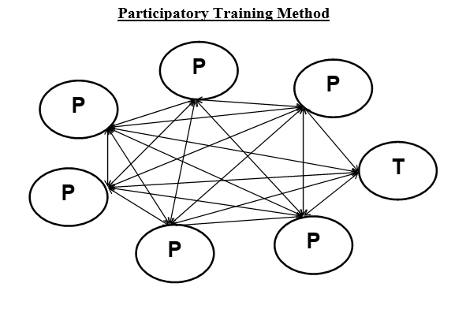
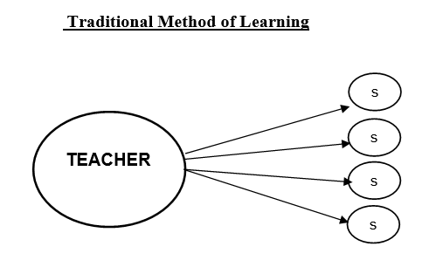
2 | Take few points from Participants. Share the following through slide or chart presentation.

Facilitator Input

PARTICIPATORY LEARNING APPROACH

The Participatory Learning Approach is a methodology that emphasizes active involvement, collaboration and empowerment of learners in the learning process.

Participatory Approach
- Is experiential ---- learner learning by doing
- Promotes active participation of the learner in the learning process, learners learn from each other, and the teacher often learns from the learners.
- Is interactive ----- encourages shared experience.
- Is reflective----- provide opportunity to reflect back upon learning activities, draw conclusions.
- Provides feedback that is cooperative and supportive.
- Shows respect for learners –mutual respect and trust between teacher and learner help the learning process.
- Provides a safe and comfortable atmosphere- a relaxed person learns more easily than one who is fearful, embarrassed or uncomfortable
- Is creative – uses multi-sensory learning

3 | Divide participants into three groups. Provide each group with flip charts and markers.
4 | Ask them to brainstorm and write down  Group 1: Difference between Teaching and Facilitation  Group 2: Responsibilities of good facilitator.  Group 3: The characteristics of good facilitator/trainer
5 | After the brainstorming session, have each group list their ideas on flip chart.
6 | Ask them to display the presentations around the room.
7 | Allow participants to walk around and read each group's ideas, noting any additional points they find interesting or important.
8 | Lead a discussion based on the ideas generated, highlighting common themes and important points. (Encourage participants to share their thoughts, experiences, and insights related to each point.)
9 | Refer participants to Handout 10.1 for further understanding and clarity.

Handout 10.1

Teaching | Facilitation
Inform, provide knowledge and clear understanding | Guide, encourage and support
Teacher starts from their own knowledge | Facilitator starts from the knowledge of the group
Teacher presents new information  from the front | Facilitator uses practical, participatory methods, eg: group discussion and activities in which all members of the group participate
Set goals and targets, monitor the learning process and outcome | Reflect through experience sharing
Information flows in one direction,  from teacher to students | Information flows in many different directions between the facilitator and individual group members – a genuine exchange of ideas
Share ideas  Give feedback and tips for improvement | Receive ideas and be a partner in learning Organize, allow space and time for thinking,
Teacher brings extensive knowledge  of the subject | Facilitator draws out and builds on the knowledge of the group, and knows where to find further information on the subject
Teacher is concerned with students  understanding the right answer | Facilitator encourages and values different views

Responsibilities of Good Facilitator

- To provide a warm, safe and trusting atmosphere by establishing the rules and structures of the group;
- Be a positive role model who is in touch with his or her own feelings and can appropriately self-disclose, setting the tone for group sharing;
- Listen, communicate acceptance, respect, empathy, caring;
- Not rescue or fix the pain of the students but believe in each person’s ability to make healthy decisions and assist in working through problems;
- Thoroughly familiar with the contents

Characteristics of Good Facilitator | SKILLS OF A GOOD Facilitator
- Humble and patient  - Understanding and accepting  - Inclusive  - An enabler  - Sensitive to the needs of others  - Willing to learn from mistakes  - Dynamic, motivator  - A good listener  - Confident  - A good communicator.  - Analyzer (reflecting on experiences) | - Well prepared whilst remaining flexible  - Think and act creatively  - Deal with sensitive issues and manage people’s feelings  - Encourage humor and respect  - Negotiate with and influence others  - Keep to time without being driven by it.  - Conflict management skills  - Understanding of group dynamics  - Affirming of everyone’s knowledge  - Good at summarizing others’ ideas  - Organizing skills (structuring activities; time keeping etc)

DO’s | DO NOT
- Be aware of self-attitude toward different people  - Be willing to share own feelings and ideas about discussion topics;  - Create warmth and trust. Ensure Confidentiality “What is said here stays here!”  - Respect all members; Confront with respect and sensitivity;  - Try to relax and learn from the group process;  - Be aware of nonverbal as well as verbal communication;  - Keep group on the subject – use direct questions, prevent avoiding,  - Periodically pull together related parts of discussion;  - Allow time to process/evaluate each group; | - Extend allocated time;  - Make fun of participants. This will hurt their feeling;  - Back bite or discuss outside Training group. It’s unethical to do.  - Be over confident that you know everything. always ask for views and opinions from participants.  - Start Group therapy: Group Therapy needs specialized Training  - Involve personally regarding participant’s issues and concerns.  - Divide group along ideological or ethnic lines;  - Do activity that are culturally or religiously inappropriate;  - Distract participants from the topic under discussion;  - Activities that are difficult to execute or conduct;

10 | Conclude the session emphasizing the importance of both Particiatory and tranditional teaching in schools. Emphasize the point that in the session with the children and teachers they will be following participatory approach with the help of modules provided. .

Session 11: Communication Skills for Facilitator (Duration：60 minutes)

Objective:

By the end of the session 11, participants will be able to:
- Better communicate as a trainer through learning and practicing communication skills.

Material Required: Cards, Communication statements, Flip charts, markers
Steps:

1 | Ask the participants to brainstorm on the word “communication, types of communication and characteristics of good communication”.
2 | Share the tools of Communication with participants with the help of 11.1 (Part-A) through an interactive lecture.
3 | Divide the participants in groups. Provide Worksheet 11.1 to each group and ask them to discuss and identify what tool is used in each statement.
4 | Invite each group to share their responses. Encourage other participants to ask questions for clarification. Provide your input with the help of facilitator key.
5 | Share with participants, important thing in body language using handout 11.1 (Part-B) and conclude the activity.

Facilitator Key for Worksheet:

S# | Statement (Short Reference) | Communication Tool
 | “So, what you are saying…” | Paraphrasing / Reflective Listening
 | “Can you explain…” | Open-ended Question
 | “I feel concerned…” | “I” Statement
 | “That’s a very thoughtful idea…” | Positive Feedback
 | “You seem upset…” | Empathy
 | “Let me summarize…” | Summarizing
 | “Why do you think…” | Open-ended Question
 | “I understand your point…” | Respectful Communication / Acknowledgement
 | “It sounds like…” | Reflective Listening
 | “What steps can we take…” | Problem-solving Question
 | “You did a great job…” | Positive Feedback
 | “From your explanation…” | Paraphrasing
 | “How did you feel…” | Open-ended Question / Emotional Awareness
 | “I noticed that…” | Constructive Feedback
 | “Let’s focus on…” | Guiding / Facilitation Skill

Notes for Teacher/Facilitator:
- It is important to make participants realize that tools of communication will help them to reflect and share their feelings and emotions.
- Participants may be confused about tools like Allow silence or Reflect listening.
- When people communicate, they convey more than words the needs and feelings behind the words. A reflective response communicates to the speaker that you have just not heard the words but also the feelings behind the verbal message. This makes the speaker feel s/he is being heard and helps you to confirm that you have understood.

Worksheet 11.1

Activity: Identifying Communication Tools

Instructions:
Read each statement carefully and write the communication tool used in the blank space.

- So, what you are saying is that the students feel nervous during exams, right?
👉 ___________________________________________________________

- Can you explain what challenges you face while managing your classroom?
👉 ___________________________________________________________

- I feel concerned when assignments are not submitted on time.
👉 ___________________________________________________________

- That’s a very thoughtful idea; it can really help improve student participation.
👉 ___________________________________________________________

- You seem upset today. Would you like to share what happened?
👉 ___________________________________________________________

- Let me summarize: you want more training on lesson planning and assessment.
👉 ___________________________________________________________

- Why do you think students are not responding to your questions?
👉 ___________________________________________________________

- I understand your point, but we also need to consider the school policy.
👉 ___________________________________________________________

- It sounds like you are saying that large class size makes teaching difficult.
👉 ___________________________________________________________

- What steps can we take together to solve this problem?
👉 ___________________________________________________________

- You did a great job in explaining the topic clearly.
👉 ___________________________________________________________

- From your explanation, I can see that time management is your main concern.
👉 ___________________________________________________________

- How did you feel when the students did not complete their work?
👉 ___________________________________________________________

- I noticed that you used examples effectively during your lesson.
👉 ___________________________________________________________

- Let’s focus on one issue at a time to find a better solution.
👉 ___________________________________________________________

Handout 11.1
Communication Tools: (Part-A)

Paraphrase: Paraphrasing is repeating portion of what the other person has just said. Paraphrasing checks for accuracy, clarifies misunderstandings and lets the other person know that he or she is being heard. It also communicates interest and empathy.

Reflect feelings: Speaker’s fear, sadness or anger is usually reflected in his tone of voice or nonverbal gestures. A reflective response communicates to the speaker that you have heard and understood what s/he is saying and what s/he is feeling. e.g., you sound angry, scared etc. because of this situation?" This helps the speaker identify and articulate his or her emotions.

Open Ended Questions: Allow students the room to explain their point of view and think from different perspectives. It helps with people who do not respond much. Open-ended questions usually start with what or how or ask for more clarification and details. These are used to elicit something about feelings, thoughts and behaviors. Guide lines to be used are:

Request description: “please tell me…” “Tell me about…”

Focus on plans: “what will you do…?”, “how will you make it happen…?”, “how will that help you?” What would be the advantage? The disadvantage?

"I" Statements: Another effective tool is using an "I" statement which means honestly sharing our concerns, thoughts and feelings, taking responsibility for a problem you have "owned" and voicing it, and speaking for oneself rather than generalizing and accusing. E.g. you are trying to work, but your colleague keeps talking loudly which bothers you. First you own the problem because it is YOU it is bothering and then you express your concern by using an "I" statement such as “I find it difficult to work when you are whistling. I would appreciate it if you could talk more softly." Instead of, "You're talking so loudly! Be quiet! Another example can be saying, "I find it difficult to trust people." instead of "No one is trustworthy."

Stroking: A "stroke" is any action that makes the receiver feel good and appreciated. Smiles, pats. compliments, etc. are strokes. It has been observed that people use negative feedback more often than positive feedback. Focusing on positive feedback can be very helpful in relationships. This is different from flattering because in stroking the appreciation is genuine and honest and is not being used to get something out of the other person. E.g. You say to your friend, "I want to tell you that I really appreciate how much you've helped me with my problems. I feel you're a very good listener and I find that very helpful."

Summarization: At the end of discussion, the trainer should summarize. It allows the participants to feel that the trainer is listening.

Important things in Body Language: (Part-B)

Eye contact: Maintaining good eye contact shows respect and interest in what other person have to say. It will give them a feeling of comfort and genuine warmth. Not maintaining eye contact give off a signal that you are lacking interest in them or their conversation.

Posture: Angle of the body in relation to others gives an indication of our attitudes and feelings towards others. We angle toward people we find attractive, friendly and interesting and angle ourselves away from those we don't,
Nodding head: Straight head position conveys that you are authoritative and what you're saying to be taken seriously. Conversely, nodding head conveys that you are friendly and, in the listening, receptive mode.

Space: Distance from others is crucial to give off the right signals. Standing too close is marked as "Pushy". Stand or sit too far away shows not wanting to be with other.

Hands movement: Palms slightly up and outward is seen as open and friendly. Palm down gestures is generally seen as dominant, emphasizing and possibly aggressive.

Facial Expressions: Facial expressions, tone, etc., play a very important role in communication, but they are generally overlooked.

Session 12: Practice Session (Duration：35 minutes)

Objective:

By the end of the session 12, participants will be able to:
- Better communicate as a trainer through learning and practicing communication skills.

Material Required: Cards, Communication statements, Flip charts, markers

Steps:

1 | Divide the participants in pairs, with one participant will play the role of facilitator and other co-facilitator
2 | Divide different sessions among the participants, give them 20 minutes for the preparation of the session. (give them the modules a day before for the preparation)
3 | Each pair will role play the session for 10 minutes of session. Participants will give feedback using facilitator checklist.

Checklist

Observations/Methodology | Used | Not used
Facial expressions
Posture and sitting style
Use of nodding
Eye contact
Encouraging participants
Asking questions from participants that keep the conversation flowing
Command over the subject
Clarifying confusion
Providing satisfactory answers to participants' questions
Giving participants complete information
Any other observations

Session 5: Root Cause of violence

Session 14: Action Planning (Duration：60 minutes)

Objectives:

By the end of session 14, participants will be able to:
- Create an action plan and personal pledge to prevent and respond to GBV in their classrooms and schools

Material Required: Whiteboard/Flip charts, Markers
Training Material: Evaluation form

Steps:

1 | Ask participants to come up with the plan including dates and time for two types of activities.  - Assembly Session  - 2 hours Session with Children  - 5 hours’ session with Teachers, PTCs etc.
2 | Let them know that the plan will be executed with the collaboration of Education and Secondary Education Department (E&SED) so it needs to be shared through an official communication.

Activity 1: Training Wrap-up (30 minutes)

Steps:

1 | Thank and congratulate the participants for all their hard work, attention and participation during the two – day training program.
2 | Remind them that they hold a very important role in the community, school and in the lives of children. Their efforts will go a long way to prevent and respond to GBV, VAC and SH.
3 | Go around the room and have all the participants share their “I Will…” statements. Write these points on flipchart paper. People can repeat the same statements; just put a check mark if more than one person says it.
4 | Remind them of their action steps, making connections between what they have learned and how it applies to some of the action steps they might have outlined.

Activity 2: Evaluation of the Two-Days training program (15 minutes)

Steps:

1 | Distribute evaluation forms among participants and ask them to rate training contents.
2 | Collect filled training evaluation forms from participants and handover to Training Facilitator.

Annexure

Legal Framework

The Article 19 of the United Nations Convention on the Rights of Child 1989
Children have the right to protection from violence. The United Nations Convention on the Rights of the Child (UNCRC) and its provisions establish the most comprehensive framework for children’s rights. The Convention defines a child as "every individual under the age of 18." Together with its optional protocols, the UNCRC provides a legal framework that enables states to enact national legislation for the protection of children.

By ratifying the UNCRC, states commit to recognizing and implementing its standards. The Convention is based on several key principles vital to child protection, including the principle of the best interests of the child, the principle of non-discrimination, the right to life and development, and respect for the child’s views.

Three specific Articles (19, 34, 39) of the Convention directly address violence against children. Most notably, Article 19 calls for "legislative, administrative, social, and educational measures" to protect children from violence and neglect. In Pakistan, several laws are enforced for child protection, including but not limited to the provisions inspired by the UNCRC.

The Constitution of Islamic Republic of Pakistan:
The constitution of Pakistan has provisions that safeguard the rights of children, including the right to education, health, and protection from abuse and exploitation. Article 25(1) of the Pakistani Constitution states that "all citizens are equal before the law and entitled to equal protection of law". Article 37(a) of the Convention states that "no child shall be subjected to torture or other cruel, inhuman or degrading treatment or punishment".

The Child Protection and Welfare Act 2010:
This law aims to protect children from physical, emotional, and sexual abuse, exploitation, neglect, and abandonment. It establishes Child Protection Committees at the district level to provide support to children in need of care and protection.
Later the Khyber Pakhtunkhwa Child Protection and Welfare (Amendment) Bill, 2022 was passed by the Provincial Assembly of Khyber Pakhtunkhwa on 31st May, 2022.

The Juvenile Justice System Ordinance 2000:
This law outlines the procedures for dealing with children in conflict with the law. It establishes juvenile courts and provides appointment of probation officers and social welfare officers to work with children who are exposed to the justice system.

The Prohibition of Corporal Punishment Act 2018:
This law prohibits the use of physical punishment against children in all settings, including homes, schools, and care institutions.

The Protection Against Harassment of Women at the Workplace Act 2010
In Pakistan, a law for the protection of women from workplace harassment was passed in 2010. Under this Act, it is mandatory to display a Code of Conduct against sexual harassment at an appropriate place in offices and ensure its implementation. Additionally, the establishment of an Inquiry Committee within workplaces is also required.
If the Inquiry Committee finds evidence that a particular accused individual has harassed a female employee, the committee can impose penalties or fines on the accused, and even terminate their employment.

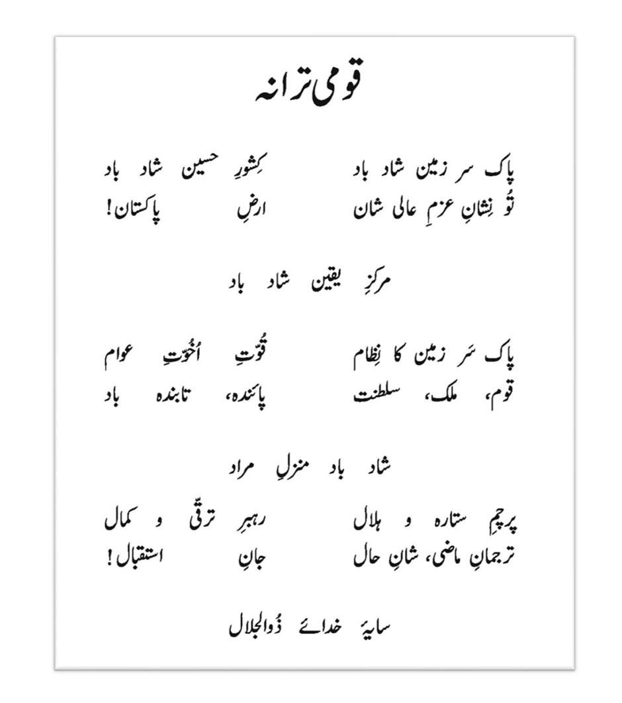

avethechildren.net/sites/www.savethechildren.net/files/SC-PR-13-Purchase-OrderTCsv2.0%20Child%20Safeguarding%20Policy%20English%20%281%29-5-9.pdf
Child Protection Handbook 2016 by the Association of International Schools in Africa (AISA); Doorway III

